Day in the Life of the Hudson River 10/10/13 Data
(Salt Front RM 69.3)
RIVER MILE 138 – Henry Hudson Park
Mary Cosgrove, 2 faculty & 10 students, Mt. St. Rose College
Susan Schiavoni, Delaware Community School – 25, 3rd grade elementary students, 2 teachers,
Coordinates: 42.64 N, 73.74 W
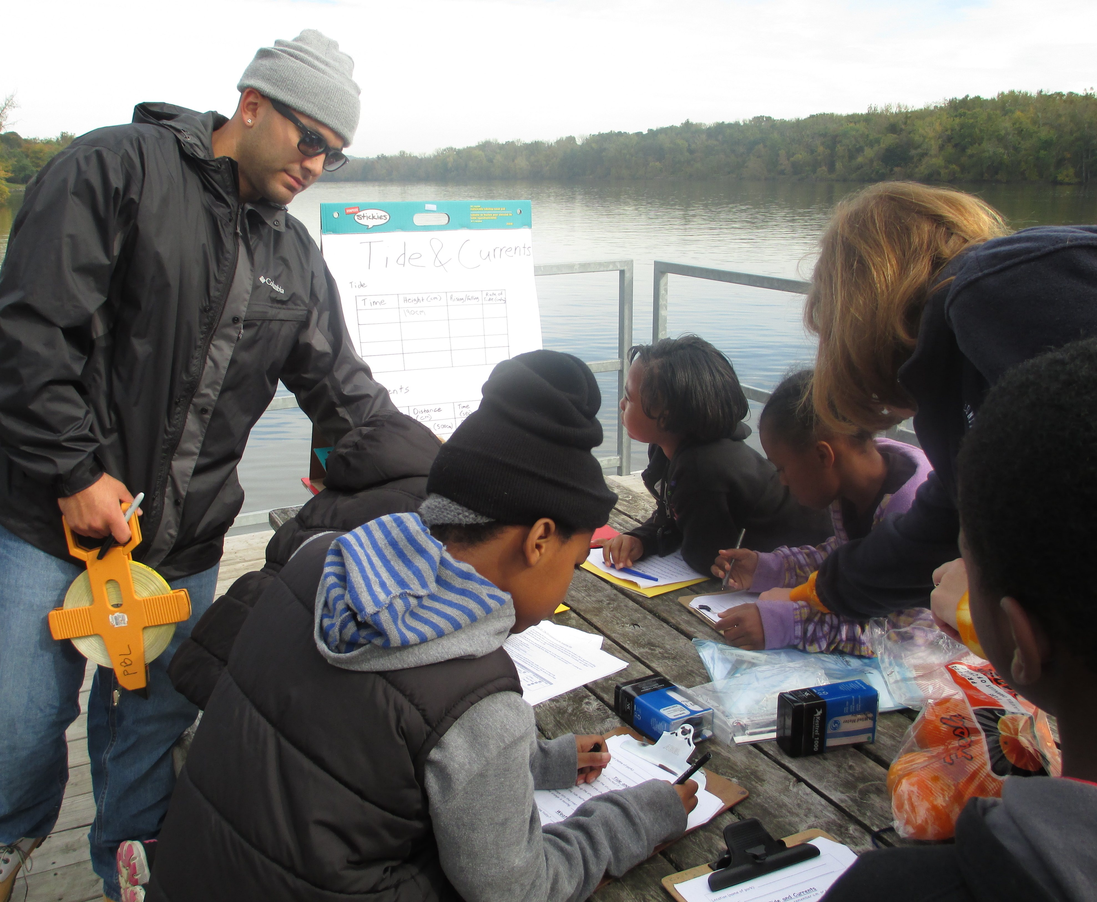 | 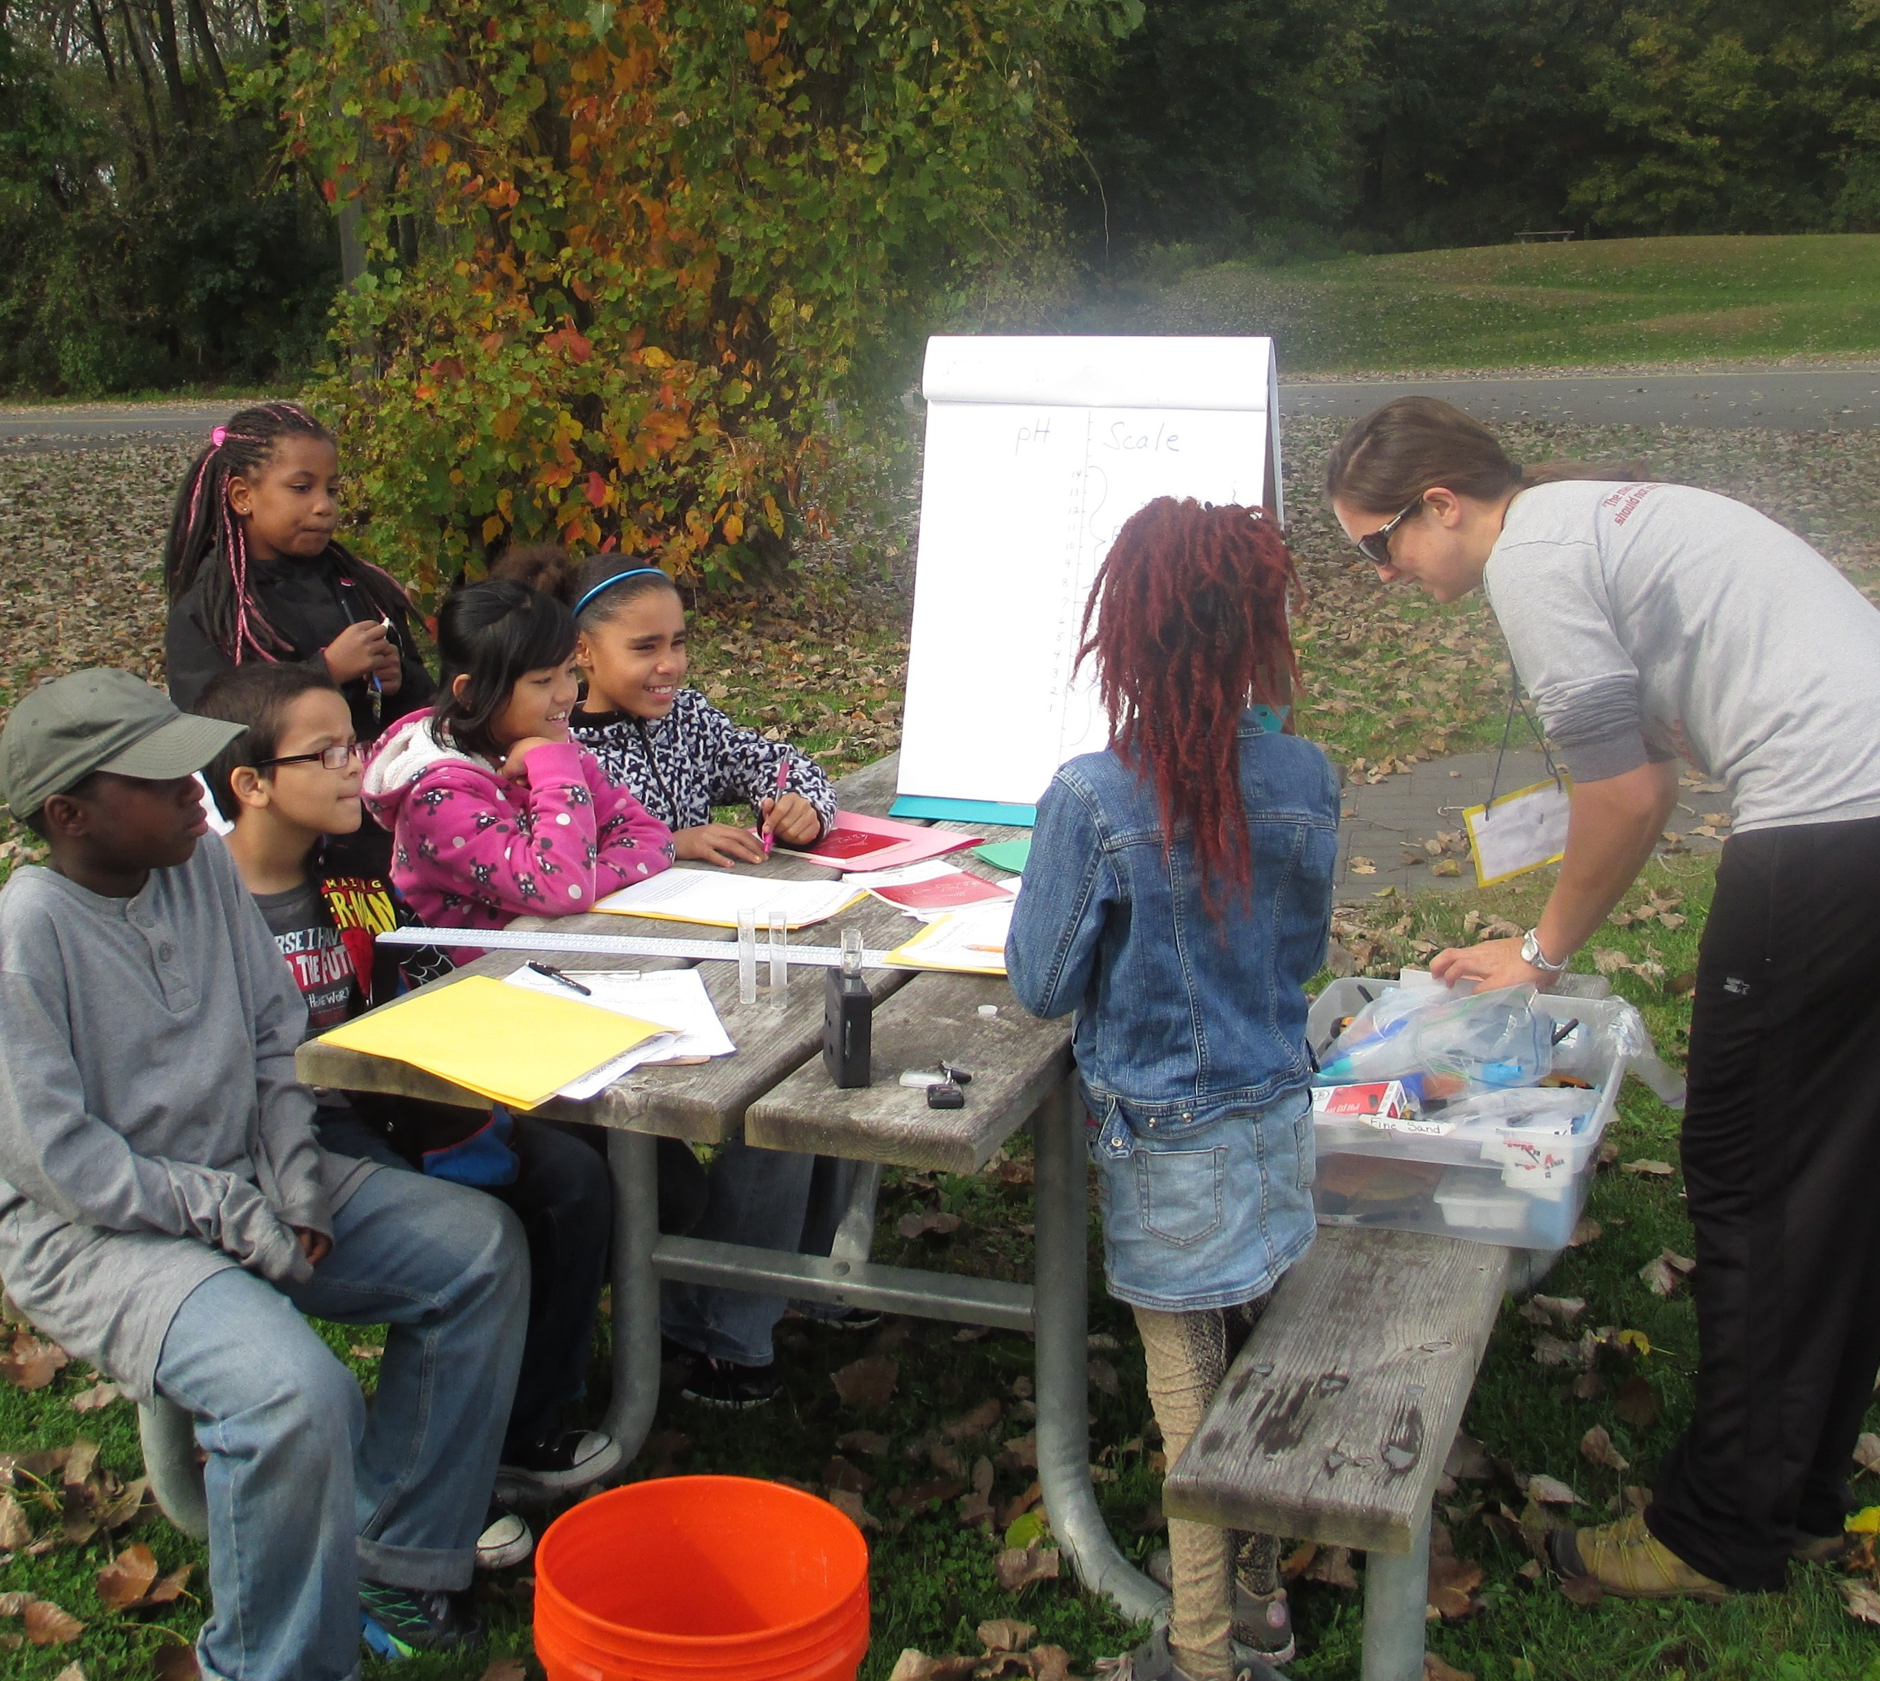
Location: Waterfront of Henry Hudson Park Area: Park/Boat launch,
Surrounding Land Use: 100% parkland with 75% vegetated coverage – grassy, parking lot, used for picnics, boating, fishing
Sampling Site: Banks altered, riprap, bulkheaded -rocky
Plants in area: Smartweed, ragweed, Joe-pye weed, jewelweed, purple loosestrife, grass
Water depth: River Bottom – Water -calm

ITEM | Time |  | Reading 1 | Reading 2 | Comments
Physical | Time |  | Temp | Wind Speed | Weather today
Air Temperature
Cloud Cover | cloudy
Weather last 3 days | Rainy, cool
Water Temperature
Turbidity Large site tube | 10:50 AM | 50 cm
 | 11:10 AM | 52 cm
 | 10:30 AM | 52 cm
 | 10:50 AM | 52 cm
Chlorophyll | 10:50 AM | 0 .4
 | 11:10 AM | 0.4
 | 11:30 AM | 0.3
 | 10:50 AM | 0.3
DO -Drop count | Time | Mg/L |  | Temp | % Saturation
 | 10:50 AM | 8 |  | 16.1 | 85%
 | 11:10 AM | 8 |  | 15.9 | 85%
 | 11:30 AM | 9 |  | 16 | 90%
 | 10:50 AM | 9 |  | 15.9 | 90%
pH | 5 tests | 6  6.6  6  6  6.5 |  |  | Average 6.2
Salinity -Test strip | Group # | Quantab # |  | Cl- | Total Salinity
 | 1 | 1.2 |  | 28 ppm | 51 ppm
 | 2 | 1.2 |  | 28 ppm | 51 ppm
Tides | Time | Height (cm)
 | 10:40 AM | 190 cm
 | 12:00 PM | 220 cm |  | Rising | 30 cm/80 min
Currents | Time | 500 cm/X sec |  | Cm/sec
 | 10:40 AM | 500cm/9 sec |  | 55.56
 |  | 500 cm/22 sec |  | 2.27
 |  | 500 cm/26 sec |  | 19.23
 |  | 500 cm/15 sec |  | 33.33
Fish Catch | Numbers | Species |  | Fish length | Diversity/Totals
 | 1 | Blueback Herring |  | 5 cm | Div = 2
 | 12 | Gizzard shad |  | 5 cm | Totals =13

