Day in the Life of the Hudson River 10/10/13 Data
(Salt Front RM 69.3)
RIVER MILE 144
Rensselaer Boat Launch, Forbes Rd., Rensselaer, NY
Alene Onion, Hudson River Estuary Program
Leah Penniman, Tech Valley High School - 9th grade
Environmental Science & Geography – 30 students, 2 Adults
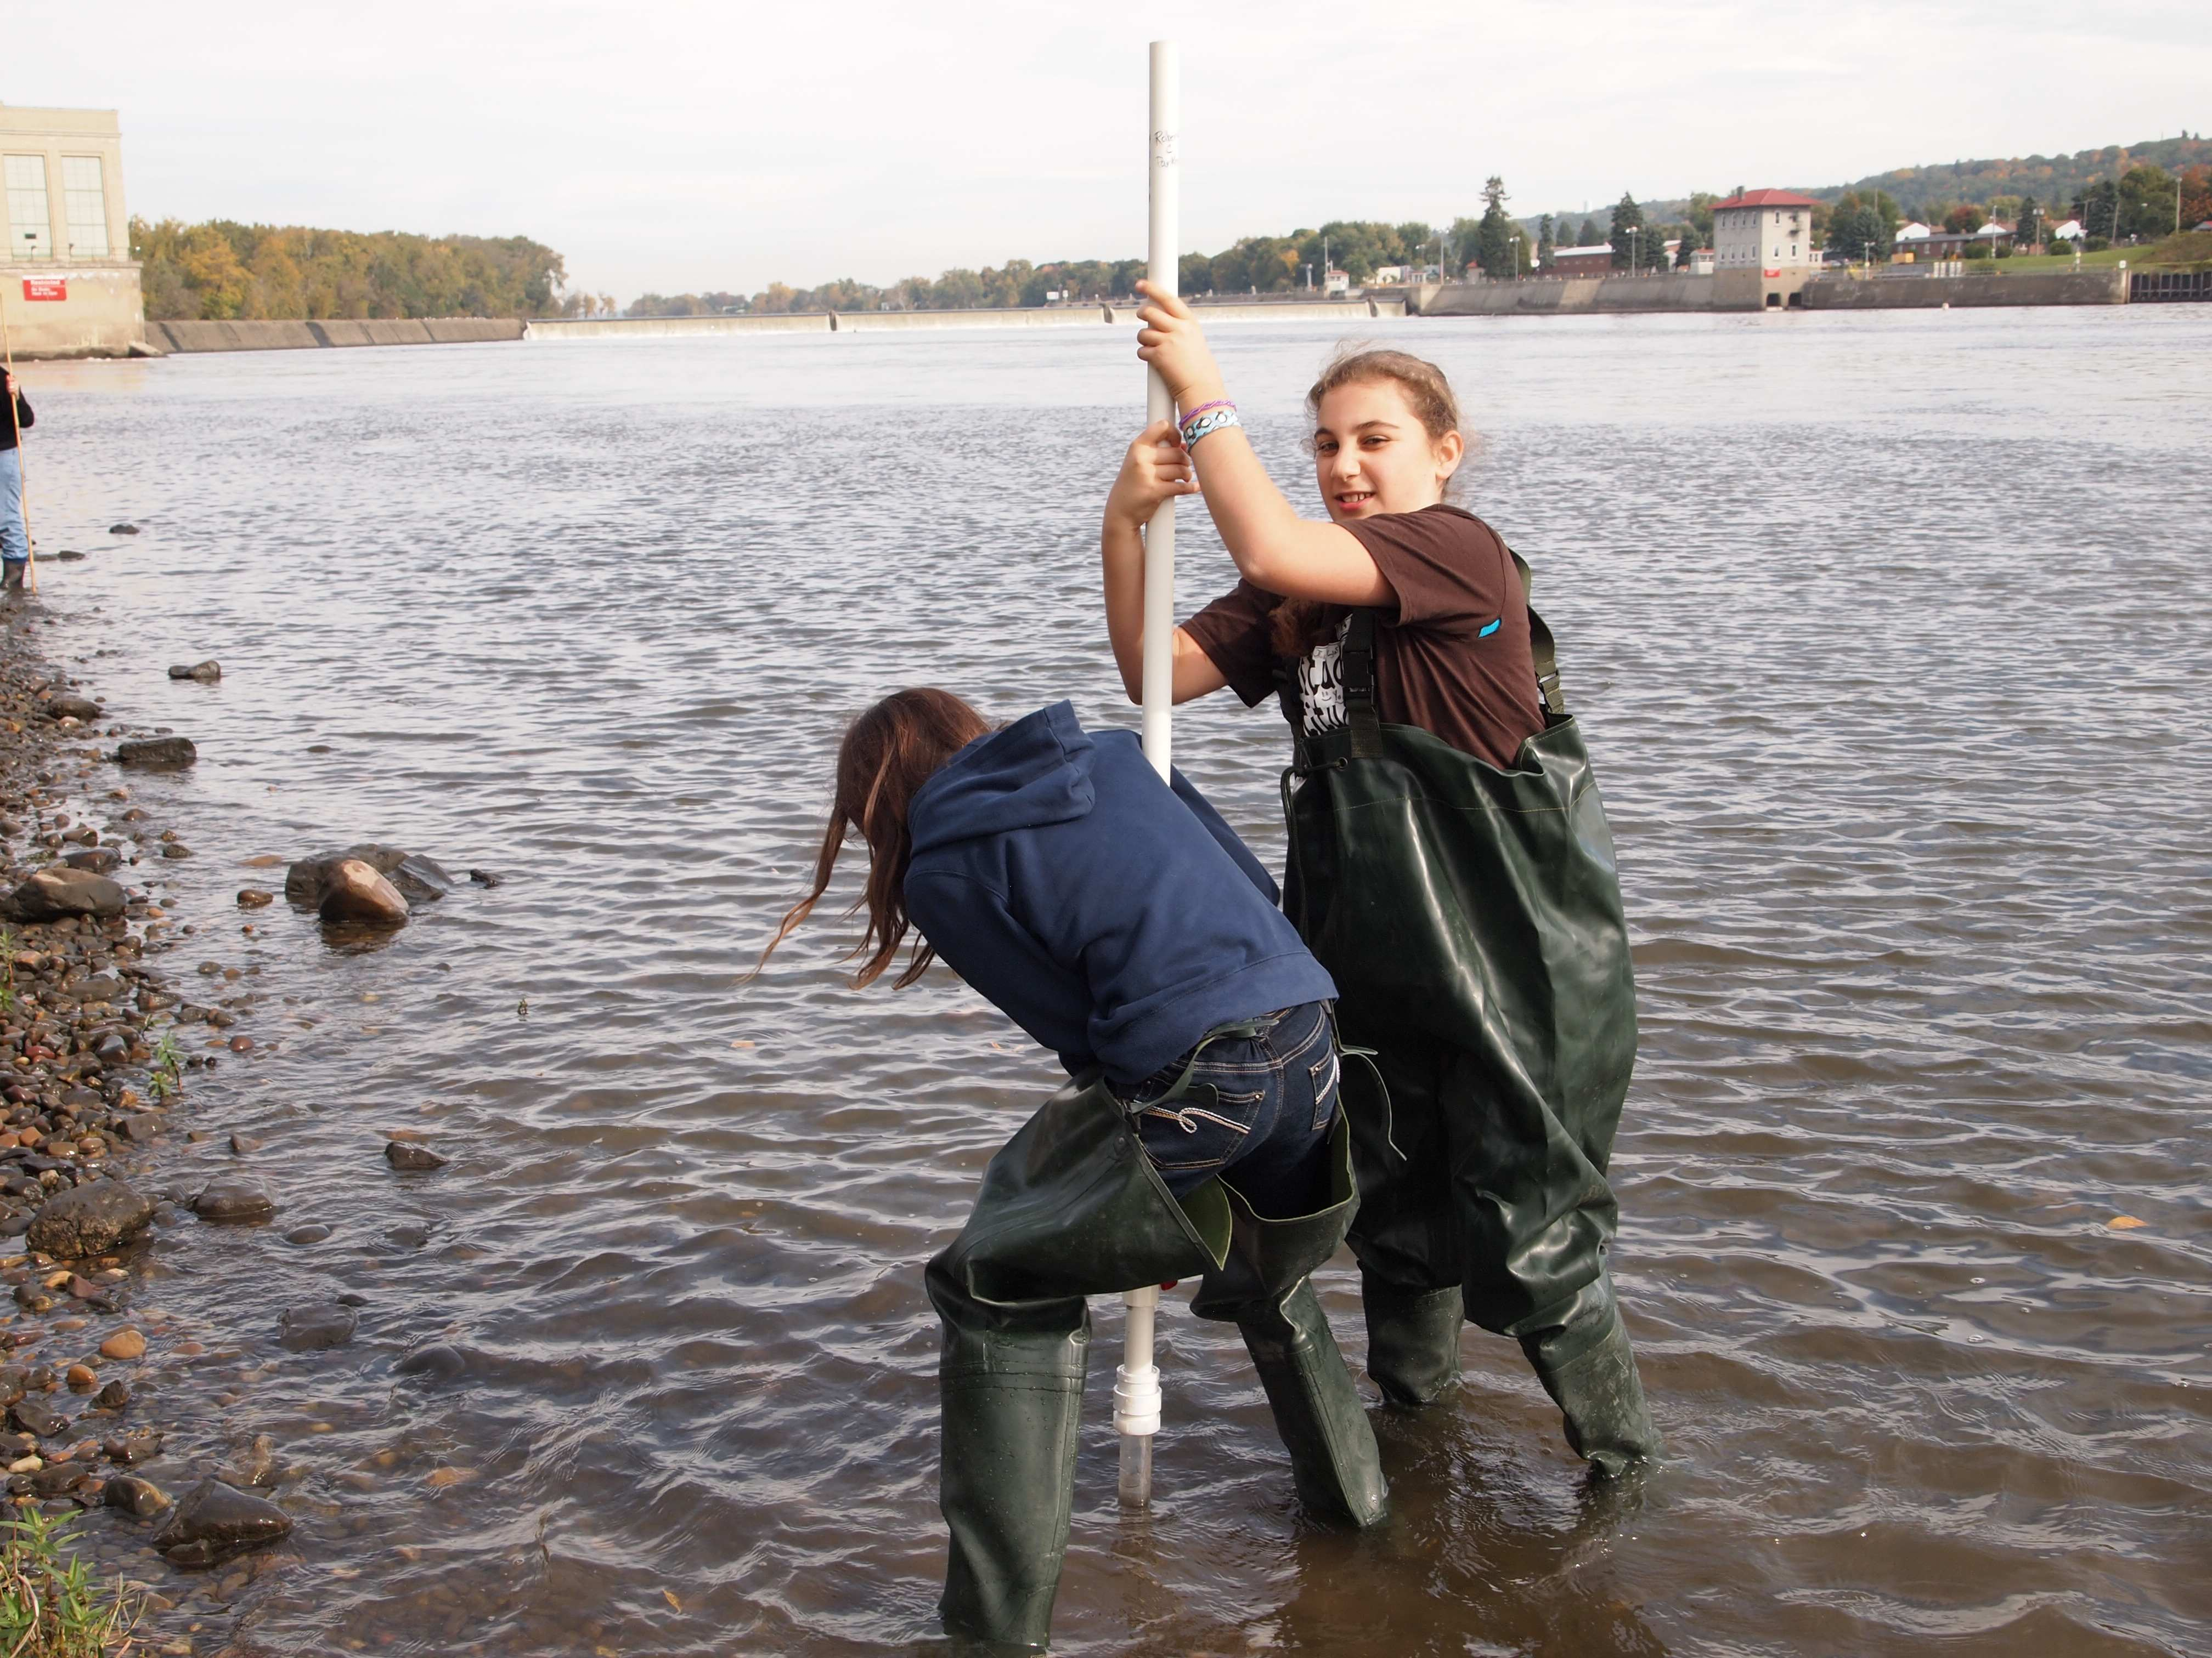
Location: Rensselaer Boat Launch
Area: Boat launch – beach area
Surrounding Land Use: Boat launch with small beach, wooded, landscaped, adjacent to urban residential area
Sampling Site: boat launch with surrounding beach area
Plants in area:
Water depth: unknown
River Bottom :
Times: All sampling 10:00 AM to 11:15 AM
ITEM | Time |  | Average Readings - |  | Comments
Physical | 9:30 AM-11:00 AM |  | 14.3°C
Air Temperature |  |  | 16.7°C
Wind Speed
Cloud Cover | Cloudy
Weather today | Foggy and wet
Weather recently | Some rain and humid
Water | calm
Water Temperature |  | 15.3°C
Turbidity (Site tube & LaMotte) |  | 19 cm |  |  | 8.9 JTU
Chemical
DO (chemet color comparator) |  | 9.3 ppm |  | 101.5% saturation
pH – pH meter |  | 6.8
Phosphate -  Chemet Color comparator |  | 0.1 mg/L
Nitrate –  LaMotte color comparator |  | 0.4 ppm
Alkalinity |  | 132.5 ppm
Salinity* |  | 1.5 on strip |  | 28 ppm Cl- | 50.56 ppm Total Salinity
Electrical Conductivity |  | 274.75 uS |  | microseimens
Coliform  Petrifilm plate 1 ml water  • stated range is based on colonies per 100 ml sample | 15,400  75,600  4,500  18,000  10,400  24,000  18,000  33,800 | 24962.5 average |  |  | * only 1 of 8 samples was below the level of 2,400-5,000
Shipping Traffic | 9:36 AM  10:10 AM | Not recorded  Margot |  | White  Blue/Black | N/R  Southbound

