**Day in the Life of the Hudson River 10/10/13 Data**

**(Salt Front RM 69.3)**

**RIVER MILE 152**

**Hudson Shores Park, Watervleit, NY**

**Amy Parks/Stacey Shepard, North Colonie CSD**

**30 students, 6th grade students and 2 adults**

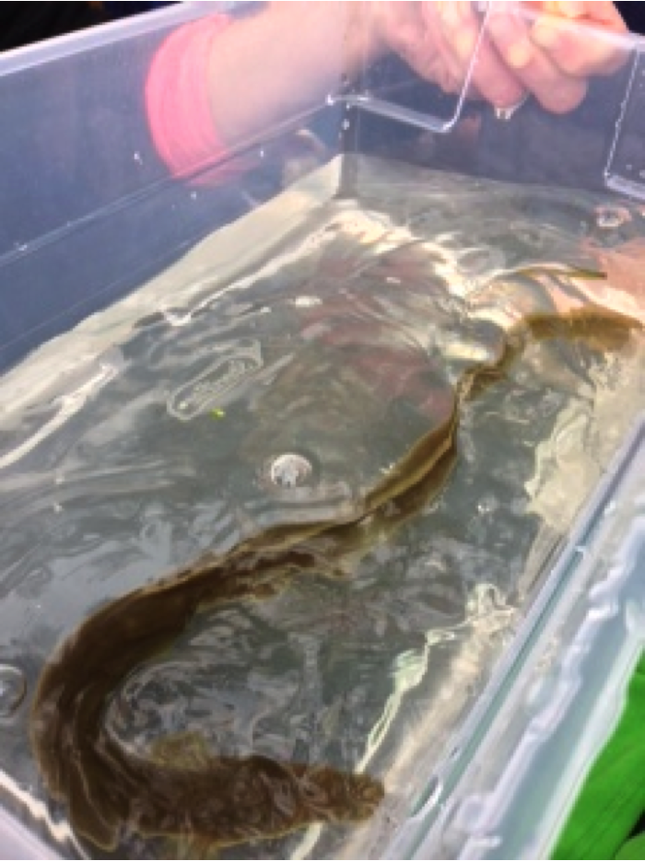

**Location:** Hudson Shores Park, Watervleit, Albany County, NY

**Area:** park right on the river’s edge

**Surrounding Land Use:** Fishing launch,Rocky with weedy vegetation and a few small shrubs (gravelly)

**Sampling Site**: 10%beach at low tide,70% park/parking area, 20% planted/forested, - across the river land use100% Industrial/Commercial

**Shoreline:** beach area, pier, shore with bulkhead, area covered with vegetation

**Plants in area:** none in the water

**Water depth**:

**River Bottom**: mixture of sand/mud, small rocks

|  |  |  |  |  |
| --- | --- | --- | --- | --- |
| ***ITEM*** | ***Time*** | ***Reading 1*** | ***Reading 2*** | ***Comments*** |
| ***Physical*** |  |  |  |  |
| Air Temperature | 9:45 AM | 61 °F  16 °C | 10:26 AM | 62 °F  17 °C |
| Wind Speed:  ***Beaufort*** | 9:45 AM | #1 Chart South | 10:26 AM | #1 Chart North 15 degrees |
| Cloud Cover | partly |  |  |  |
| Weather today | Cool and cloudy | | | |
| Weather recently | Cool but early fall like | | | |
| ***Water surface*** |  |  |  |  |
| ***Water Temperature*** | 9:41 AM | 60 °F | 15 °C |  |
|  | 10:12 AM | 60 °F | 15 °C |  |
|  | 10:30 AM | 65 °F | 18°C |  |
| ***Turbidity – long site tube*** | 12:20 PM | 49.6 cm  50.8 cm  19.2 cm |  | Average 39.9 cm |
| ***Chlorophyll*** | 9:45 AM | 0.3 | 10:26 AM | 1.0 |
| ***Chemical*** |  |  |  |  |
| DO  (Drop count kit | 9:41AM  10:12 AM  10:30 AM | 11 mg/L  11 mg/L  12 mg/L | 15°C  15  18 | 110%  110%  125% |
| pH – indicator solution | 9:41AM  10:12 AM  10:30 AM | 7.5  7.5  7.5 |  |  |
| Salinity - quantab | 9:41AM  10:12 AM  10:30 AM |  | 32 ppm Chl  32 ppm  32 ppm | 58 ppm TS  58  58 |
| ***Fish Catch -*** | ***Time*** | ***Number Caught*** |  | ***Macroinvert.*** |
| Set 2 minnow traps  & seined | 12:30 PM in trap | American eel | 12-14 inches |  |
| ***Tides*** | ***Time*** | ***Height dock to water*** |  | ***Rate of change*** |
|  | 9:45 AM | 7 inches | Base reading |  |
|  | 10:26 AM | 8 inches | Falling |  |
| ***Currents -*** | **Cm/30 sec** | **cm/sec** | **knots** | **N/S E/F/S** |
| 9:45 AM | 530 cm/30 sec | 17.67 |  | Ebb |
| ***Core Sample*** | ***Area very rocky*** | **Abundant** |  |  |
| ***12:20 PM*** | 2 inch core | Gravel/ pebbles |  |  |
| ***Boat Traffic*** | **Time** | **Name** | **Type** | **Direction** |
|  | 9:46 AM | Canadian | Yacht | Southbound |
|  | 9:45 AM | Margot | Tugboat | South |
|  |  | Southbeach Indiana |  |  |
|  | 12:15 PM | American Star | Cruise ship | Southbound |