Day in the Life of the Hudson River 10/10/13 Data
(Salt Front RM 69.3)
RIVER MILE 153
River Park, Green Island Park, Green Island NY
Kate Perry & Lynn Schuster, Robert C. Parker School
51 students - 2nd & 3rd and 6th and 7th grade students, 17 adults
42.74 N -73.69 W
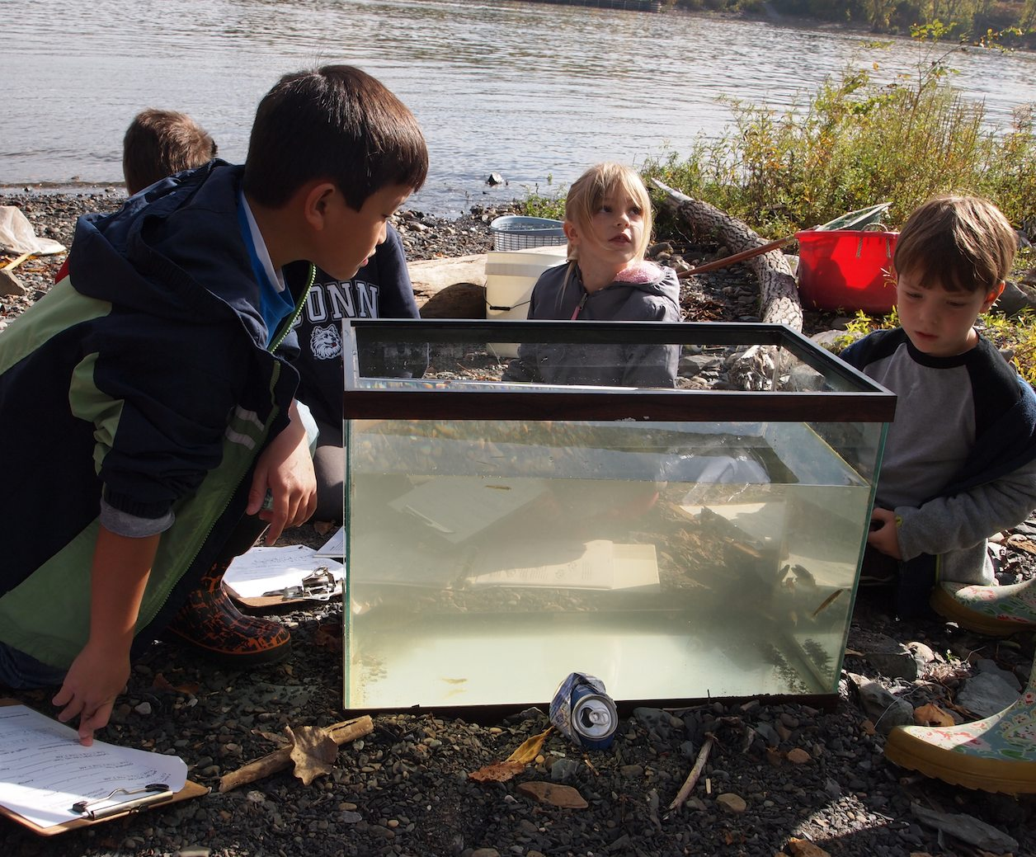 | 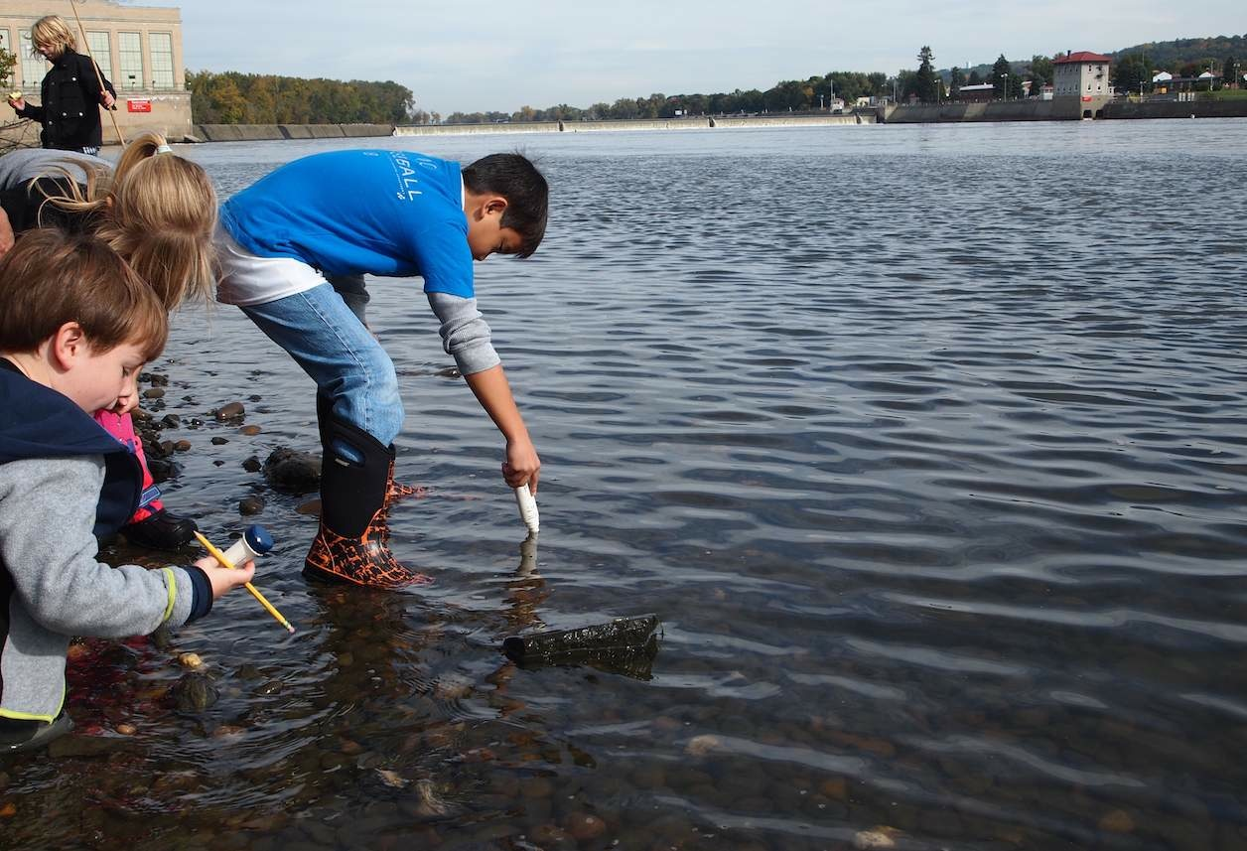

Location: Green Island Park boat ramp, below the Troy Dam, Albany County, NY
Area: park above bluff and then beach below just south of the Troy dam
Surrounding Land Use: Forested, Rocky, Fishing
Sampling Site: 70% industrial/commercial, 10% urban/residential, 20% planted/forested,
Shoreline: Rocky, broken concrete docking, very rocky shoreline, slag, concrete at the launch, brick pieces, vegetation
Plants in water: Some plants in the water – less than half covered.
Plants in area: goldenrod, grasses, fleabane, Joe Pyeweed, Virginia creeper, meadowsweet, and willows
Water depth: 0-10 cm along shore
River Bottom: rocky bottom

ITEM | Time |  |  | Reading 1 | Reading 2 | Comments
Physical
Air Temperature | 10:16 AM |  |  | 58 °F  14°C
 | 10:56 AM |  |  | 60 °F  15°C
Wind Speed | #2 Beaufort |  |  |  | North
Cloud Cover | Mostly cloudy
Weather today | Clouds increased as the morning progressed
Weather recently | Large storms came through Monday evening – nothing else unusual.
Water surface | Mostly calm
Water Temperature | 10:19 AM |  | 15°C
 | 10:49AM |  | 15°C
 | 11:14 AM |  | 15°C
Turbidity –long site tube | 10:30 AM |  | 20 cm  22.3 cm  23.1 cm |  | 21.8 cm average
 | PM |  | 51.1 cm  53.46  78.0 |  | 60.85 cm average
Chlorophyll | 10:30 AM |  | 0
Chemical | 10:00 AM |  | 1.0
DO  (Drop count kit | 10:19 AM  11:14 AM |  | 15°C  15 |  | 14 ppm  11 | 138%  112%
pH - pen | 10:30 AM |  | 8.0  8.5  8.3 |  |  | Average 8.3
Salinity – test stripes | 11:00 AM |  | 1.3 on strip |  | 28 ppm chloride | 50.56 ppm total salinity
Fish Catch – 20 ft.X4 net | Time |  | Number Caught |  | Species | Size Largest
20 ft. pull -  3 seines, traps | 10:00 AM Seine |  | 4 |  | Brook Silversides | 3 cm
 |  |  | 1 |  | Bluegill Sunfish | 7 cm
 |  |  | 8 |  | Banded Killifish | 5 cm
Shocking backpack | 10:30 AM |  | 3 |  | Bluegill Sunfish | 3 cm
 |  |  | 3 |  | American Eel | 10 cm
 |  |  | 6 |  | Banded Killifish | 5 cm
 | TOTAL CATCH |  | 25 |  | TOTAL SPECIES | 4
 | Macro- invertebrates |  | Blue Crab Pieces |  | Aquatic Snails
Tides | Time |  | Height in cm |  | Rising/Falling | Rate of change
Group 1 | 10:07 AM |  | 16 cm
 | 10:23 AM |  | 9 cm |  | Falling | 0.44 cm/min
Group 2 | 10:30 AM |  | 24 cm |  |  | 1.25 cm/min
 | 10:48 AM |  | 15 cm |  | Falling | 0.50 cm/min
Group 3 | 10:54 AM |  | 10 cm
 | 11:09 AM |  | 4 cm |  | Falling | 0.40 cm/min
Currents ** | Time | Cm/30 secs | Cm/sec |  | Knots | N/S Ebb/Fld/Still
 | 10:04AM | 450 cm | 15.0 |  | 0.29 kts | S- Ebb –
 | 10:05 | 732 | 24.4 |  | 0.47 | S Ebb – C
 | 10:42 | 124 | 4.1 |  | 0.08 | S Ebb – S
 | 10:47 | 297 | 9.9 |  | 0.19 | S Ebb – S
 | 11:02 | 741 | 24.7 |  | 0.48 | S Ebb - C
** Students noted that the differences in results were due to throwing ability, human error, closeness to shore, and not necessarily a change in current. Some of the results were noted with “C” for channel and “S” for shore. Note the different in the speed of the current in the main channel versus along the shoreline.
Traffic | 10:45 AM |  | Speedboat |  | Southbound | Recreational
Core | Alene took the only core – they tried many times during the day but overall the site is very gravelly, especially at high tide
Other Items | There was a sad amount of garbage scattered along the bank.  We saw only a few birds (gulls) flying and no other shore wildlife.
Almanac | Overcast skies and high tide kept a lot of wildlife at bay at the Troy Dam. Students were thrilled by the changes in the water level as the tide went out. The uncovering of the shoreline brought shells, rocks and formations to light. The American eels and bluegills swimming in the aquarium stimulated questions and curiosity.

