Day in the Life of the Hudson River 10/10/13 Data
(Above the Troy Dam and the Head of Tide)
RIVER MILE 154
Peebles Island State Park, Waterford, NY
Kathy Czajkowski Mohawk Watershed Coordinator, and 2 SCA helpers
Ms. Fecura, Ms. Town and Mr. Flannery and the Wynantskill Union Free School District
32 students – 4th grade, 10 adults total

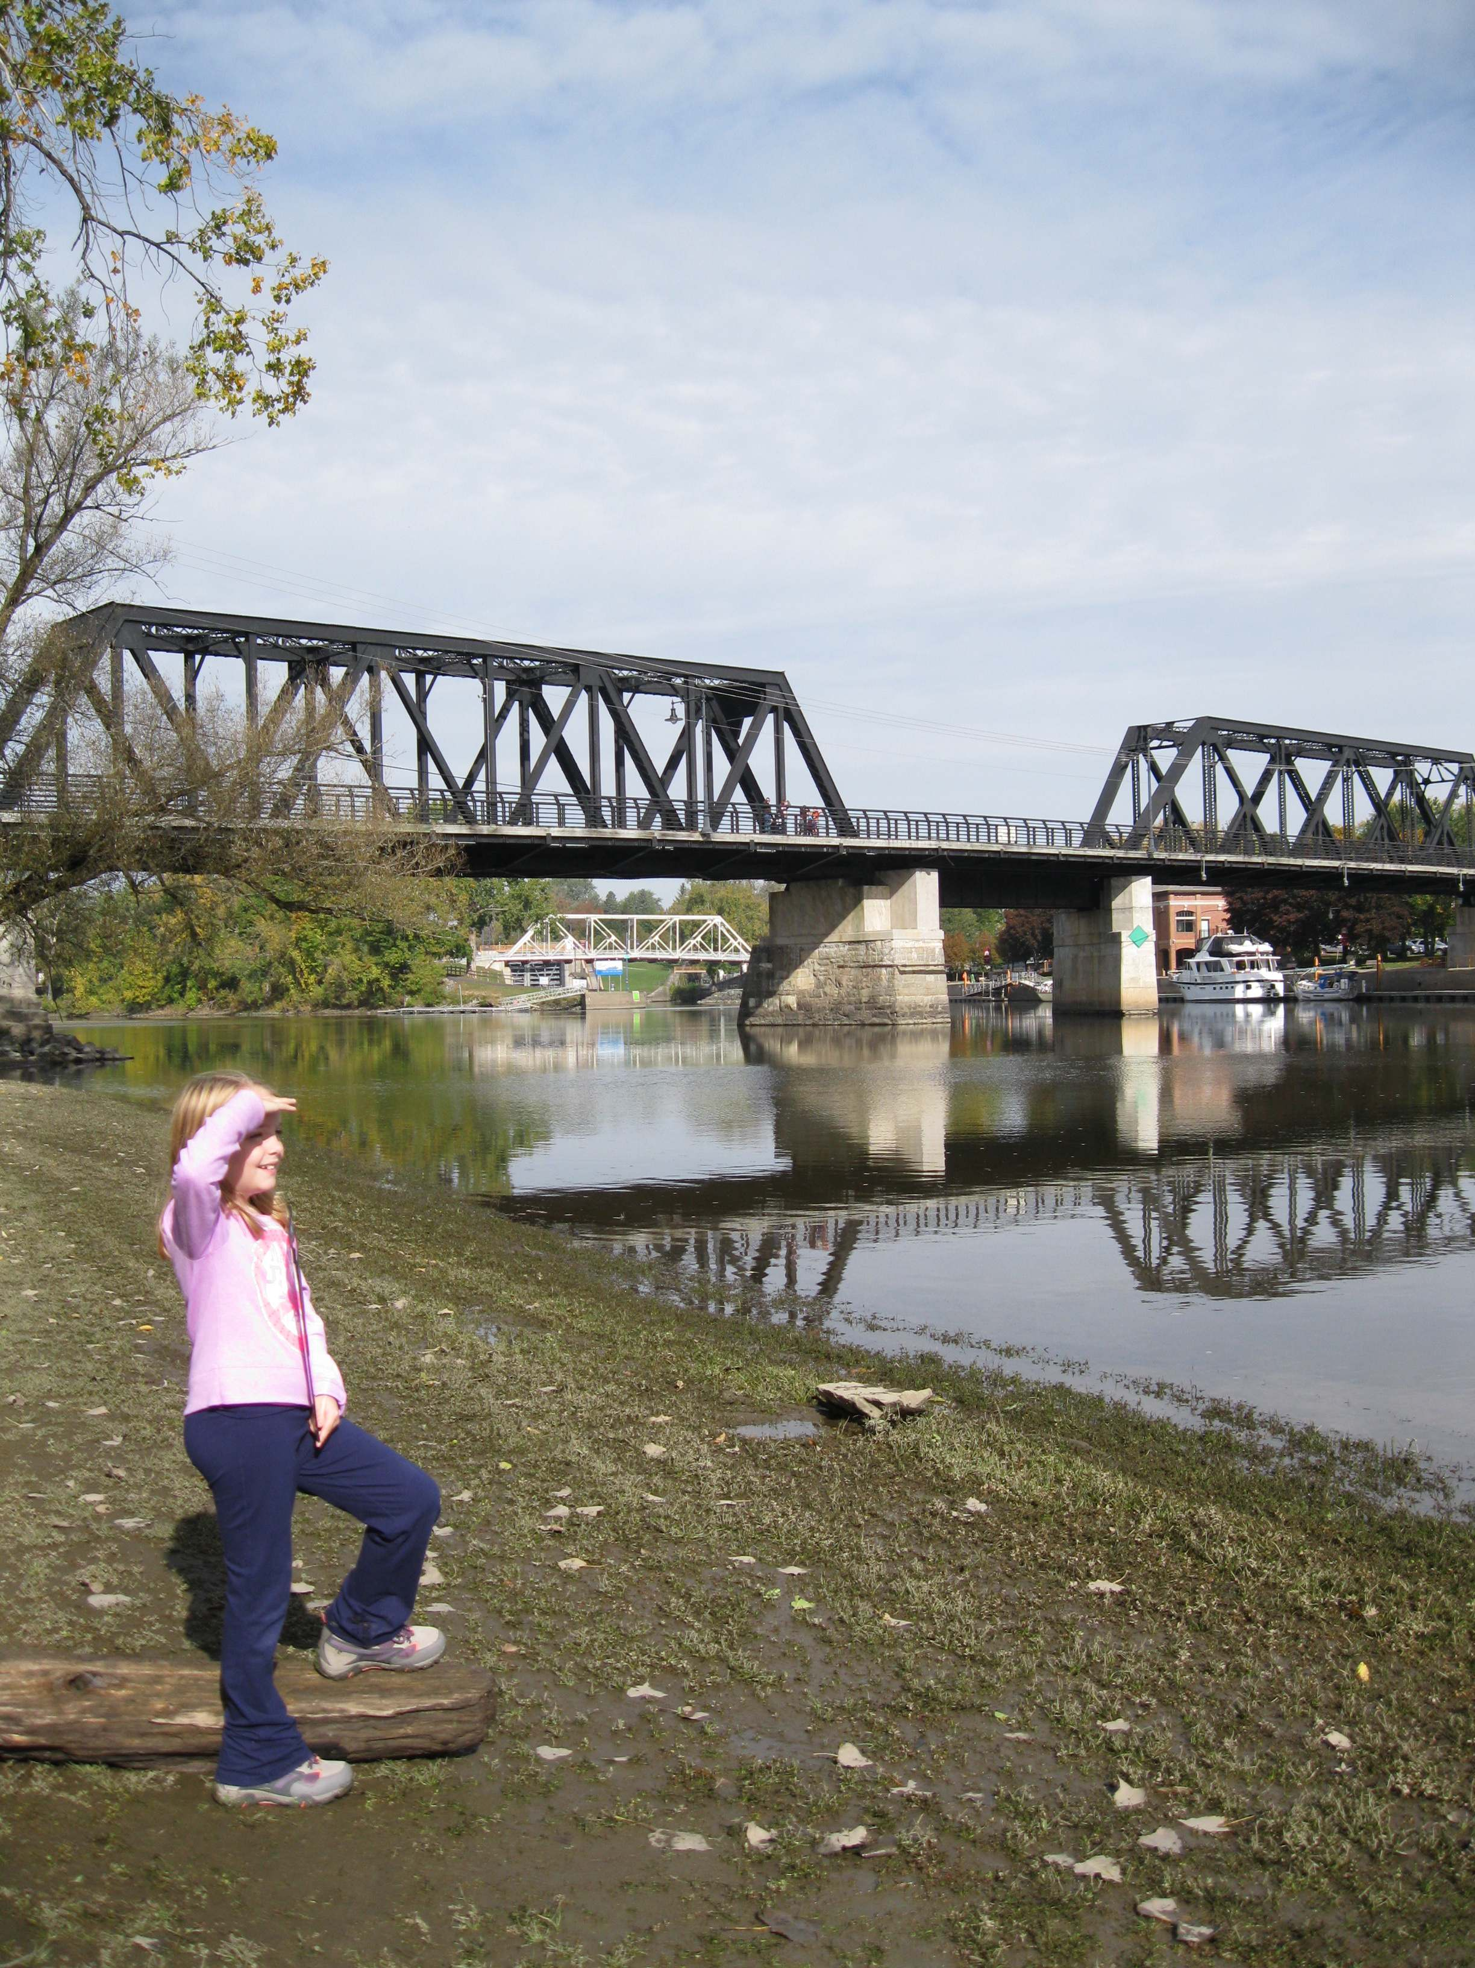
Location: Pebbles Island Park at the confluence of the Hudson River and the Mohawk River, Waterford, NY
Area: park just north of the Troy dam
Surrounding Land Use:
Sampling Site:
Shoreline:
Plants in area:
Water depth:
River Bottom description:

A | Time |  | Reading 1 | Reading 2 | Comments
Physical
Air Temperature | 9:15 AM  9:35  9:55  10:25  10:55 |  | 54°F  53  54  52  54 | °C
Wind Speed | 9:35 AM  9:55  10:25  10:55 |  | 1.2-1.7 mph  0.8-2.6  1.0  1.3 | Direction:
Cloud Cover
Weather today | Sun tapering to clouds, cool and light breeze
Weather recently
Water surface
Water Temperature |  | °C |  |  | °C
Turbidity –  long site tube | 9:15 AM  9:35  9:55  10:25  10:55 | 12 cm  25 cm  22 cm  10.2 cm  31 cm |  |  | °C
Chemical | Time | Water Temp |  | ppm | saturation
DO | 9:15 AM  9:35  9:55  10:25  10:55 | 15 °C  16  16  16  16 |  | 13 ppm  12 ppm  9  17  12 | 126%  120  120  150  120
pH - meter | 9:15 AM  9:35  9:55  10:25  10:55 |  |  | 8 ppm  7.5  7.5  7.5  7.5 | Average
Fish Catch – 25 ft. net | Time | Number Caught |  | Species | Size Largest
 | 9:35 AM | 3 fish |  | unidentified
 | 9:55 AM | 2 |  | Golden Shiners
 | 10:25 AM | 2 |  | Golden Shiners
 | 10:55 AM | 1 |  | Spottail Shiner | 1.5 inches
River Velocity | 9:15 AM  9:35  9:55  10:25  10:55 | 18.2 ft/min  30.3 ft/min  12.2 ft/min  15.4 ft/min  15.4 ft/min |  | 555cm/min  924cm/min  372cm/min  469cm/min  469cm/min | 9.25 cm/sec  15.4 cm/sec  6.2 cm/sec  7.82 cm/sec  7.82 cm/sec
Core Sample | 7.5 cm core sample
Flow |  | cm/sec
Boat Traffic

