Day in the Life of the Hudson River 10/10/13 Data
(Salt Front RN 69.3)
RIVER MILE 18.5W
Alpine Boat Basin
Christina Fehre, Alpine Park, Palisades Interstate Park
Lisa, Wolfelsperger, & Rivka Rosenstein, Alpine Elementary School
Alpine NJ – 6th grade – 11 students
N 40°56.43”– W -73°55,7”
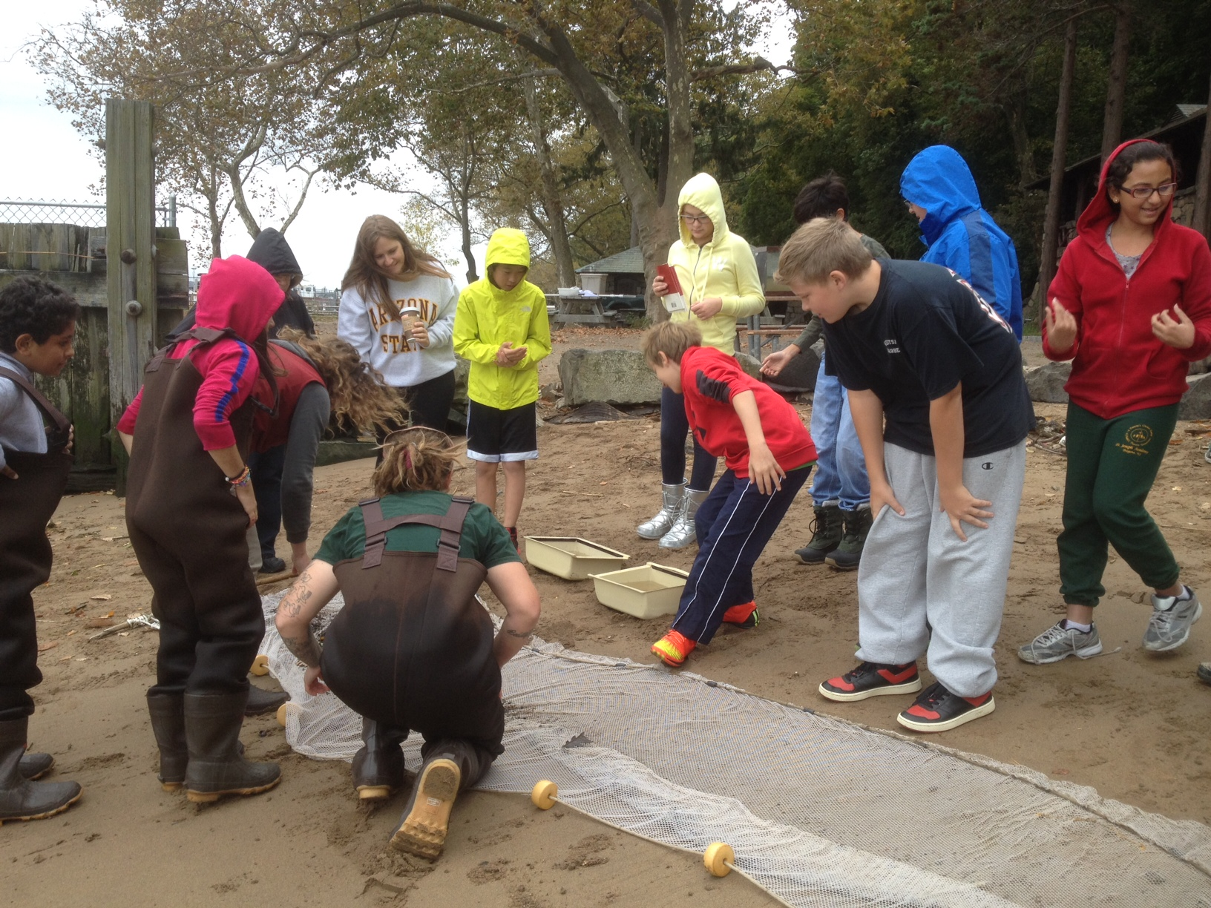
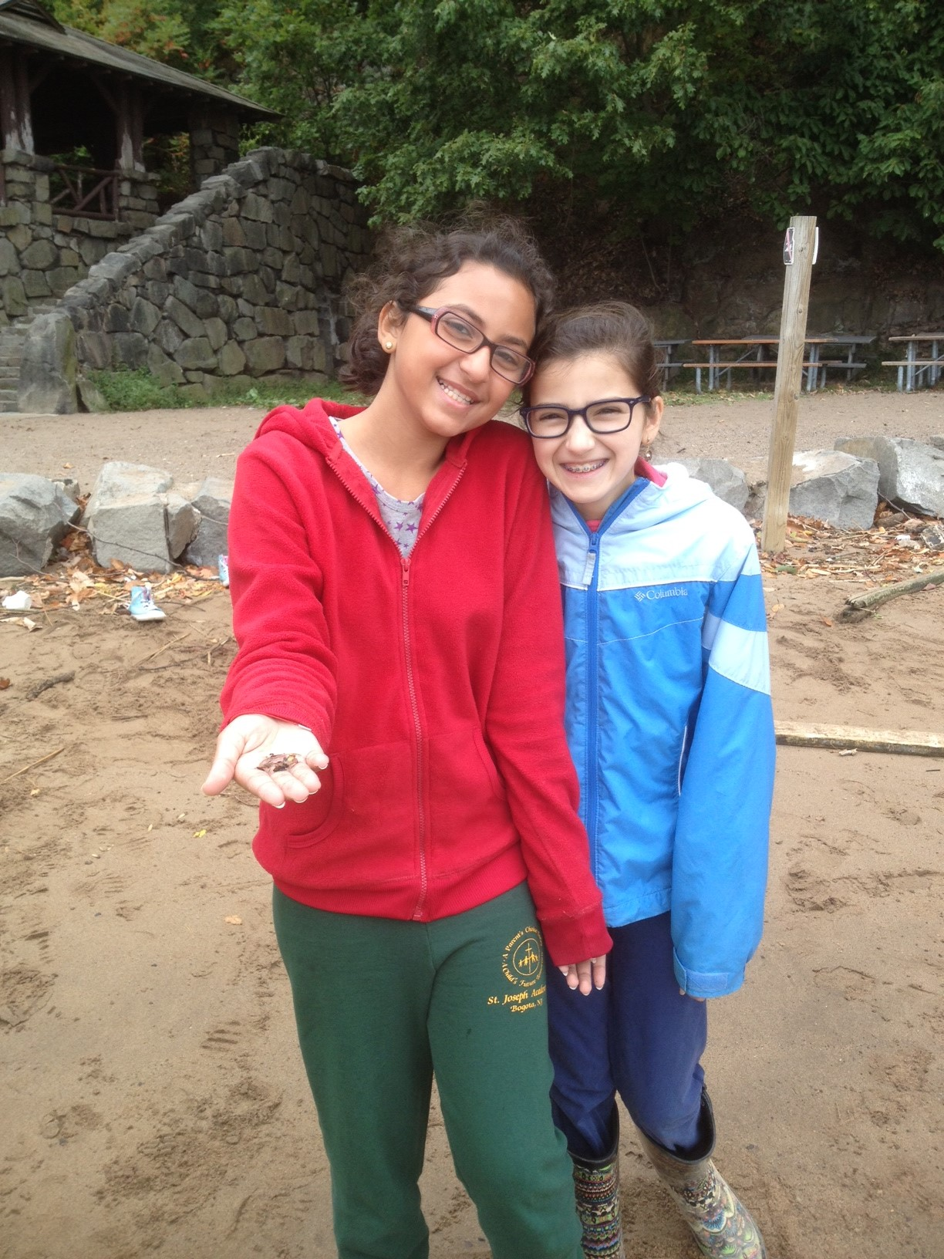
Location: North end of the Alpine Boat Basin, adjacent to a sandy beach area
Area: Pier, Forested, parking lot, used for picnics, boats, fishing and education programs
Surrounding Land Use: 50% Forested (at the foot of the Palisades, 25% Man made Sandy Beach , 25%, recreationally developed pier
Sampling Site: sandy beach, banks altered, rip rap, bulkhead, pier
Plants in area: none
River Bottom – sandy, muddy

ITEM | Time |  | Reading 1 | Reading 2 | Comments
Physical
Air Temperature | 11:12 AM |  | 59 °F  15°C
Wind Speed | 11:26 AM |  | Beaufort #4 |  | N
Cloud Cover | Cloudy, drizzly
Weather today | Rain/drizzle
Weather recently | Some rain and light wind
Water | choppy
Water Temperature | 11:12 AM | 5°C  41 °F
Turbidity | 10:35 PM | 52 cm  40  50 |  | Average 47.3cm | Secchi Disk
 | 2nd reading | 54  53  53 |  | 53 cm
Chlorophyll
Chemical
DO -  Drop count kits | Not read
pH – test strips | 11:15 AM | 6.5
Salinity - hydrometer | 11:00 AM | 17.5 ppt
Fish Catch - 8X4 ft. seine net | Number Caught | Species |  | Size | Seine
9:30-11:30 AM | 1 | White Perch |  | 5-7 inch
TOTAL CATCH 2 | 1 | Shiner |  | 3-4 inch
DIVERSITY 2 | ~40 | Jellyfish
MACRO | 8 | Comb Jelly
Total Catch | 1 | Shrimp |  | 1.5 inch
Tides
Currents-

Sediment Core | TOTAL Length | Common |  | Rare | Description
 | Not recorded | Mud |  | Gravel, pebbles  coal | sand
Shipping

