Day in the Life of the Hudson River 10/10/13 Data
(Salt Front RM 69.3)
RIVER MILE 2.5
Hudson River Pier #45 - Christopher Street
Hana Takebe
Wallerstein Collaborative for Urban Environmental Education/NYU (6 Adults)
Blue School 19 students & Chelsea High School two groups 25 each (50 total CHS) plus teachers
(69 students and 10 adults)
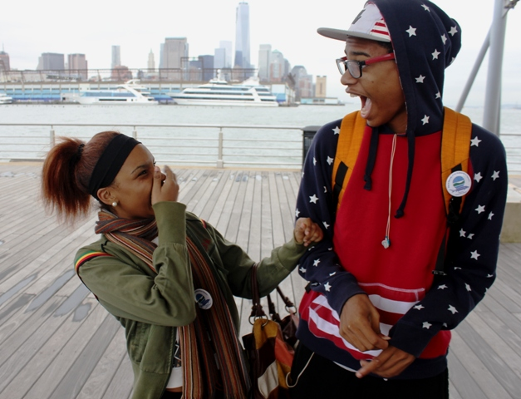
Location: Christopher Street Pier West end closest to the roadway on the South side
Area: Pier – bulkhead – mainly metal and wooden pier
Surrounding Land Use: roads and parking lots nearby, very little tree or grass cover
Sampling Site: Recreational pier
Plants in area: None

ITEM | Time |  | Reading 1 | Reading 2 | Comments
Physical
Air Temperature | 10:40 AM  10:50 AM  11:06 AM  11:17 AM  11:55 AM  12:06 PM  12:22 PM  12:36 PM  12:54 PM  1:01 PM  1:24 PM  1:31 PM |  | 16°C  16  16  16  16°C  17  17  17  17 °C  17  17  17 | Blue School  Chelsea HS 1  Chelsea HS 2
Wind Speed | Windy
Cloud Cover | AM sunny  PM cloudy
Weather today | Windy, cloudy & cold
Weather recently | Sunny & warm
Water description | Choppy & murky
Water Temperature | 10:40 AM  10:50 AM  11:06 AM  11:17 AM  11:55 AM  12:06 PM  12:22 PM  12:36 PM  12:54 PM  1:01 PM  1:24 PM  1:31 PM | 15°C  15  15  15  15°C  14  16  14  15°C  14  15  15 |  | Blue School  Chelsea HS 1  Chelsea HS 2
Turbidity – 60 cm site tube | 10:37 AM  10:49 AM  11:07 AM  11:16 AM  11:53 AM  12:08 PM  12:34 PM  12:40 PM  12:56 PM  1:04 PM  1:27 PM  1:37 PM | >60  >60  >60  >60  >60  >60  >60  >60  >60  >60  >60  >60 |  | Blue School  Chelsea HS 1  Chelsea HS 2
Chemical
DO  (ampules - chemettes) | 12:00 PM – 1:00 PM | 6.6 mg/L  6.0 |  | Chelsea HS 1  Chelsea HS 2
pH – litmus paper | 10:40 AM  10:50 AM  11:00 AM  11:10 AM  11:20 AM | 7  7.5  7.3  7.5  7 |  | Wide range solution | 7.5  7.3  7.3  8.5  7
Salinity |  | Hydrometer |  | refractometer
 | 10:40 AM  10:50 AM  11:1 AM  11:20 AM  12:10 PM  12:30 PM  12:50 PM  1:05 PM  1:25 PM  1:30 PM | 15 ppt  18  16.7  15.4  16.7  16.5  22.2  20.6  21/7  20.6 |  | 14  20  20  20  20  20 | Blue School  Chelsea HS 1  Chelsea HS 2
Tides | 10:40 AM  11:53 AM  12:54 PM | High  Mid tide  Mid tide |  | Blue School  Chelsea HS 1  Chelsea HS 2
Other | Boats, birds  Water Bottle (trash)

