Day in the Life of the Hudson River 10/10/13 Data
Above the Troy Dam
RIVER MILE 200
Hudson Crossing Park, Lock 5, Schuylerville , Hudson River
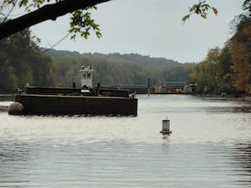
Where EPA is doing their dredging

Nancy Robertson, Cornell Cooperative Extension, 4H
Homeschool Group, 7 students K2-7th and 4 adults
43°00.044’ N & 73°51.078’W
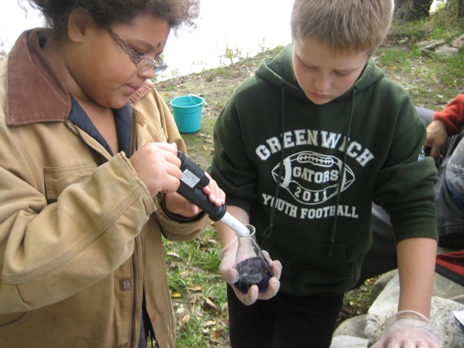 | 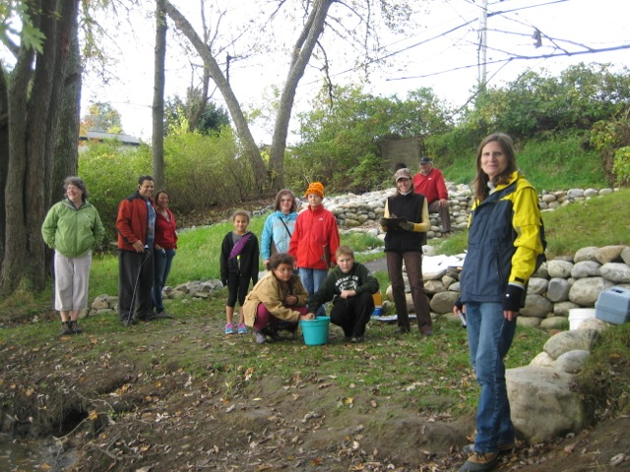

Location: Kayak launch, Hudson Crossing Park, Lock 5 in Schylerville, Saratoga Co.
Area: Old industrial site now used for recreation – waterfalls, boating, fishing
Surrounding Land Use: urban/residential several houses on the site; 85% forested; 1% beach, Industrial/Commercial dredging downriver, lots of barge activity
Sampling Site: Small beach area, pier and lock, construction gravel in the area and covered in vegetation
Plants in water: yes - <5% has water celery
Plants in area: oak, sumac, honeysuckle
Water Bottom: sandy, muddy, bedrock nearby
Water depth: 3-5 ft.
ITEM | Time |  | Reading 1 | Reading 2 | Comments
Physical
Air Temperature | 11:45 AM |  | 17.2 °C  63 °F | Noted water is warmer than the air
Wind Speed |  |  | Beaufort #1
Cloud Cover | Partly cloudy to mostly cloudy
Weather today | No rain today
Weather past few days | Heavy rain on Monday, temps. In the 60-70°s range Tues & Weds
Water Temperature | 11:00 AM | 17°C  62 °F
Water surface | Water calm
Turbidity - secchi | 12:00 PM | .75 meter
Chlorophyll | 11:00 AM | 0.5
Chemical
pH – color drop kit | 11:15 AM | 7.4  7.4 |  |  | Average 7.4
Salinity – quantabs | 10:30 AM | .06* |  | *below conversion scale
Dissolved Oxygen – digital titration | 11:15 AM | 8.66 ppm  9.38 ppm |  | 17° C | 80% saturation
Flow | Secs/1524 cm | Cm/sec |  | Knots | North/South
We measured a stick traveling a 50 ft. run in the water. This year we sampled below the bridge we have used in the past. The river is “crowned” here – very shallow and fast in the middle. We measured the current in the deep channels to either side. There were waterfalls above and bridge abutments just north of the site.
50 foot run – convert-  1524 cm/avg. time recorded to get avg. cm/sec | 28 sec  27 sec  26 sec | 56.4 cm/sec |  | 1.1 kts | South
Core | Length | Abundant |  | Common | Rare
11:30 AM – 2-3 ft. deep water – at small beach – water celery nearby | 12 cm – oxidized top – 2-3 cm | mud |  | Freshwater mussels in a mound (perhaps something’s feeding spot) | Clay  Sand  Gravel
Shipping | All day Tugs and Barges | Heading both ways |  | Part of the dredging operation | Moving river sediment & sand
Other Items | Blue heron, Vs of geese (~30) , pileated woodpecker’s head

