Day in the Life of the Hudson River 10/10/13 Data
(Salt Front RM 69.3)
RIVER MILE 25W
Piermont Pier
Margie Turrin & 5 Lamonters, Lamont-Doherty Earth Observatory
Kathy Galione, Rockland County Americorps
Latitude N 41 degrees 02’592 Longitude W 73 degrees 53’789
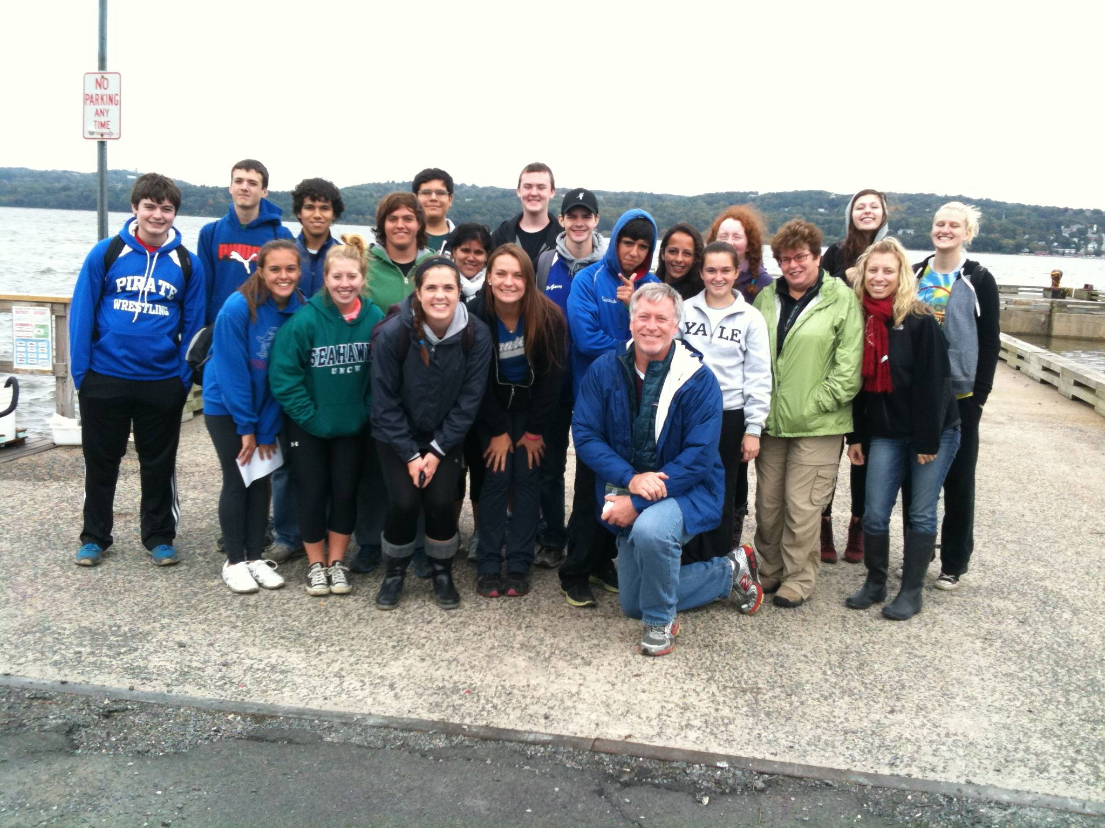 | 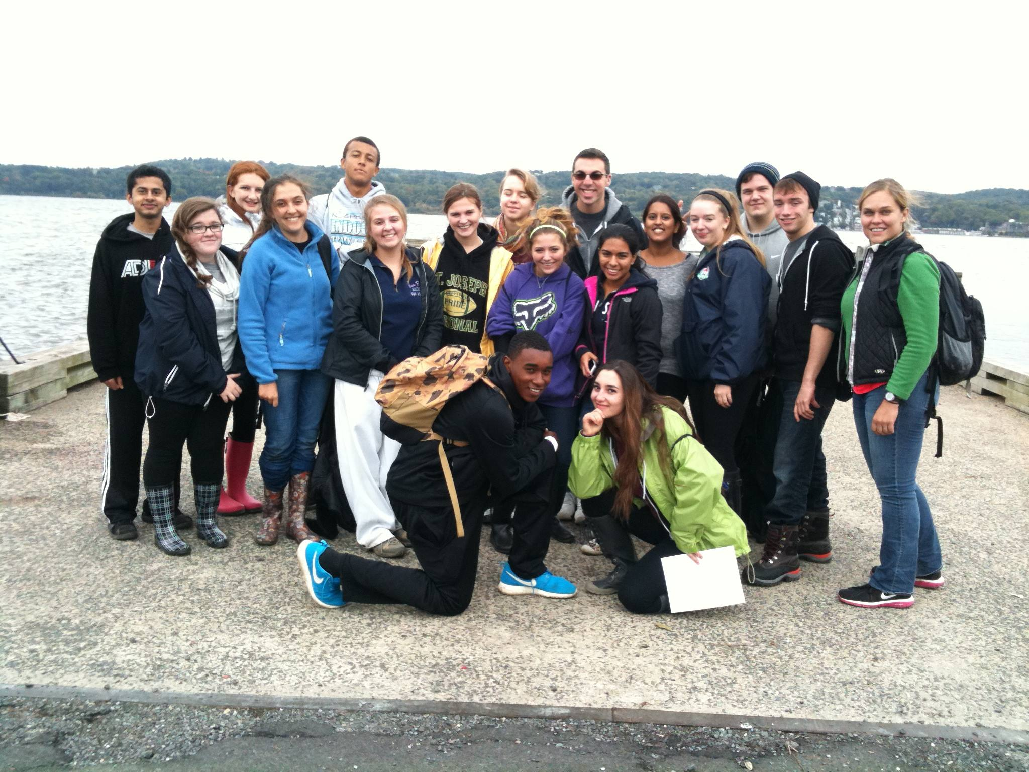
Tom Mullane, Eileen McCaffrey, and Catherine Bonanno– Pearl River HS APES – 18 students | Jen Mazza,– Clarkstown South High School –  17 APES & IB Env. Sci.
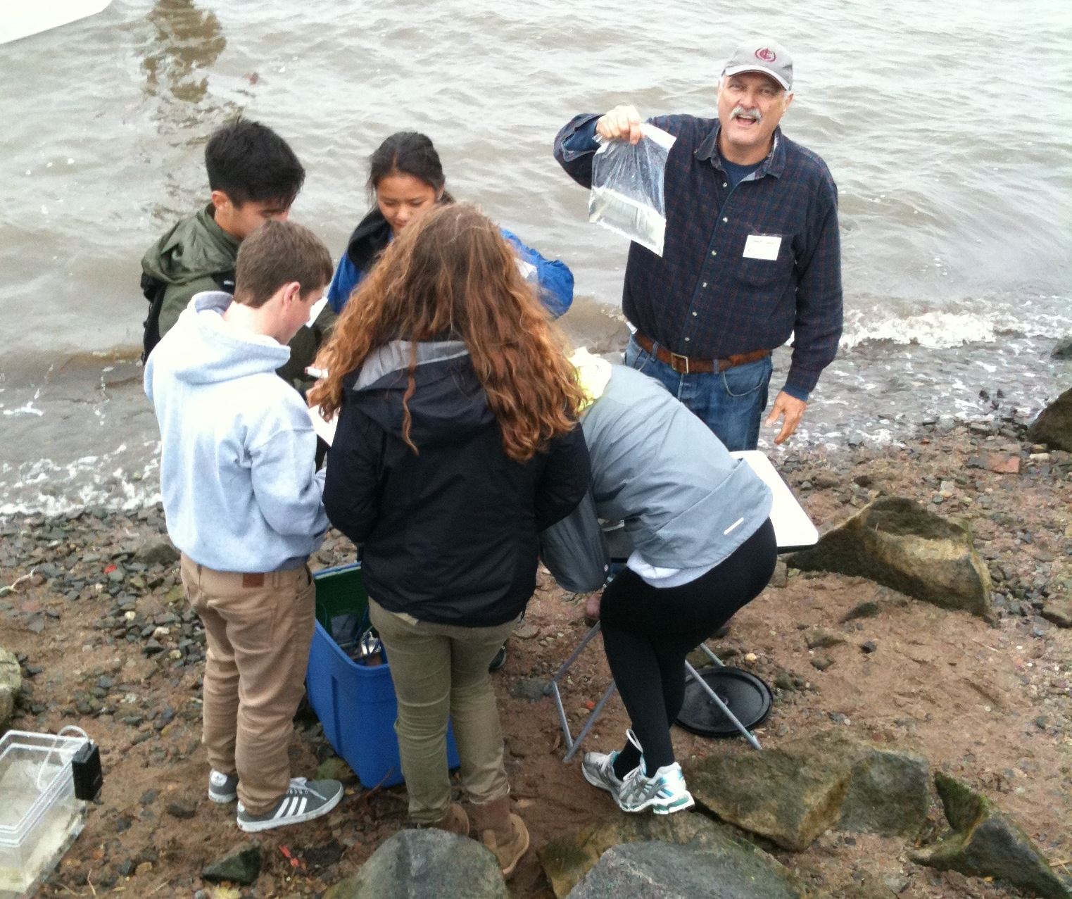
Pat Kilkelly and Brian Newburger Tappan Zee HS –APES & Env. Sci. – 37 students
Latitude 41°02.591N Longitude 073°53.794W
Location: Piermont Pier, Piermont NY
Area: Man made fishing/shipping pier at the east end, long pier with paved roadway and vegetated strip along both sides
Surrounding Land Use: Urban/residential 80% , Forested 20%
Sampling Site: Pier, roadway in center of whole pier, parking area at end, Plants and trees along side. Shoreline Rip Rap, collected wood in area and piping entering river on the south of sampling site
Plants in area: no submerged aquatic plants in the water
Water depth: Varied by location on the pier and by tide
River Bottom – sandy/rocky bottom with marsh grass growing in or near the water
Plants in area: sumac and other plants 15%; phragmites 85%
ITEM | Time |  | Temperature |  | Weather & Observations
Physical
Air Temperature | 9:10AM |  | 14°C  57°F
 | 9:35 AM |  | 15.2°C |  | Water choppy!
 | 9:50 AM |  | 16°C |  | sprinkling
 | 10:13 AM |  | 15 °C |  | Water choppy
 | 10:37 AM |  | 15.5 °C |  | Water choppy
 | 10:58 AM |  | 16.25 °C |  | Water choppy
 | 11:33 AM |  | 16 °C |  | Water choppy
 | 11:52 AM |  | 16.25 °C |  | Water choppy
 | 12:46 PM |  | 18.5 °C |  | Water choppy
 | 1:05 PM |  | 18.5 °C |  | Water calmed a bit
Wind Speed | Time |  | Beaufort # & Direction |  | Anenometer |  |  | Description
 | 9:10AM |  | #2 |  | 6.5 kts. Or 13.7 mph |  |  | Cloudy, drizzle
 | 9:35 AM |  | #3 |  | 9.7 kts |  |  | Partly cloudy, drizzle
 | 9:50 AM |  | #3 |  | 7.7 kts.  8.9 mph |  |  | Cloudy, sprinkling
 | 10:13 AM |  | #3 |  | 7.7 kts  8.9 mph |  |  | North wind
 | 10:37 AM |  | #3 |  | 7.4 kts. |  |  | North wind, light rain
 | 10:58 AM |  | #3 |  | 7.8 kts  9.5 mph |  |  | Light rain
 | 11:33 AM |  |  |  | 6.3 kts.  9.6 mph |  |  | overcast
 | 11:52 AM |  | #2-3 |  | 6.3 kts  8.0 mph |  |  | overcast
 | 12:46 AM |  | #2 |  | 6.2 kts.  7.1 mph |  |  | North wind,
 | 1:05PM |  | #2 |  | 5.5 kts  8.7 mph |  |  | North East wind, overcast
Weather recent | Some rain last few days, some wind
Water Temperature | Time | Surface Sample
 | 9:17 AM | 16°C
 | 9:30 AM | 15.5°C
 | 10:05 AM | 14°C
 | 10:15 AM | 18°C
 | 11:32 AM | 15°C
 | 12:45 PM | 15°C
 | 12:45 PM | 16°C
Turbidity – | Time | 3 readings |  |  |  | Average |  | Pier Northside
Long Site Tube | 9:20 AM | 31.8 X3 |  |  |  | 31.8 cm |  | Long site tube
 | 10:01 AM | 35 |  |  |  | 35 cm
 | 10:36 AM | 27.5 |  |  |  | 27.5 cm
 | 11:00 AM | 27 |  |  |  | 27 cm
 | 11:23 AM | 33 |  |  |  | 33 cm
 | 11:38 AM | 36.8 |  |  |  | 36.8 cm
 | 12:45 PM | 38.9 |  |  |  | 38.9
Secchi | 9:15 AM | 25,25,25 |  |  |  | 25 cm |  | Secchi
 | 9:15 AM | 40,40,40 |  |  |  | 40 cm
 | 9:45 AM | 35,35,40 |  |  |  | 37 cm
 | 10:13AM | 90,30,31 |  |  |  | 50.3 cm
 | 10:36 AM | 25, 40, 35 |  |  |  | 35 cm
 | 11:00 AM | 40 |  |  |  | 40 cm
 | 11:23 AM | 29,27,22 |  |  |  | 26 cm
 | 11:38 AM | 30,35,25 |  |  |  | 30 cm
 | 12:45 PM | 25, 30, 30 |  |  |  | 28.3 cm
Chlorophyll | 9:20AM | 1.5 |  |  |  |  |  | Pier End
 | 10:05 AM | 2.0
 | 11:00 AM | 2.5
 | 11:25 AM | 1.0
Chemical | SURFACE SAMPLES * see HRECOS readings appended at the end of the student reporting
DO | TIME | DO Reading |  |  | Water Temp |  | % Saturation
Drop count | 9:45 AM | 7 ppm |  |  | 15.5°C |  | 68%
 | 10:20 AM | 7 ppm |  |  | 14°C |  | 65%
 | 11:11 AM | 10 ppm |  |  | 18°C |  | 102%
 | 11:34 AM | 11 ppm |  |  | 19°C |  | 70%
 | 11:45 AM | 7 ppm |  |  | 15°C |  | 68%
 | 1:07 PM | 9 ppm |  |  | 16°C |  | 90%
pH | TIME
colorimeter | 9:17 AM | 7.0
 | 10:05 AM | 7.0
 | 11:08 AM | 7.0
 | 11:32 AM | 8.0
 | 11:40 AM | 7.0
 | 12:55 PM | 8.0
Phosphates | TIME
colorimeter | 9:25 AM | 0.22 mg/L
 | 11:40 AM | 0.6 mg/L
 | 12:45 PM | 0.5 mg/L
Nitrates | TIME
Drop count | 9:30 AM | 0 mg/L
 | 10:18 AM | 0 mg/L
 | 11:07 AM | 0.1 mg/L
Alkalinity | TIME
Drop count | 10:15 AM | 82 ppm
 | 10:54 AM | 65 ppm
 | 11:05 AM | 60 ppm
 | 12:50 PM | 45 ppm
*Salinity - | Refracto. | Hydrometer Glass  Hydrometer Plastic |  |  | Quantab ppm cl⁻ |  | *Quantabs ppm total sal
9:30 AM | 12 ppt | 8 ppt  8 ppt |  |  | 8.8 units - 5835 ppm cl⁻ |  | 10541 ppm
10:10 AM | 10 ppt | 17 ppt  16 ppt |  |  | 8.6 units - 5133 ppm cl⁻ |  | 9273 ppm
11:00 AM | 10 ppt | Not read  11 ppt |  |  | 8.4 units - 4554 ppm cl⁻ |  | 8227 ppm
11:40 AM | Not read | 16.2 ppt  15 ppt |  |  | Not Read
12:50 PM | 14 ppt | 16.6 ppt  14 ppt |  |  | 8.6 units - 5133 ppm cl⁻ |  | 9273 ppm
Tides-  Time | Total Depth | To Water Surface |  |  | Tide Depth |  | Ebb/Flood
9:00 -1:00 |  |  |  |  |  |  | Flooding
Currents | CM/30 SEC | Cm per sec |  |  | Knots/hr |  | North/South Ebb/Flood/Still
9:27 AM | 159 cm | 5.3cm/sec |  |  | 0.1 |  | Flood
10:02 AM | 100 | 3.3 cm/sec |  |  | 0.06 |  | Flood
10:20 AM | 0 | 0 cm/sec |  |  | 0 |  | Still
10:43 AM | 720 | 24 cm/sec |  |  | 0.47 |  | Flood
11:12 AM | 0 | 0 cm/sec |  |  |  |  | Still
11:34 PM | 680 | 22.7 cm/sec |  |  | 0.44 |  | Flood
12:12 PM | 690 | 23 cm/sec |  |  | 0.45 |  | Flood
12:53 PM | 255 | .45 cm/sec |  |  | 0.67 |  | Flood
Fish Catch  Northside of pier | Number Caught | Species |  |  | Measure of largest |  | TIME & CATCH
Rotation #1 | 7 | Atlantic Silverside |  |  | 9 cm |  | 9:00 AM
 | 5 | Striped Bass |  |  | 14 cm |  | Diversity 4
 | 2 | Bay Anchovy -yoy |  |  |  |  | 19 total
 | 5 | Baby Blue Crab |  |  | 1.5cm
 | 44* | Ctenophore Comb Jelly |  |  |  |  | *Not in totals
Rotation #2 | 1 | Atlantic Silverside |  |  |  |  | 9:40 AM
 | 3 | Striped Bass |  |  | 8 cm |  | Diversity 3
 | 3 | White Perch |  |  | 21 cm |  | 7 total catch
 | 174* | Ctenophores
Rotation #3 | 135* | Ctenophores |  |  |  |  | 10:30 AM
 | 2 | Naked Goby from trap |  |  |  |  | Diversity 1
 |  |  |  |  |  |  | 2 Total catch
Rotation #4 | 1 | Mummichog |  |  | 10 cm |  | 11:30 PM
 | 2 | Blue Crab |  |  |  |  | Diversity 2
 | 63* | Ctenophores* |  |  |  |  | 3 Total Catch
Rotation #5 | 1 | Atlantic Silverside |  |  |  |  | 12:45 PM
 | 3 | Naked Goby |  |  |  |  | Diversity 3
 | 2 | Blue Crab |  |  |  |  | 6 Total Catch
 | 132* | Ctenophore
Grand Total | Count 37 | w/o ctenophores |  |  | 548 Total Ctenophores |  | Diversity 7 + ctenophores
Plankton | Time | ID |  |  | Magnific.
 | 9:20 AM  9:30 AM  9:40 AM  9:45 AM  9:58 AM  10:17 AM  10:27 AM  10:44 AM  11:26AM  11:43 AM  11:22 AM  11:13 AM  1:10 PM  1:26 PM | Algea, Diatom chain  Phyto-Diatom chain, biddulphia  Coscinaiscus species  Diatom  Corophium Lacustre Van hoffen  Diatom  Polychate worm larvae  Phytochain  Anaoystis Species  Skeletonema Species  Copepod – Calanus  Dinoflagellate  Copepod – Nauplius  Zoo copepod  Coscinodiscus X 3 |  |  | 2X  2X  10/0.25  3X  2X  20X  20 X  20 X  2.5X  35
Sediment Cores | Length | H2S Smell |  | Rare | Common |  | Abundant
9:00 AM |  |  |  | Mud | Sand |  | Clay
9:35 AM  water 34 cm | 7 cm |  |  | Gravel, pebbles (plastic) |  |  | Clay, mud, sand
10:00 AM  water 45 cm |  |  |  | Wood, shells, mussels |  |  | Clay, gravel, sand, pebbles
10:26 AM – | 8 cm |  |  |  | Clay, sand, gravel, pebbles, living vegetation
10:45 AM  (saved core) | 11 cm – |  |  |  | Pebbles |  | Clay
11:04 AM (core stuck in tube - photo)  water 50 cm | 22 cm – layers with sandy top 6 cm & clay below |  |  | Living vegetation | leaves |  | Clay, sand
11:30 AM | 22 cm |  |  | Gravel | Clay, sand, pebbles, leaves, wood, slag
11:52 AM | 17 cm |  |  |  |  |  | Clay, sand, leaves
12:50 PM | 8 cm |  |  | Sand, gravel, pebbles | Mud |  | clay
1:12 PM | 9-10 cm |  |  | Leaves, brick | Gravel, pebbles |  | Clay, sand
Other Observations | During much of our sampling day an Osprey circled out and around the southern end of the pier. We never saw him dive for food but his vigilance was noted.

HRECOS Screen Captures on following pages
HRECOS site is located just behind the rectangular eastern end of the pier attached to one of the pier stations. When operational it is a continuous data feed recorded every 15 minutes.
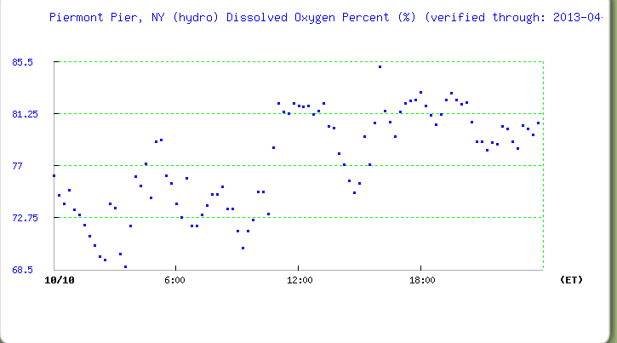
DO % Saturation
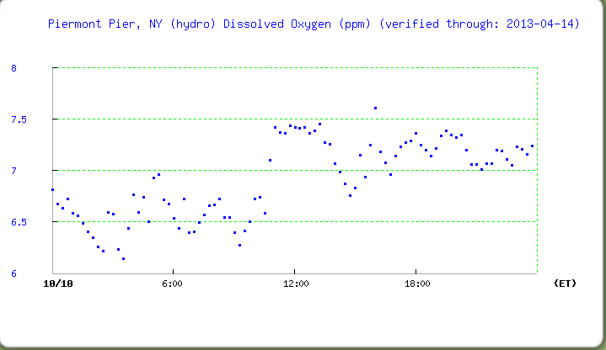
DO ppm
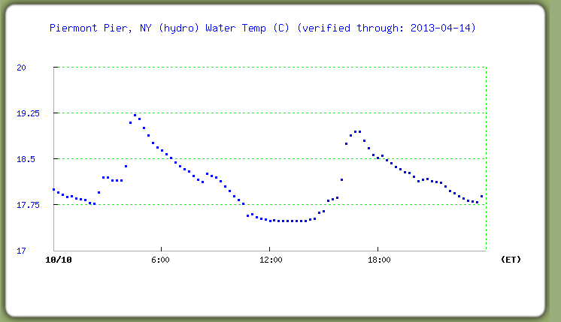
Water temperature
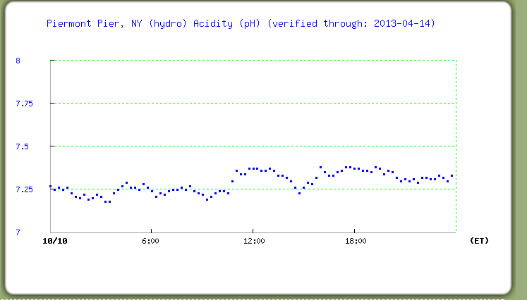
pH
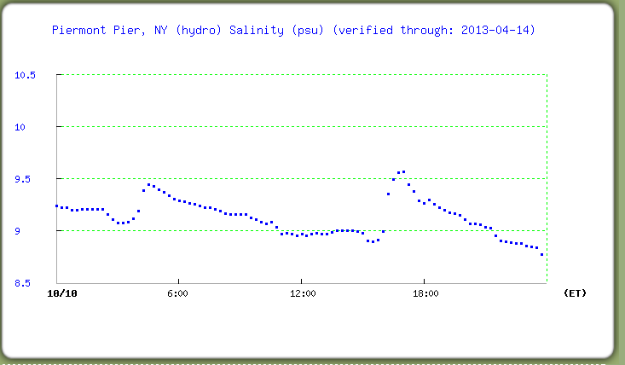
Salinity in psu (equates in the Hudson to ppt) (compare to Quantab conversion)
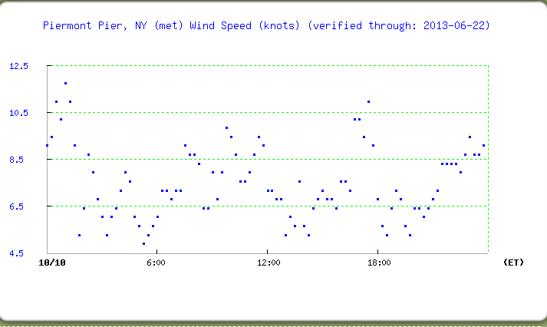
Windspeed in knots
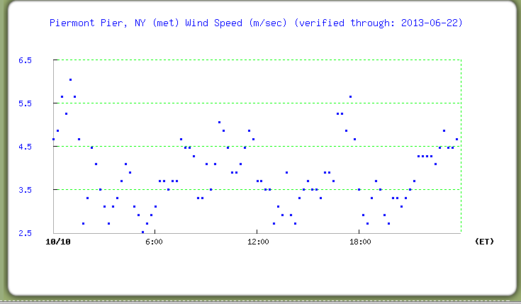
Windspeed in meters per second
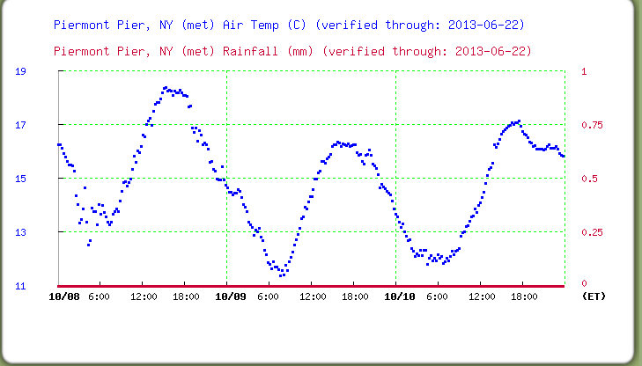
Air Temperature & Rainfall for 3 days

