Day in the Life of the Hudson River 10/10/13 Data
(Salt Front RM 69.3)
RIVER MILE 28
Nyack Memorial Park
Tom Perry - Nyack High School APES Class 40 students, 11-12th graders
Latitude 40°05.243’N, Longitude 73°54.988 ‘W
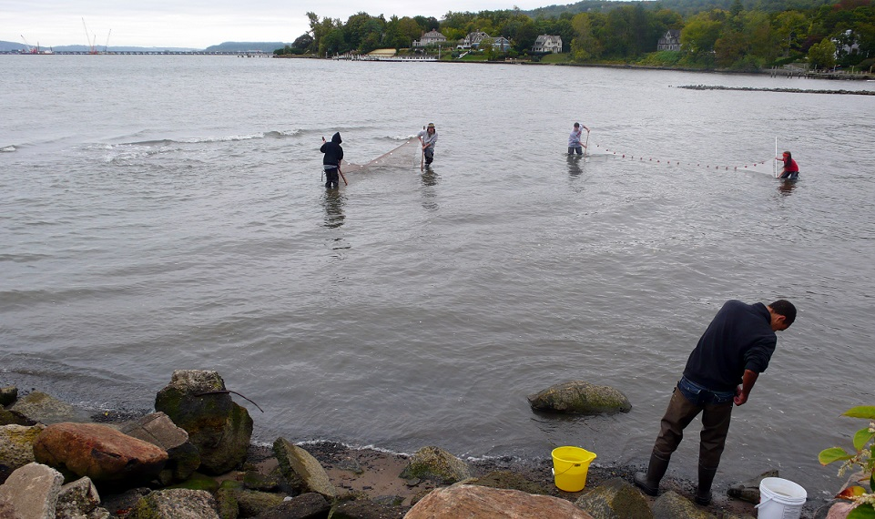
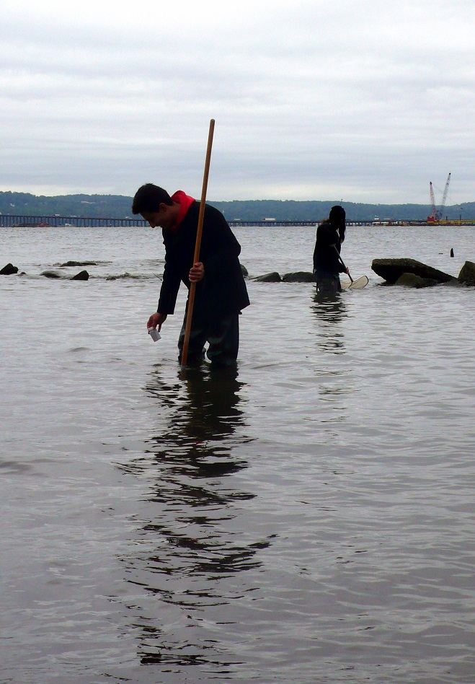
Location: Nyack Park where Nyack Brook feeds in
Area: Open and grassy, has a parking lot, used for picnics, fishing
Surrounding Land Use: 100% park
Sampling Site: beach, banks altered, riprap on shoreline, bulkhead
Plants in area: no water plants in area
Water depth: varied
River Bottom – sandy/muddy bottom , water calm

A Comparison between two stations, at surface & depth: Surface and Bottom Samples were taken at Station #6 (closer to the Hudson River) and Station #3 (closer to the Nyack Brook inlet) to compare salinity & temperature at surface and depth & close to the Hudson and closer to the freshwater tributary (Nyack Brook).

The Hudson water is from the estuary and so is saltier and denser so it rides underneath the freshwater water entering from the Nyack Brook. It might seem surprising that the surface water is cooler than the bottom water, but the water on the surface is fresher so it seems to come in from Nyack Brook. If you follow the water from Nyack Brook from station #1 down towards Station #10 it appears is cooler than the Hudson River water.

ITEM | Time |  | Reading 1 | Reading 2 | Comments
Physical
Air Temperature
Wind Speed
Chlorophyll
Fish Catch  Seine 12X4 | Number Caught | Species |  | CPUE | Seine
Div = 4  Totals = 111 | 75 | Atlantic Silversides |  | Menidia menidia | Station 10
 | 3 | Striped Bass |  | Morone Saxatilis | Station 10
 | 1 | White Perch |  |  | Station 10
 | 2 | Bay Anchovy |  |  | Station 10
 | 3 | Blue Crab |  | Monroe Americana | Station 10
 |  | Sand Shrimp
 |  | Comb Jellies
 |  | Rock Crabs
Sediment Cores
Tide

Sketch Map of Sampling Site
1

2

3
4

Nyack Brook
5

6

7
8

9

10

Hudson River

Time: ___9:30 am___ Tide: __Low_____ Depth: Surface Sample

Station # | Distance (m) | Salinity (ppt) | Temperature (ºC) | DO mg/L | pH | Nitrate | Phosphate
1 | 0 | 0.4 | 15.5 | 6.2 | 7.5 | 8.8 | <1
2 | 10 | 0.5 | 15.4 | 6.7 | 7.5
3 | 20 | 0.7 | 15.5 | 6.2 | 7.5
4 | 30 | 0.7 | 15.6 | 8.4 | 7.6
5 | 40 | 0.8 | 15.6 | 6.2 | 7.6
6 | 50 | 1.5 | 15.7 | 6.1 | 7.6
7 | 70 | 2.1 | 15.9 | 6.3 | 7.6
8 | 80 | 2.5 | 16.3 | 6.3 | 7.6
9 | 90 | 4.5 | 16.5 | 6.8 | 7.6
10 | 120 | 9.0 | 17.2 | 6.5 | 7.7 | 4.4 | 0

Data Table 2: Time _12:30 AM Tide ___High_ Depth Surface Sample

Station # | Distance (m) | Salinity (ppt)  #1 | Salinity (ppt)  #2 | Temperature (ºC) | DO mg/L | pH | Nitrate | Phosphate
1 | 0 | 1.1 | 1.6 | 15.7 | 8.4 | 7.8 | 8.8 | <1
2 | 10 | 6.0 | 8.6 | 16.2 | 8.0 | 7.8
3 | 20 | 6.3 | 8.5 | 16.1  17.1 | 8.3 | 7.9
4 | 30 | 6.7 | 8.4 | 16.5  17.1 | 8.2 | 7.7
5 | 40 | 7.3 | 8.7 | 15.6  17.1 | 9.4 | 7.8
6 | 50 | 6.9 | 8.4 | 16.1  17.1 | 7.5 | 7.8
7 | 70 | 7.0 | 8.6 | 16.8 | 7.0 | 7.8
8 | 80 | 7.1 | 8.7 | 17.6 | 7.2 | 7.9
9 | 90 | 7.3 | 8.8 | 17.7 | 8.6 | 7.8
10 | 120 | 7.7 | 8.9 | 17.7 | 10.2 | 7.9 | 4.4 | 0

