A Day in the Life of the Hudson River 10/10/13 Data
(Salt Front RM 69.3)
RIVER MILE 28
Memorial Park, Nyack
Nicole Liable, Schyler Turrin, Caity Kwiecinski, Anita Agarwal, Emily Selover, Rockland County AmeriCorps
Dr. Brand, Ms. Holmes and Mr. Pregiato
Upper Nyack Elementary School, 71 students 3rd grade
Latitude: +41.087267 degrees North Longitude: -73.915652 degrees West
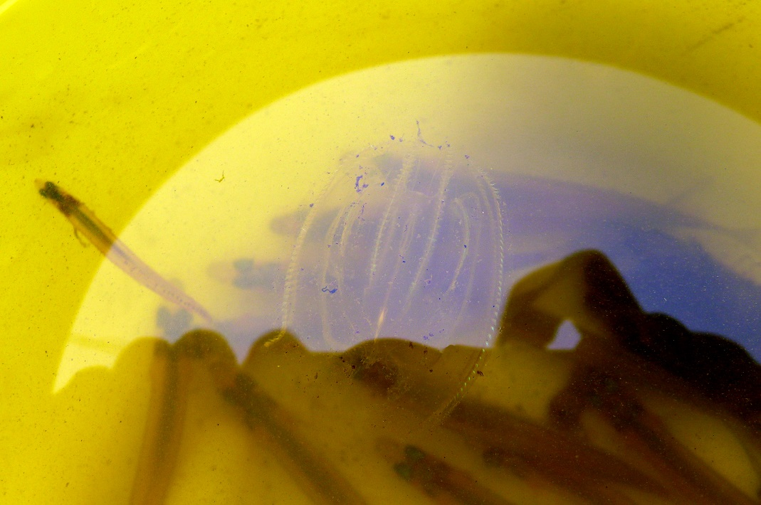
Ctenophore in a bucket

Location: Nyack Memorial Park, at the end of Piermont Ave, Nyack NY
Area: Park shoreline with a sandy and slightly rocky beach and pier area
Surrounding Land Use: Park with homes behind - Located along the shoreline of Memorial Park, Piermont Avenue, Nyack, NY. This stretch of shoreline is lined with riprap, a short pier, a concrete boat ramp, freshwater input site (Nyack Creek- NYS Environmental Protection Fund site), and some mud flats where HS students seined.
Sampling Site: Surrounding the shoreline is a large parking lot and some mowed grass fields. The area’s main use is for boating, fishing, and jogging as it is a major recreation site for the Village of Nyack residents. The altered banks were 95% riprap covered and the remaining 5% were mudflats.
Shoreline: Primarily rocky due to the riprap with muddy (silt/clay/mud) sediments. Tappan Zee bridge construction was in the view of our site, dredging, and increased boat traffic in the distance was noted.
Plants in area: vegetation is sparse
Water depth:
River Bottom heavy alteration of the river bottom
ITEM | Time |  | Reading 1 | Reading 2 | Comments
Physical
Air Temperature | 9:50AM -  11:35 AM |  | 12°C | 54 °F | Read total of 8 times – all same
Wind Speed & Direction | 9:50 AM through 11:35 AM |  | Beaufort chart 2 | SW | Used long stick with ribbon to assess
Cloud Cover | 19:50-11:35 AM |  | Overcast | drizzle
Weather today | Overcast & drizzle
last 3 days | Sunny with some rain
Water | Slightly choppy
Water Temperature – average 2 readings per | 9:50 AM  10:00 AM  10:15 AM  10:35 AM | 14.8°C  14.7  14.8  14.8 |  | 10:40 AM  11:00 AM  11:20 AM | 14.9°C  14.9  14.9
Turbidity  Long site tube – used 60 cm site tube | 9:50 AM  10:00 AM  10:15 AM  10:35 AM | 39 cm  37.8 cm  36 cm  35.3 cm |  | 10:40 AM  11:00 AM  11:20 AM | 33.5 cm  37.3 cm  32.5 cm
Chemical
DO  Drop count | Not read
pH  meter – average of 2 readings per group | 9:50 AM  10:00 AM  10:15 AM  10:35 AM | 6.9  6.9  6.9  7.0 |  | 10:40 AM  11:00 AM  11:20 AM | 6.9  7.1  6.9
Salinity  Quantab chloride reading | 9:50 AM  10:00 AM  10:15 AM  10:35 AM  10:40 AM  11:00 AM  11:20 AM | 1614 ppm  1610  3834  2060  2660  1610  2660 |  | Total Salinity | 2916 ppm  2909 ppm  6929 ppm  3721 ppm  4805 ppm  2909 ppm  4805 ppm
Fish Catch –  HS used seine, fish trap and crab pots | The high school team seined and we looked at their catch – included:  Atlantic Silverside  White Perch  Striped Bass  Bay Anchovy  Blue Crab  Ghost Shrimp  Comb Jelly (ctenophores)
Tides  Group 1 | 9:50 AM  10:00 am  10:15 am  10:35 am | Reference  Rising  Rising  Rising |  | Tides- Several sand filled jugs were placed along the tide line. Students noted the change in tide (rising or falling- no numerical data was recorded for this section)
Group 2 | 10:40 am  11:00 am  11:20 AM  11:30 AM | Reference  Rising  Rising  Rising
Currents | Time
Other Observations | Little to no recreational traffic took place as the weather was gloomy and forecasts predicted heavy rain.

