Day in the Life of the Hudson River 10/10/13 Data

(Salt Front RM 69.3)
RIVER MILE 2
Chris Anderson - The River Project
Bob Wallace - NYU
Karen Johnson, Vanessa Jump, Teachers for the
3rd grade Trevor Day School – 60 students + 4 teachers and 12 adults
Latitude N 40.72825 N Longitude -74.01382 W*
(*Floating dock off Pier 40 where water samples were collected)
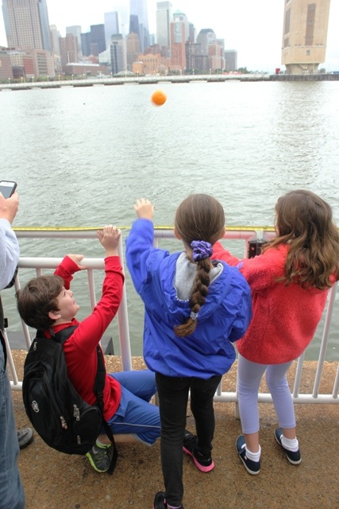
Location: Pier 40 Hudson River (also called North River)
Area: Large urban pier with many sports facilities: athletic fields, kayaking and boathouse, seasonal moorings available, parking, fishing on the pier, benches & picnic tables for the public
Surrounding Land Use: 100% Urban Industrial - parking lot – area used for picnics, boating, fishing
Sampling Site: Banks altered; concrete & wood pilings, pier extends into river/cement bulkhead
Plants in area: None visible
NOTE: This highly urban site is just west of the busy Westside Highway – it is the largest pier in Hudson River Park (with a 14 acre footprint); Pier 40 is used for recreation; school groups use the athletic fields; there are 3 public boathouses; there are many people by on the river’s edge: jogging, bike riding, walking.

ITEM | Time |  | Reading F | Reading C | Comments
Physical
Air Temperature | N/R
Wind Speed | Time |  | Beaufort Chart
 | 11:15 AM |  | #1 | South
Cloud Cover | Overcast @ 1:30 PM
Weather today | Very light rain in the AM
Weather recently | Rain
Water | slightly choppy
Water Temperature -4 feet of water | 11:04 AM  11:16 AM  11:30 AM  11:40 AM  11:58 AM  12:13 PM | 50 °F  50 °F  50 °F  50 °F  50 °F  54 °F |  | 10°C  10°C  10°C  10°C  10°C  12°C | Average – 50°F  10 °C  taken ~400 ft. down the pier off the floating dock
Turbidity (long site tube | 10:59 AM  11:10 AM  11:29 AM  11:35 AM  11:54 AM  12:13 PM | 56 cm  61  60  56  55  60 |  |  | Average 58 cm
Chlorophyll
Chemical | TIME | TEMP. |  | PPM | % SAT.
DO:  LaMotte Green Low Cost Water Monitoring Kit | 11:04 AM  11:16 AM  11:30 AM  11:40 AM  11:58 AM  12:13 PM | 10°C  10°C  10°C  10°C  10°C  12°C |  | 5.1 ppm  5.5 ppm  5.0 ppm  5.0 ppm  5.0 ppm  5.0 ppm | 45%  49%  44%  44%  44%  44%
pH – color match LaMotte kit | 10:56 AM  11:08 AM  11:26 AM  11:40 AM  11:54 AM  12:09 PM | 6.5  6.0  6.5  6.0  6.5  6.5 |  | 6.0  6.5  6.0  6.5  6.5  7.0 | Average 6.25  6.25  6.25  6.25  6.5  6.75
Salinity – hydrometer - | 10:56 AM  11:08 AM  11:26 AM  11:40 AM  11:54 AM  12:09 PM | 21 ppt  23  20  22  20  21 |  | 22 ppt  22  22  20  20  20 | Average 21.5 ppt  22.5  21  21  20  20.5
Vertebrate Catch | Number Caught | Species |  | Size | Minnow traps
Unable to do fish
Tides
Currents
Boat Traffic –  None close enough for names | Pleasure boats (sailboats and small motor boats),  Transit boats (commuter ferry)  Working boats (tugs and police)
Other Observations | Seagulls | pigeons

