Day in the Life of the Hudson River 10/10/13 Data
Freshwater Section of the Hudson River
RIVER MILE 300
Upper Works Trailhead (Adk High Peaks Wilderness), Tahawus Rd.
Adirondac (abandoned mining village), Newcomb NY
GPS Latitude 44°05.370’ N Longitude 74°03.358’ W
Elevation 1,820 ft/550 meters
Doug Reed, Hudson Basin River Watch
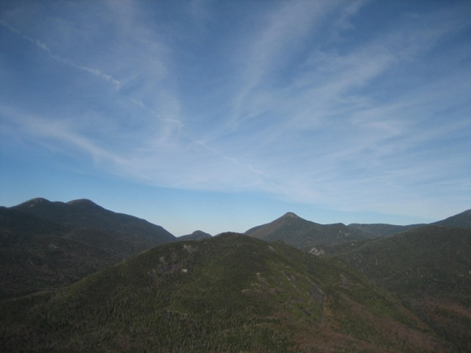
The High Peaks of the Adirondacks

Location: Adirondack (abandoned mining village), Newcomb NY, where the Hudson takes its name
Area: a rushing river
Surrounding Land Use: 100% forested
River Bottom : cobbles

Lake Henderson outlet where the Hudson River Begins.
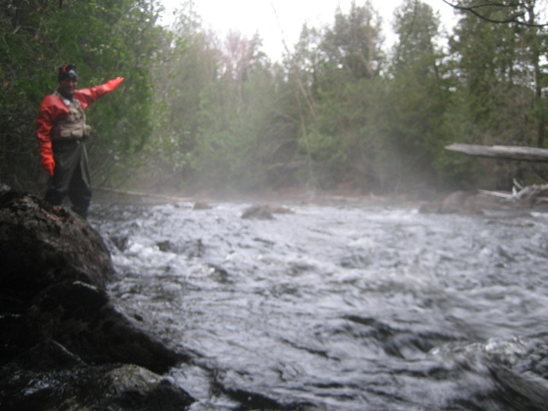 | 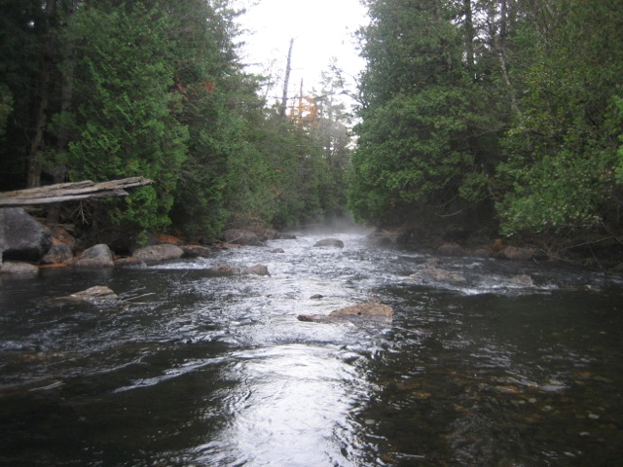
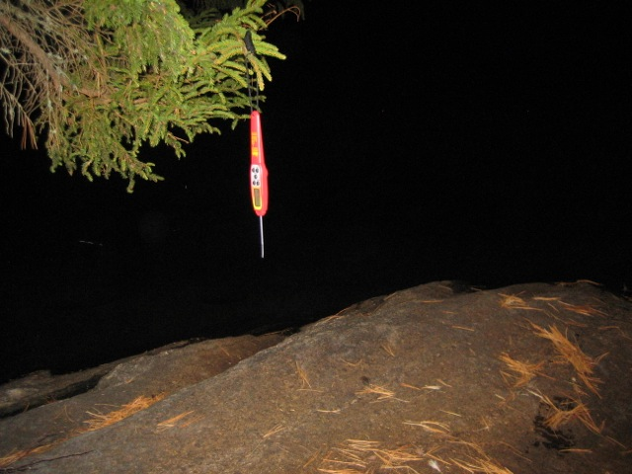
Taking the temperature @ Arbutus Lake

Arbutus Lake
Newcomb NY
Air Temperature | 4:00 AM | 35.3°F  1.8°C
Water Temperature | 4:00 AM | 55.9°F  13.3°C
Dissolved Oxygen |  | 7.44 mg/L
Hudson Headwaters @ Henderson Lake
Air Temperature | 7:25 AM | 34.3°F  1.3°C
Water Temperature |  | 55.1 °F  12.8°C
Dissolved Oxygen |  | 7.92 mg/L
pH |  | 6.5

