Day in the Life of the Hudson River 10/10/13 Data
(Salt Front RM 69.3)
RIVER MILE 31 – Hook Mountain State Park
Laurie Seeman & Joanne Dickey– Strawtown Art & Garden Studio
Lorraine Marden, Jennifer Armoceda -Blue Rock School –
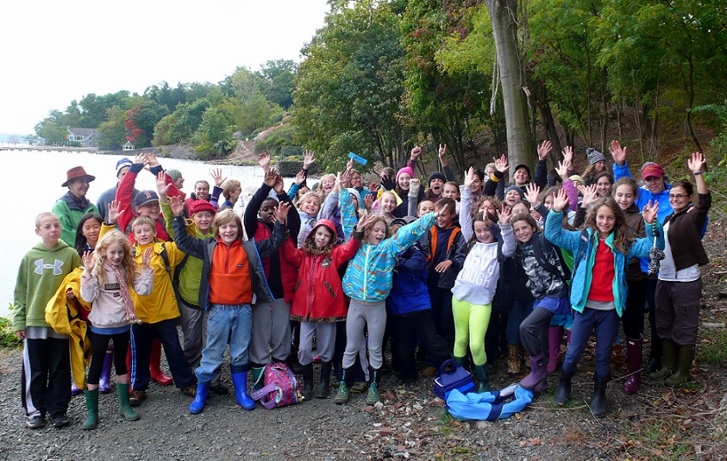
4^{th,} - 8th – 45 students, total 12 adults
41°N Latitude - 74° W Longitude
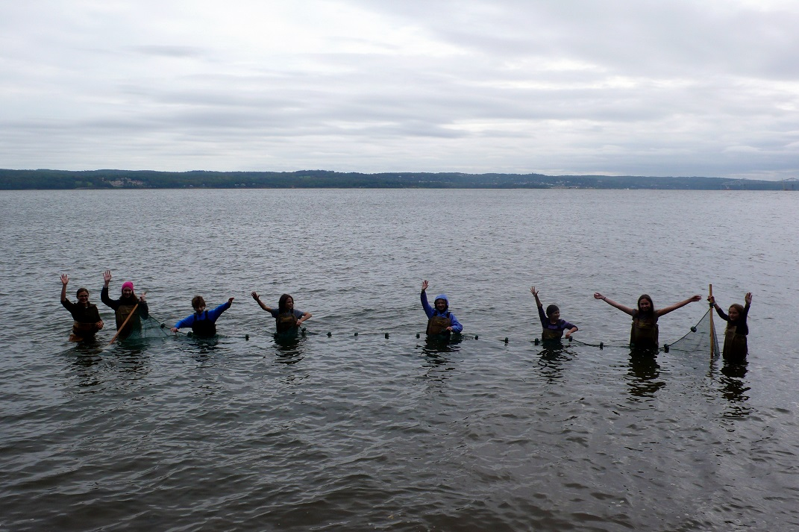
Location: Nyack Beach near Hook Mountain Sandy Beach right side of riverfront area
Area: Park/Boat launch, sandy beach area on the point with riprap
Surrounding Land Use: 10% urban/residential; 1% forested; 90% beach
Sampling Site: Sandy beach with retaining wall enclosing it and behind a lot of trees, picnic tables, sandy and rocky at edges, covered with vegetation beyond the beach, stone wall, riprap shore, concrete docking. Boat launch spits the site and steep bank behind picnic table area. Sandy beach is only available during lower to mid tide
Plants in water: no plants in area
Plants in area: none
Water depth: 13 cm
River Bottom –rocky, sandy
ITEM | Time |  | Reading 1 | Reading 2 | Comments
Physical
Air Temperature | 10:40 AM |  | 13.9°C  57°F
 | 12:55 PM |  | 18°C  61°F
Wind Speed | Beaufort 2
Cloud Cover | Mostly cloudy
Weather today | Cloudy some light showers
Weather last 3 days | Rain 3 days prior. Very windy – mild/cooler fluctuations in temp.
Water | choppy
Water Temperature | 10:58 AM | 63°F X 3 |  | 17°C X3 | Average
 | 11:55 AM | 60°F X 3 |  | 13°C X 3 | Average
 | 1:06 PM | 68°F X 3 |  | 18°C X 3 | Average
Turbidity – short site tube | 11:05 AM | 35 JTU  23 |  |  | Avg – 30 JTU
Chlorophyll | 12:07 PM | 1.0
Chemical
DO  Drop count | 11:15 AM | 8 mg/L |  | 16 ° C | 85%
pH  Indicator solution | 11:22 AM | 7.5  7 |  |  | 7.25
Salinity  Test strip | 11:30 AM | 0.243%CaCl |  | 1474 ppm CL- | 2662 Total Salinity
Fish Catch | 15 ft. pull X 12 time | Number Caught |  | Species | Length of largest
Seine 20 ft. X 4ft.  Mesh 0.25 inch |  | 0 fish |  | Lots of Comb Jellies (ctenophores)
Tides | Time | Height |  | Rate of Change | Rising/Falling
 | 10:05AM | 13 cm |  |  | rising
 | 12:00 PM | 23 |  | 10 cm/55 mins | rising
 | 1:15 PM | 30 |  | 7cm/75 mins | rising
Currents* | CM/30 secs | Cm/Sec |  | North/South Ebb/Flood/Still | Knots
10:30 AM | 213 cm | 7.1 cm/sec |  | Ebb | 0.138 kts
11:11 AM | 330 cm | 11.0 cm/sec |  | Ebb | 0.21 kts
11:47 PM | 317.5 | 10.6 cm/sec |  | Ebb | 0.21 kts
Current measured in a protected embayment
Shipping Traffic | 10:20 AM | Barge |  | White | Southbound/
 | 10:45 AM | Barge |  |  | Southbound/ Loaded
 | 1:04 PM | Large Boat |  | White | Northbound/ loaded
Other Items | Water Chestnuts, seagulls
Other Observations | I saw many sparrows flying around. I also saw a bird eating a fish. Julie L.  Using the sense of sight to look around me along the river:  “There are three spaces of total green grass. I think it is interesting because they look small they must be very big. I can see little tiny cars driving across the bridge and I think it is cool.”

