**Snapshot Day 10/10/13 Data**

**(Salt Front RM 69.3)**

**RIVER MILE 32**

**Lewis & Engel Park**

**Bridget Baumann & Artie Carlucci, Ossining HS AP Environmental Science**

**9th-12th grade – 45 students**

**41°10’N - 73°52’W**

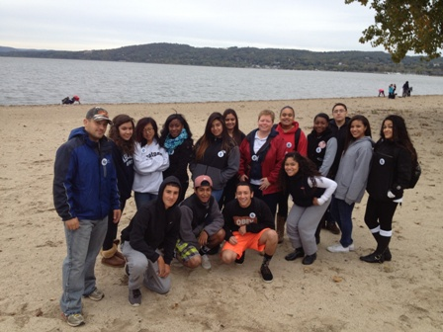

**Ossining High School Team**

**Location:** Wading beach at Lewis J. Engell Park, Ossining, NY

**Area:** Beachfront area with a ferry pier,paved sidewalk, rock wall lining the river, grass

**Surrounding Land Use:** 100% beach

**Sampling Site:** bulkhead lines the shoreline with pier, rock wall, beach, riprap, rocky, weedy, used for picnics and boats. Pipe enters the river North of the sample site.

**Plants in area:** yes - about 15% of the area had plants – of that 80% was water celery (Vallisnaria). Aside from plants in the water there was Japanese knotweed and other grasses in the sampling area.

**Water depth**: 0-4 feet deep

**River Bottom**: sandy, rocky

|  |  |  |  |  |  |
| --- | --- | --- | --- | --- | --- |
| ***ITEM*** | ***Time*** | | ***Reading 1*** | ***Reading 2*** | ***Comments*** |
| ***Physical*** |  | |  |  |  |
| Air Temperature | 9:00 AM | | 54°F  12.3°C |  |  |
| Wind Speed | 9:00 AM Beaufort #3 | | NE |  |  |
| Cloud Cover | 10:15 AM | | Mostly Cloudy | 51-75% |  |
| Weather today | 10:00 AM small amount of rain | | | | |
| Weather last 3 days | Monday evening/ night Rain, Tues/Weds Fair and dry wind, unusual temperatures | | | | |
| Water | Choppy | | | | |
| ***Water Temperature*** | 9:30 AM | 66.2° F  19 °C | |  | 3 replicates – all the same |
|  | 10:30 AM | 68° F  20 °C | |  | 3 replicates – all the same |
| ***Turbidity- secchi*** | 9:57 AM | 40 cm | |  |  |
| ***Chemical*** |  |  | |  |  |
| DO ( drop count) ***overcast, 3 ft. from shore in slightly choppy water*** | 9:30 AM  10:30 AM | 2.0 mg/L  6 mg/L | | 19 ° C  20 ° C | 25% saturated  70% saturated |
| pH (indicator sol.) | 8:57 AM | 7.0 | |  |  |
| Salinity- hydrometer | 8:57 AM | 15 ppt | |  |  |
| ***Fish Catch***  ***30 ft. seine*** | ***Number Caught*** | ***Species*** | | ***Length of largest*** |  |
| 8:30-11:30 AM | 1 | Juvenile blue crab | |  | ***Diversity - 3*** |
|  | 1 | Juvenile mud crab | |  | ***Total Count -8*** |
|  | 6 | Comb jellies | |  |  |
| ***Tides-*** | **Time** | **measurement** | | **Rate of Change** | ***Rising/Falling*** |
|  | 9:00 AM | 51 cm | |  |  |
|  | 10:00 AM | 60 cm | | 9 cm/60 minutes | Rising |
|  | 10:30 AM | 75 cm | | 15 cm/30 min | Rising |
| ***Currents*** | ***Time*** | ***Cm/30 secs*** | | ***Cm/sec*** | ***kts*** |
| ***Flood Current*** | 9:00 AM | 2 cm/30 secs | | 0.067 cm/sec | 0.0013 kts |
|  |  |  | |  |  |
| ***Shipping*** | Ossining to Haverstraw Ferry | Ran 6 times while we were there | |  |  |
| ***Core Description*** | ***Length*** | ***Abundant*** | | ***Common*** | ***Rare*** |
| ***Observations*** | Cormerants, Sea Gulls, Mallard Ducks | | | | |