Day in the Life of the Hudson River 10/10/13 Data
(Salt Front RM 69.3)
RIVER MILE 35E
Croton Point Park, Croton on Hudson
Maureen Dillon, Jennifer Barth, Catherine Brennan – Pierre Van Cortland MS –150 5th graders
Latitude 41degrees 11.174’N Longitude 73 degrees 53.913’W
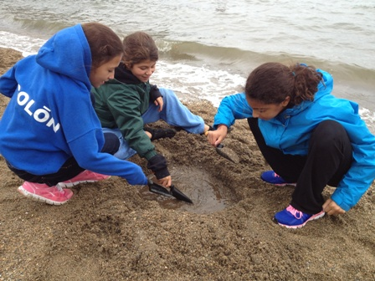
Location: Mother’s Lap, Croton Park NY
Area: Rocky beach surrounded by rising forested land and small yard and driveway
Surrounding Land Use: Forested 70%, Beach 30%
Sampling Site: Beach area with with raprap @ north end, collected wood debris in area
River Bottom – sandy/rocky bottom
ITEM | Time |  | Reading 1 |  |  | Comments
Physical
Air Temperature
Wind Speed | Time |  | Beaufort #
Cloud Cover | cloudy
Weather today | Some rain
Weather recently | Fall like
Water Temperature | AM
Turbidity –  turbidity tube | AM | 35 cm
Chemical | TIME | Reading
DO | AM | 6.0 ppm
pH (litmus paper) | AM
Nitrates | AM | 0.25 ppm |  |  | Nitrite | 5-10 ppm
Ammonia | AM | 0.25 ppm
Salinity - | AM | 10 ppt
Tides
Currents

Fish – | Number | Species |  | Totals
Multiple seines | 4 | Atlantic Silversides |  | Diversity 2
 | Lots | Ctenophores (Comb Jellies) |  | Total Catch 4 +
Core Sample | Abundant | Common | Rare
 | Gravel | Mud | Clay  Sand  Pebbles  Wood  Shells/oyster  Brick  Coal  Living Vegetation  Fish Bones

