Day in the Life of the Hudson River 10/10/13 Data
(Salt Front RM 69.3)
RIVER MILE 35W – Bowline Park, Haverstraw Waterfront
Chuck Barone, Nanuet High School – 12th grade – 12 students, 2 adults
41.° 12’11” N 73.° 57’ 48” W
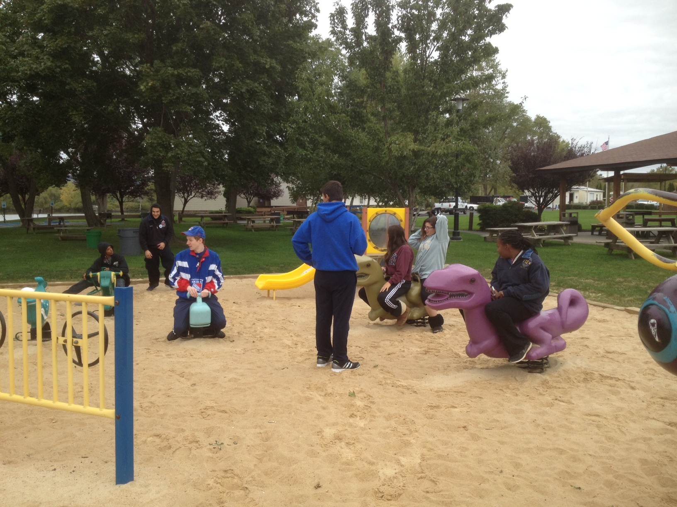
Relaxing after a morning of hard work doing field science!

Location: Bowline Park, Haverstraw waterfront, Rockland County NY
Area: Parking lot, recreation, fishing
Surrounding Land Use: 15% beach, 20% Industrial/commercial, 60% recreational, 5% forested
Sampling Site: shoreline is sandy, muddy, rocky, small beach, bank altered, large rip rap, bulkhead, industrial tress spans the water to the north and east, bricks in the sand
Other Notes: The beach has a distinctive marker showing the high tide line or more commonly referred to as the ‘rack line’ where natural and man made debris line up
Plants in area: none
Water depth:
River Bottom – muddy
ITEM | Time | Reading 1 | Reading 2 | Comments
Physical
Air Temperature | 9:32 am | 54°F  12.2°C | 10:00 AM | 54°F  12.2°C
Wind Speed | 9:30 AM Beaufort #2 | 1-3 kt  1-3 mph | Ripples no foam  NE | Light air  Wave height 15 cm
 | 12:00 PM  Beaufort #3 | 7-10 kts  8-12 mph | White caps  NW | Gentle breeze Wave height 60-90 cm
Cloud Cover | cloudy
Weather today | Overcast | Cold | Light rain/drizzle ~ 10:00 AM
Weather last 3 days | Clear and sunny | Observation: Warmer weather the last few days may have kept the water warmer with more DO
Water | See wave height above
Water Temp. | 9:32 AM | 21°C  21.0  21.0 | 68°F  70  70 | Average  69.3°F  21°C
 | 11:00 AM | 20.5°C X 3 | 70°F X3 | Average  70°F  20.5°C
Turbidity – Long site tube | 9:32 AM | 41 cm | 12:00 PM | 48.2 cm
Chlorophyll | 9:32 AM | 0.3
Chemical
DO  Drop count | 9:32 AM | 21 C | 8.2 PPM | 90 % sat
 | 11:00 AM | 20.5 C | 10 PPM | 110 % sat
pH  litmus paper | 9:32 AM | 8 | 12:00 PM | 7
Salinity: | *NOTE – neither set of  salinity measurements makes sense
Hydrometer | 9:37 AM |  |  | 6 ppt*
 | 12:00 PM |  |  | 1.00 ppt*
Test strips | 9:37 AM | 0 |  | 0*
 | 12:00 PM | .006 % | 39 ppm Cl- | 70 ppm TS*
Fish Catch | Time | Number Caught | Species | Length of largest
Seine 50 ft. X 6ft.  Mesh 0.25 inch | 9:30 AM four seines | NO FISH CAUGHT!!!
Tides | 9:32AM | 150 cm
 | 10:53 AM | 500 cm | rising | 350cm/79 min  4.43 cm/min
Currents* main channel would be flooding but this area is set back and may still be ebbing | CM/60 secs | Cm/Sec | North/South Ebb/Flood/Still | Knots
9:32 AM | 430cm/60 sec | 7.17 cm/sec | South/ebb
10:53 AM |  | 10 cm/sec | South/ebb
Core – | Length | Rare | Common | Abundant
Shipping
Observations

