Snapshot Day 10/10/13 Data
(Salt Front RM 69.3)
RIVER MILE 39.5
George’s Island County Park, Montrose
Blake Burgess, Pocantico Hills School
50 – 6-8th grade students
Latitude 41°14’N Longitude 73°56’40”W

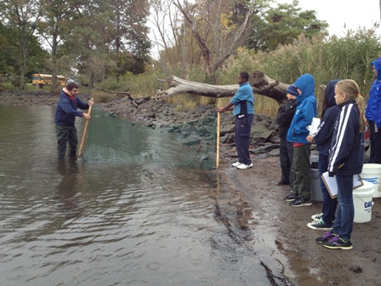 | 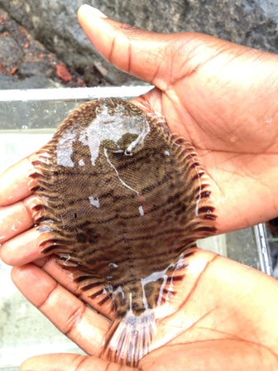
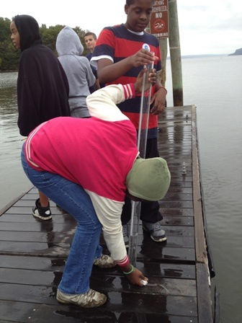
Location: Waterfront park in Westchester County Park
Area: Shoreline is rocky with brick pieces, forested, grassy with parking area
Surrounding Land Use: Park picnic area & boat launch – Forested 40%, Beach 10%, Park/Pier 50%
Sampling Site: Beach, Rip Rap and Concrete Bulkhead
Plants in area: none listed
Water depth:
River Bottom – muddy, rocky, sandy
Plants in the area: Birch Trees 7%, Willow trees 5%, Weeds 8%, grass 80%

ITEM | Time |  | Reading 1 | Reading 2 | Comments
Physical
Air Temperature | 10:24 AM  10:35 AM |  | 13.4°C  13.5
 | 12:57 PM |  | 15.7 °C
 | 1:07 PM |  | 16.5 °C
 | 1:25 PM |  | 16.4 °C
Wind Speed | 10:10 AM  12:37 PM  1:25 PM |  | Beaufort #2  Beaufort #1 | 4.9 kts  5.3 mph | N  NW  East
Cloud Cover | 10:15 51-75% overcast, by noon >75% - overcast
Water Surface | Calm
Weather today | Rain 1:20 PM for about 30 minutes
Weather recently | Normal to cold temperatures
Water Temperature | 11:00 AM | 20°C  24  20 |  | 27°C - 78°F  24 – 75°F  22 – 73°F | Average 23°C
6 ft. depth | 11:32 AM | 24  24  24
 | 12:55 PM | 21°C
 | 1:05 PM | 21°C
 | 1:10 PM | 20°C
Turbidity | 10:30 AM | 76.3 cm  71  70.5 |  |  | Average 72.9 cm
 | 10:31 AM | 81.4 cm  80  79.8 |  |  | Average 80.4 cm
 | 12:47 PM | 60.2 cm  61.5  79.2 |  |  | Average 79.2 cm
 | 1:30 PM | 64.9 cm  77.2  75.8 |  |  | Average 73
Chlorophyll | 10:30 AM | 1.0-2.0 |  | Average to 1.5
Chemical
DO  (drop count kit) | 10:00 AM | 22°C |  | 7.0 mg/L  7.0 | 65%  65%
 | 12:20 PM | 22°C |  | 8.0 mg/L | 92% saturated
pH  indicator solution | 10:35-10:41 AM | 8.0  8.5  8.0 |  |  | 8.2 average
 | 11:15 AM | 7.8  7.8  7.8 |  |  | 7.8 Average
 | 11:40 AM | 8.0
 | 12:50 PM | 8  8  7.5 |  |  | 7.5 average
 | 1:00 PM | 6.5  6.0 |  |  | 6.25 average
 | 1:35 | 6.5  8  8 |  |  | 7.5 average
Phosphate
Nitrate
Alkalinity
Salinity - Quantab | No time | 1.9 on strip
Refractometer | No time | 1  1  1  1
Fish Catch | Number Caught | Species |  | Size
 | 1 | Striped Bass
 | 1 | Banded Killifish
 | 1 | Hog choker |  | Palm sized ~ 4 inch
 | 2 | At. Silversides |  | 4 inch
Total Catch | 5 | Diversity |  | 4
Macros | 3 | Sand crab |  | 2 inch
Tides | 10:37 AM | 3 cm
 | 10:49 AM | 5 cm |  | Rising
 | 11:19 AM | 10 cm |  | Rising
 | 11:22 AM | 12.5 cm |  | Rising
 | 12:34 PM | 15 cm |  | Rising
 | 12:49 PM | 17 cm |  | Rising
 | 1:00 PM | 16 cm |  | Rising
 | 1:23 PM | 27 cm |  | Rising
 | 1:37 PM | 31 cm |  | Rising
 | 1:39 PM | 38 cm |  | Rising
 | 1:48 PM | 42 cm |  | Rising
Currents | 11:15 AM | 48 cm/30 secs |  | ~1.5 cm/sec
 | 12:43 PM | 51 cm/30 sec |  | ~2 cm/sec
 | 12:48 PM | 50 cm/30 sec |  | ~ 2cm/Sec

 | 12:50 PM | 39 cm/40 sec | ~ 1cm/Sec
 | 1:01 PM | 41 cm/30 sec | ~1.3 cm/sec
?would have expected flood with rising tide? | 1:25 PM | 58 cm/30 sec | ~ 2 cm/sec | Ebb ?
 | 1:32 PM | 57 cm/30 sec | ~ 2cm/sec | Ebb ?
 | 1:39 PM | 110 cm/30 sec | ~3.5 cm/sec | Ebb ?
Core | Description | Abundant | Common | Rare
9:42 AM |  | Sand | Brick | Clay
10:40 AM | H2S smell  Oil  5-6 cm | Mud | Clay  Sand  Gravel  Pebbles | Slag
11:19 AM | 5 cm | Sand  Gravel | Pebbles | Leaves  Brick
11:30 | 5 cm | Mud  Sand  Gravel  Slag | Pebbles | Shells  Brick
1:15 PM | 10 cm | Mud  Sand | Slag | Clay  Gravel  Pebbles  Shell  Macros  Brick  Coal
No time listed |  | Brick | Mud  Sand  Gravel  Pebbles | Shells
Traffic | 10:21 AM | Named “Jared”
 | 10:22 AM | Blue & White | Light | Southbound
 | 1:02 PM | White | Light | Southbound
Other Items | Shells and lots of rocks and flecks of bricks  Lots of shells and shell pieces  Birds & Squirrel
Student Observation | “Maybe the fish might not go here because the fish might be cold and not go in the net.”

