Day in the Life of the Hudson River 10/10/13 Data
(Salt Front RM 69.3)
RIVER MILE 41
Steamboat Dock Park, Verplanck, Westchester
Bob Connick, Sott Rizzo, Mahopac High School; Teatown Lake Reservation
Environmental Research and Field Biology 10th - 12th graders –18 students
Latitude N 41°14958 & 41.24936 Longitude W 73°936474
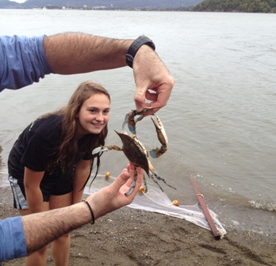 | 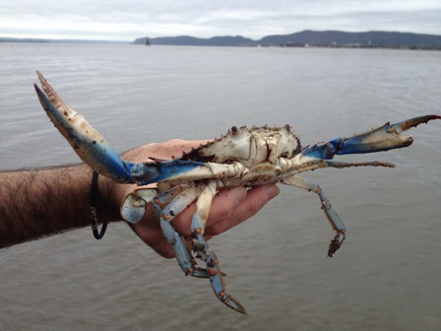

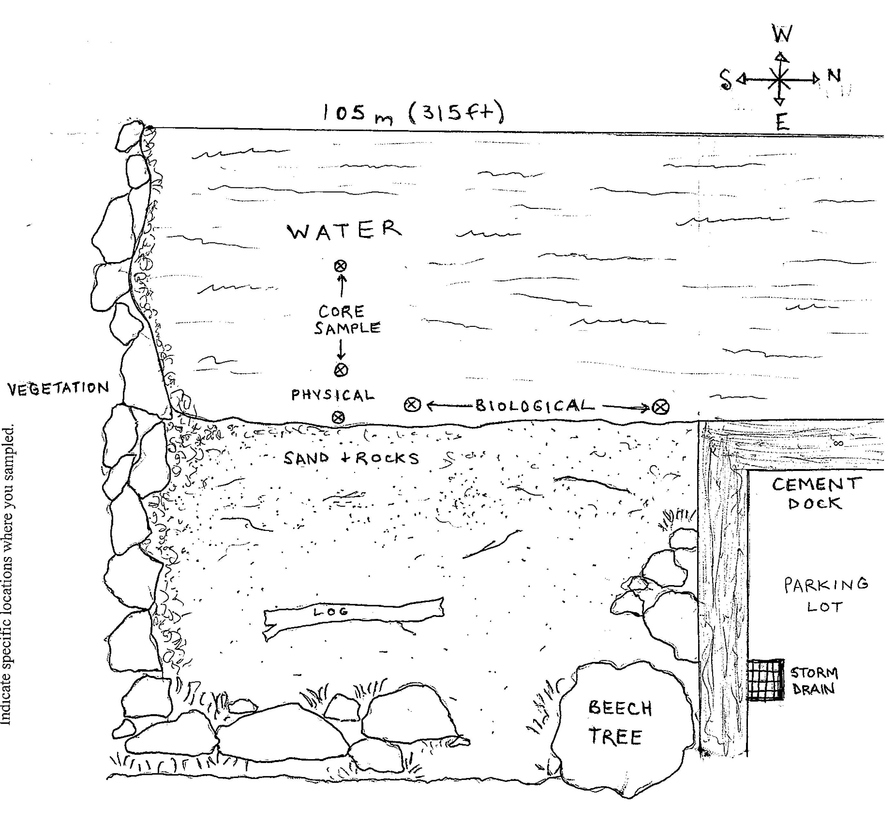
Location: Steamboat Dock Park beach, City of Verplanck in Westchester County
Area: located in a small cove between a point and a bulkhead – Pier, Grassy, Parking Lot
Surrounding Land Use: Boating, Picnics, Swimming, Fishing, Jogging
Sampling Site: beach, riprap, banks altered, dock, bottom rocky, bulkhead, pipe south of the sampling site 10-15 m.
Shoreline: Sandy, rocky
Plants in area: 95% wild grape, 3% honey suckle, 1% locust, 1% sumac
Other: Plants Water celery in water, green and brown algae covering rocks.
Water depth: 12 meters
River Bottom – sandy, rocky
Area Observations: brick pieces on ground, water chestnut seeds, shell pieces, 3 crab shells, overgrown.
Possible Impacts: stormdrains, roads, parking lot
ITEM |  | Time |  |  |  | Reading 1 | Reading 2 |  |  | Comments
Physical
Air Temperature
Wind Speed |  | 10:30 AM |  |  |  | 5-10 mph | NW
Cloud Cover |  | 10:25 AM |  |  |  | >75% cloud cover | Overcast |  |  | 100% stratus
Weather today |  | 11 AM – constant rain
Weather recently
Water Surface |  | Choppy
Water Temperature – |  | 10:20 AM  11:30 AM |  |  | 0.75 cm water  0.75 cm water |  |  | 21.7ºC  21.7ºC |  |  | Overcast
Turbidity – |  | 11:30 AM |  |  | 54 cm  Transparency tube |  |  |  |  |  | Lot of suspended material
Chlorophyll |  | Test 1 |  |  | 0.3 |  |  | Test 2 |  |  | 1.0
Chemical
DO  (drop kits) |  | 10:10 AM  10:20 AM |  |  | 21.7 ºC  21.7 ºC |  |  | 8 ppm  8 ppm |  |  | 87%  87 % Saturation
pH  Indicator solution |  | 10.50AM  11:10 AM |  |  | 8.0  7.8 |  |  | 8.0  7.6
Salinity  YSI SCT meter |  | 10:20 AM  11:30 AM |  |  | 6.2 ppt  5.4 ppt |  |  | 6.1 ppt  5.4 ppt
Conductivity  YSI SCT meter |  | 10:20 AM  11:30 AM |  |  | 10.19 mS  9.07 m/S |  |  | 10.14 mS  8.87 mS |  |  | ppm is ~ = 0.64 conductivity
Alkalinity  (Hach kit: drops) |  | 10:40AM |  |  | 80 mg/L
Nitrates  (Hach color kit) |  | 10:30 AM |  |  | 1.1 mg/L
Phosphate  (colorimeter) |  | 10:30 AM  10:40 AM  11:13 AM |  |  | 0.55 ppm  0.25 ppm  0.00 ppm |  |  | Used color |  |  | wheel
Fish Catch- 11:00 AM |  | Number Caught |  |  | Species |  |  | Size of largest |  |  | Seine
25 ft net X 4ft– 300 ft. pull |  | 8 |  |  | Striped Bass |  |  | 7 cm
6 seines in 60 minutes |  | 1 |  |  | White Perch |  |  | 20 cm
Totals |  | 2 |  |  | Shiners |  |  | 8 cm
Total Catch |  | 11 |  |  | Total Diversity 3 species
Invertebrates |  |  | 1  12 |  | large male blue crab  combjelly (ctenophore)
Coring | Too rocky to core
Tides | TIME |  |  | Amt. Rise/ Fall
 | 10:20 AM |  |  |  | 2 inches |  |  |  | Set stick
Currents | 10:45 AM |  |  |  | 4.5 inches |  | Rise
Currents | 10:55 AM |  |  |  | 6 inches |  | Rise
Currents | 11:05 AM |  |  |  | 10 inches |  | Rise
Currents | Time |  |  |  | Direction |  | Ebb/Flood |  | Speed
 | 10:45 AM |  |  |  | North |  | Flood |  | Slow
Traffic - commercial | Color |  |  |  | Name |  | North/South |  | Loaded/Light
10:14 AM  10:56 AM  11:15 AM  Recreational  10:40 AM  11:35 AM | White  Red (tug pushing barge)  White  ________  Black  White |  |  |  | David Scudder  Fred Johanntsen  David Scudder  ___________  Wild Child  Isis |  | Southbound  Southbound  Northbound  _________  Southbound  Northbound |  | Light  Light  Light  ______  Light  Light
Birds | 20 Ring Bill Gull, 2 Cormorant, 2 Canadian geese, 1 Turkey Vulture

