Day in the Life of the Hudson River 10/10/13 Data
(Salt Front RM 69.3)
RIVER MILE 4
Pier 84
N 40.76408 W-74.001893
Mark Cheever, Carrie Robles and staff, Hudson River Park Trust
Christine Kecskemeti, Liz Walden and staff, Elias Howe, PS 51, 47, 4th graders
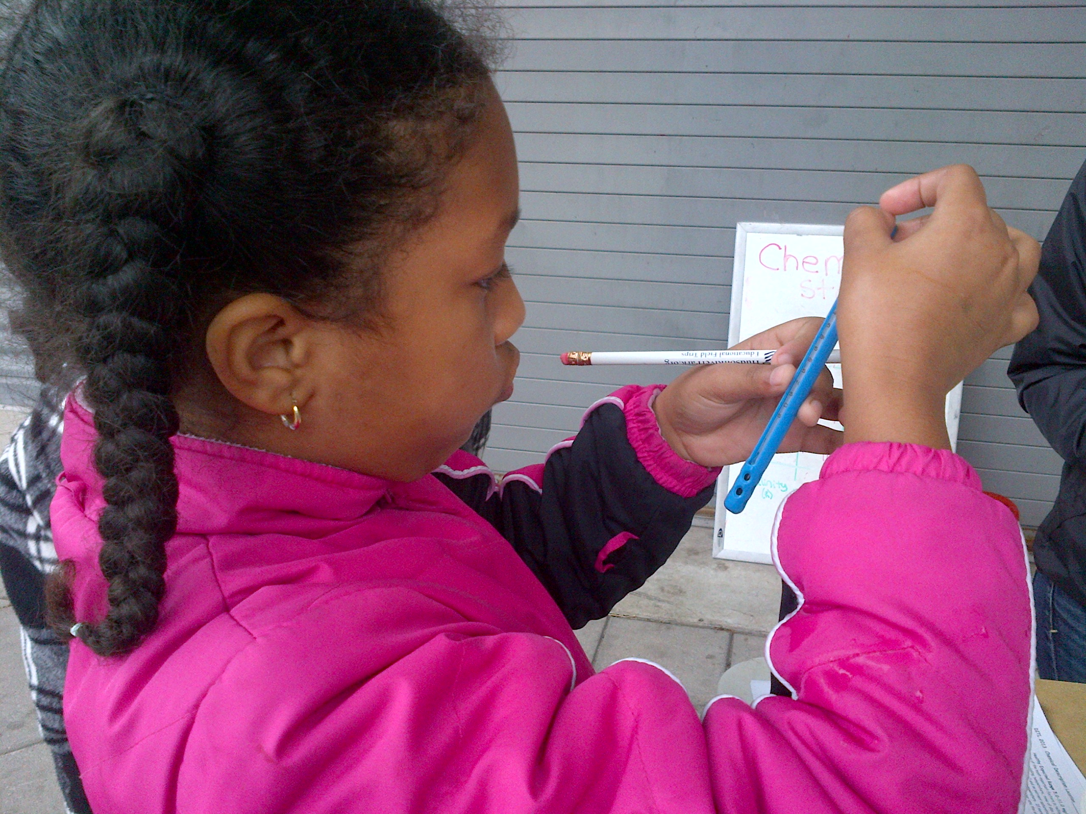 | 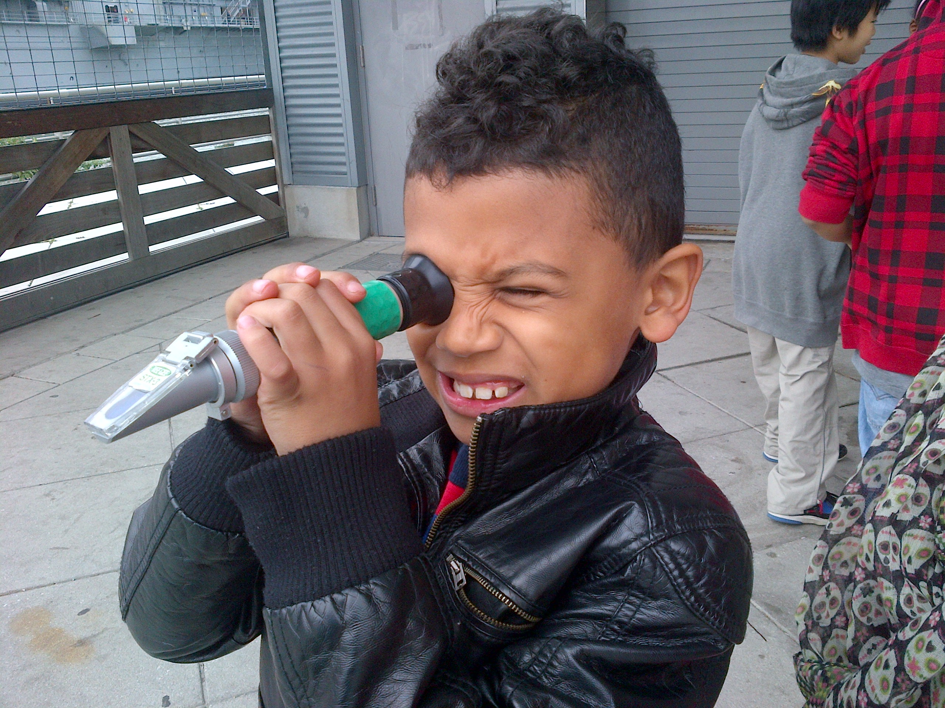
Location: Pier 84, is an educational pier used for picnics, boating, jogging, fishing
Area: Pier – bulkhead – mainly concrete & wood
Surrounding Land Use: 100% urban/residential
Sampling Site: Recreational pier – rocks near the edge, banks altered – all hard edged
Depth: ~12 feet off pier
Plants in area: No plants

ITEM | Time |  | Readings
Physical
Air Temperature | 12:15 PM  12:46 PM  1:03 PM |  | 16°C  16°C  15°C
Wind Speed
Cloud Cover | 12:15 PM  12:46 PM  1:03 PM  1:33 PM |  | 100%  100%  100%  100%
Weather today | Foggy, damp |  |  |  | Water surface | choppy
Weather recently | Nice
Water Temperature | 11:10 AM  12:02 PM | 21°C  20.6°C
Turbidity  Turbidity tube | 12:25 PM  12:50 PM  1:10 PM  1:40 PM | 50,53,45 cm  55,48,37 cm  36,25,34 cm  51, 40, 38 |  |  | 49 cm avg  47 cm  32 cm  43cm
Chlorophyll
Chemical | Time | ppm |  | Avg | Temp | % Sat
DO  Estuary wide monitoring Kit – | 12:20 PM  12:50 PM  1:10 PM  1:40 PM | 3,3,4  4,7,4  8,8,6  8,8,8 |  | 3.3  5  7.6  8 | 15° C  15°C  15°C  15°C | 29%  50%  74%  79%
pH  kit as above | 12:20 PM  12:50 PM  1:10 PM  1:40 PM | 7, 7, 7  7,7,7  7,77  7,7,7 |  |  | 7 average  7  7  7
Salinity -refractometer | 1:10 PM | 20 ppt
Salinity -hydrometer | 12:20 PM  12:50 PM  1:10 PM  1:40 PM | 16, 14, 17  16, 17, 16  16,16,17  17, 18, 18 |  |  | Average  Average  Average  Average | 15.6 ppt  16.3 ppt  16 ppt  17.6 ppt
Fish Catch | Time | Species |  |  | Size | All caught on line
Hook, line, sinker | 12:24 PM | White Perch |  |  | 7 inches
w/ clam bait | 12:40 PM | White Perch |  |  | 6 inches
 | 12:45 PM | Striped Bass |  |  | 8 inches
Tides (from pier to water) | Time | Distance to water |  |  | Rate of change | Flood or Ebb
 | 12:15 PM  12:46 PM  1:03 PM  1:35 PM | 160 cm  162 cm  171 cm  173 cm |  |  | Start point  2 cm  9 cm  2 cm | Flooding  Ebbing  Ebbing
Currents | Time | Meter/sec |  |  | Cm/sec | Ebb/Flood
 | 12:15 PM |  |  |  |  | Flooding
 | 12:46 PM |  |  |  |  | Still
 | 1:03 PM |  |  |  |  | Ebbing
 | 1:35 PM |  |  |  |  | Ebbing

