Day in the Life of the Hudson River 10/10/13 Data
RIVER MILE 55
Little Stony Point
Pete Salmansohn, Andrea Maasik, of the Hudson Highlands Land Trust
Mark Patinella, Leah Horn additional teachers/chaperones,
18 Haldane Middle (8th) & 20 High (12th) Schools total 38 students
41°N - 73°W
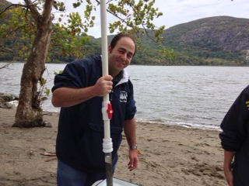 | 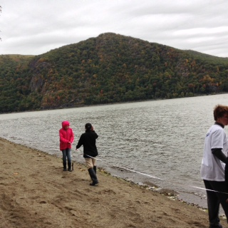

Location: Little Stony Point beach, Cold Spring, Putnam County
Area: On the beach at Little Stony Point, facing Beacon across from Storm King
Surrounding Land Use: 100% forested & beach
Sampling Site: beach area, concrete, docking
Plants in area:
Water depth:
River Bottom –sandy
SAMPLING TIMES 9AM to 1PM
ITEM | Time |  | Reading 1 |  |  | Reading 2 | Comments
Physical
Air Temperature | 10:00 AM  10:30 AM  11:18 AM  12:02 PM |  | 10°C  12.8°C  8.9 °C  12.2 °C
Wind Speed | 10:00 AM  10:30 AM  11:18 AM  12:02 PM |  | 17-21 kts  11-16 kts  17-21 kts  11-16 kts |  |  | Cloudy  Cloudy  Light rain  cloudy
Cloud Cover | Overcast
Weather today | Overcast, drizzle rain
Weather recently | Fall like
Water
Water Temperature | 10:00 AM  10:30 AM  11:18 AM  12:02 PM | 14°C  20.2  20.5  18
Turbidity – | 10:00 AM  10:30 AM  11:18 AM  12:02 PM | 100 JTU  40 JTU  55 JTU  110 JTU
Chlorophyll
Chemical
DO  (ampules) | 10:00 AM  10:30 AM  11:18 AM  12:02 PM | 8 mg/L  7  8  7 |  |  | 14°C  20.2  20.5  18 |  | 85% saturated  75  75  70
pH | 10:00 AM  10:30 AM  11:18 AM  12:02 PM | 8  8  8  8
Salinity – quantabs | 10:00 AM  10:30 AM  11:18 AM  12:02 PM | 8.4 quantab #  9.0 quantab #  8.8 quantab #  8.2 quantab # |  |  | ppm Cl- |  | ppm total salinity
Fish & Crab Catch | Time | Species |  |  | Number |  | Size
Diversity- 3 | 10:00 AM | White Perch |  |  | 1 |  | 4 inches
Totals - 4 |  | Darters |  |  | 2
 |  | Blue Crab |  |  | 1 |  | Male
Diversity- 3 | 10:30 AM | Striped Bass |  |  | 1 |  | 2.5 inches
Totals - 2 |  | Blue Crab |  |  | 1 |  | Male
Diversity – 6 | 11:18 AM | White perch |  |  | 8 |  | 7.5 inches
Totals - 15 |  | Killifish |  |  | 1
 |  | Pumpkin seed |  |  | 2
 |  | American eel |  |  | 1
 |  | Darter |  |  | 2
 |  | Blue Crab |  |  | 1 |  | Male
Diversity- 4 | 12:02 PM | Darter |  |  | 1
Totals - 4 |  | Smallmouth Bass |  |  | 1
 |  | Blue Gill |  |  | 1
 |  | Blue Crab |  |  | 1 |  | Male
2 | TOTAL | DIVERSITY - 9 |  |  | NUMBERS |  | 25
Tides | 10:00AM  10:30AM  11:18AM  12:02PM | 19 cm  22 cm  38 cm  47 cm |  |  | Rising
Currents | Time | Cm/30 sec |  |  | Cm/Sec
 | 10:00 AM  10:30 AM  11:18 AM  12:02 PM | 70cm/sec  97 cm/sec  95.4 cm/sec  247 cm/sec |  |  | 2.3 cm/sec  3.2 cm/sec  3.2 cm/sec  8.2cm/sec
Core Description | Length | Rare |  | Common | Abundant |  | Notes

