Day in the Life of the Hudson River 10/10/13
(Salt Front RM 69.3)
RIVER MILE 85
Mills Mansion, Staatsburgh, NY, Dutchess County
Maribel Pregnall, Arlington High School
Sara (Orange County), Christine (SCA), Marshall Pregnall (Vassar College)
23 High School 11-12th graders, 4 adults
N41.8566°N W73.9299°W (iphone coordinates)
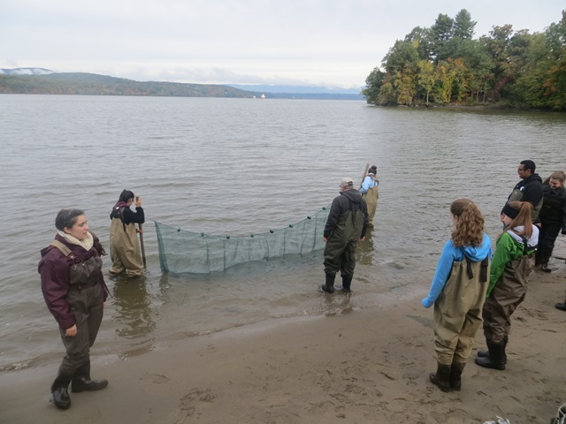
Location: Sampling done on beach at Northside of the pumphouse at Mills Mansion
Area: pastoral setting, clean no houses except mansion and pumphouse, Forested; grassy; beach
Surrounding Land Use: picnics, fishing, sight seeing
Sampling Site: Physical station: on beach at Northside of the pumphouse at Mills Mansion;
Fish Station: off beach area, ebb tide, sandy, made our way over riprap rocks with fencing (erosion control), sandy/rocky and then muddy
Chemistry: near beach at mansion – at pumphouse/icehouse
Shoreline: sandy and rocky close to shore, further out it gets muddy
Plants in area: none in water
River Bottom –

ITEM | Time | Reading 1 |  |  | Reading 2 | Comments
Physical | Time
Air Temperature | 10:20 AM  11:30 AM  11:34 AM | 10.6°C  11.1  11.7 |  |  | 51°F  52  53
Wind Speed | 11:18 AM | Beaufort #2 |  |  | 0.9m/sec on meter | N/NE
Cloud Cover | 11:19 AM | Overcast >75%
Weather today | Cloudy and threat of rain but @ 11:32 AM no rain
Weather recently | Mon 10/7 strong winds and heavy precip (~2/3 inch in afternoon, Tues 10/8 ~2/3 in precip in afternoon, Wed. 10/9 partly sunny
Water | choppy
Water Temperature 9:36 1 ft. water  11:40 0-6 inch water | 9:36 AM  11:40 AM |  | 17.8°C  17.4 | 17.1°C  17.1 |  | Avg. 17.5°C  Avg. 17.3
Turbidity | 10:45 AM |  | 56.4 cm  63.9 cm  60.2 cm |  |  | Average 60.2 cm
 | 11:50 AM |  | 63.6 cm  62.6 cm  66.8 cm |  |  | Average 64.4 cm
Chemical
DO  (drop count) | 10:08 AM  10:08 AM |  | 8.6 mg/L  8 mg/L | 17.6 °C  17.6 °C |  | 90% sat  85% sat
 | 11:54 AM  11:54 AM |  | 8.1 mg/L  8.4 | 17.1°C  17.1°C |  | 82.5 % sat  85 % sat
pH | Time |  | Hach kit | meter
 | 9:51 AM  11:49 AM  11:49 AM |  | 8.3  8.2  8.2 | 8.39  7.95  7.91
Salinity | Time |  | PPT | PPM |  | Conductivity
YSI | 9:36 AM  11:44 AM |  | 0.1  0.1 | 100 ppm  100 ppm |  | 263.8  255.6
Refractometer | 9:36 AM  11:44 AM |  | 0  0
Fish – seine ~30 ft. net

FISH TOTALS | Species | Number | Size | Totals
9:15-10:30 AM | Banded Killifish | 1 | 4 inch | DIVERSITY  6 species
 | Spottail Shiner | 7 | 2 inch | TOTALS
 | Striped Bass | 1 | 3 inch | 27 fish
 | Bay Anchovy | 1 | 3 inch
 | Shiner | 16 | 3 inch
 | YOY Sunfish | 1 | 1 inch
11:30-12:15 PM | Shiner | 3 | 3 inch | DIVERSITY  3 species
 | Banded Killifish | 2 | 2 inch | TOTALS  8 total
 | Bay Anchovy | 3 | 2 inch
GRAND TOTALS | DIVERSITY | SPECIES #6 | TOTALS | FISH #35
Tides | time | cm | Rate of change |  | Rising/Falling
 | 10:09 AM | 54.5 cm
 | 10:37 AM | 47 cm | 7.5cm/26 min |  | F
 | 11:09 AM | 36.5 cm | 10.5cm /29 min |  | F
 | 11:36 AM | 29 cm | 7.5 cm/25 min |  | F
 | 12:09 AM | 27 cm | 2 cm/33 min |  | F
Currents | 11:24 AM | 91cm/30 sec | 3.03 cm/sec |  | Ebb
 | 11:28 AM | 70 cm/30 sec | 2.33 cm/sec |  | Ebb
 | 11:30 AM | 70 cm/30 sec | 2.33 cm/sec |  | Ebb
Sediment Core | 6 inch core | H2S smell |  |  | Dark core
Shipping | Saw no commercial boats
 | 11:30 AM | Recreational sailboat |  |  | southbound
Observations | At Mills Mansion there are no water chestnuts which makes it unique – other sites in this area have lots of water chestnut  Lots of Canadian geese and vultures (birds of prey)

