Snapshot Day 10/10/13 Data
(Salt Front RM 69.3)
RIVER MILE 11.5 – Fort Washington Park
Jenny Shao – International High School for Health Sciences
9th – 40 students and 5 adults
Latitude 40.8462385 N - Longitude -73.94624335W
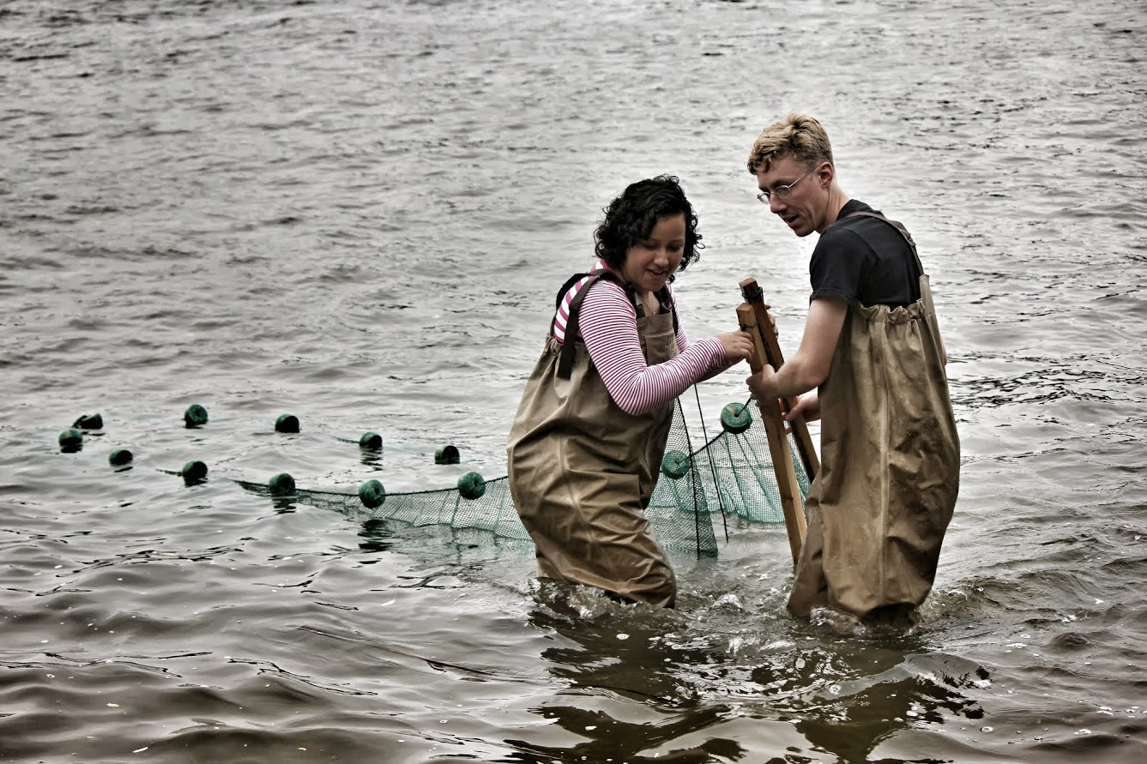 | 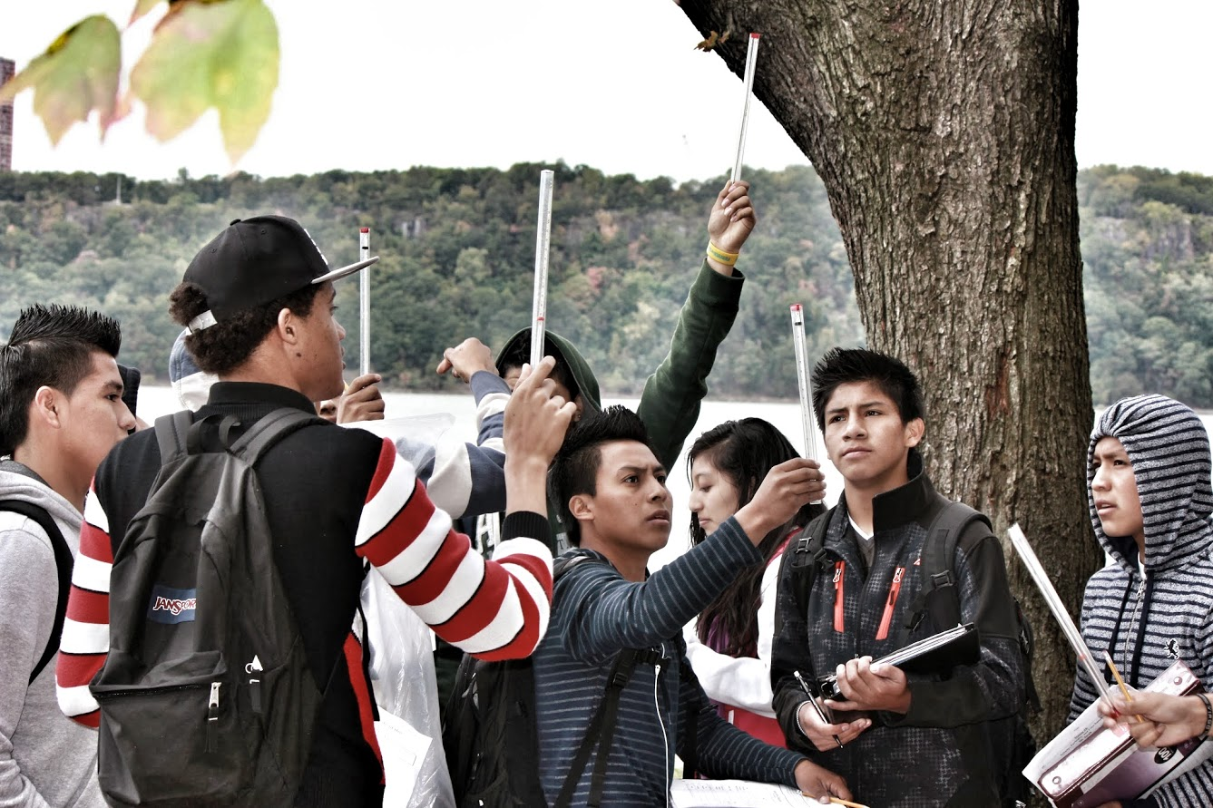

Location: Fort Washington Park just South of the George Washington Bridge
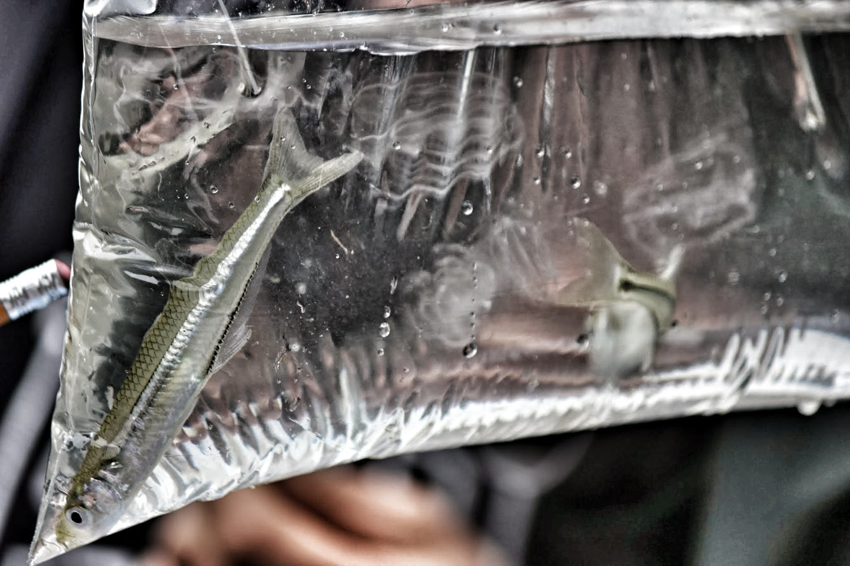
Area: Park/Boat launch, sandy beach area on the point
Surrounding Land Use: 15% forested, 85% park used for recreation & picnics
Sampling Site: Park with a lot of trees, picnic tables, covered with vegetation, riprap shore, collected wood debris.
Plants in water: <10% - a grass of some sort
River Bottom –sandy

Atlantic Silverside

ITEM | Time | Reading 1 | Reading 2 | Comments
Physical
Air Temperature | 10:57 AM  11:33 AM  12:37 PM  1:02 PM | 20°C
Wind Speed | 10:57 AM  11:33 AM  12:37 PM  1:02 PM | Beaufort #2  Beaufort #3  Beaufort #3  Beaufort #3
Cloud Cover | cloudy
Weather today | Slight rain in AM
Weather last 3 days | Rainy Monday, sunny
Water Surface
Water Temperature | 10:57 AM  11:33 AM  12:37 PM  1:02 PM | 20 °C  19 °C  19 °C  17 °C
Turbidity  Site tube | 11:05 AM  11:11 AM  11:40 AM  12:36 PM | 45.4 cm  49 cm  63 cm  51 cm |  | Average 52.1 cm
Chemical
DO | 1:00 PM | 17 °C | 9 ppm | 93%
pH – litmus paper | 11:09 AM  11:45 AM  1:00 PM  1:30 PM | 8.0  8.0  8.0  7.5
Salinity  Hydrometer | 11:05 AM  11:11 AM  11:40 AM  12:36 PM | 16.5 ppt  17 ppt  14 ppt  14 ppt |  | 15.38 ppt Avg.
Fish Catch | Number Caught | Species
5 rotations | 28 | Jellyfish -Comb Jelly |  | DIVERSITY 1
 | 2 | Atlantic Silversides |  | TOTAL 2 +  Comb Jelly
Tides | 10:57 AM  11:33 AM  12:37 PM  1:02 PM | 45 cm  52 cm  66 cm  76 cm | Set  Rising  Rising  rising
Core Sample | Layered | Big rocks at the bottom | Smaller rocks on top | Color dark brown

