**Day in the Life of the Hudson River 10/16/14 Data**

**(Salt Front RM 65.9)**

**Brighton Beach, Brooklyn NY**

**Olivia Tandon, Poly Prep Country Day School**

**100 students, 9th graders, and 7 Adult Helpers**

**Latitude: 40.6°N, Longitude: 74.0°W**

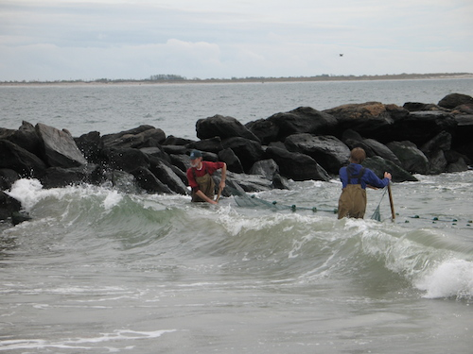

**The surf was pounding the beach creating challenging seining conditions**

**Location:** Brighton Beach, Brooklyn

**Area:** Beach mainly

**Surrounding Land Use:** 55% residential; 35% beach/recreational; 10% commercial

**Sampling Site:** Beach – large rocks make up the breakwater (see image above), smaller pebbles in sand

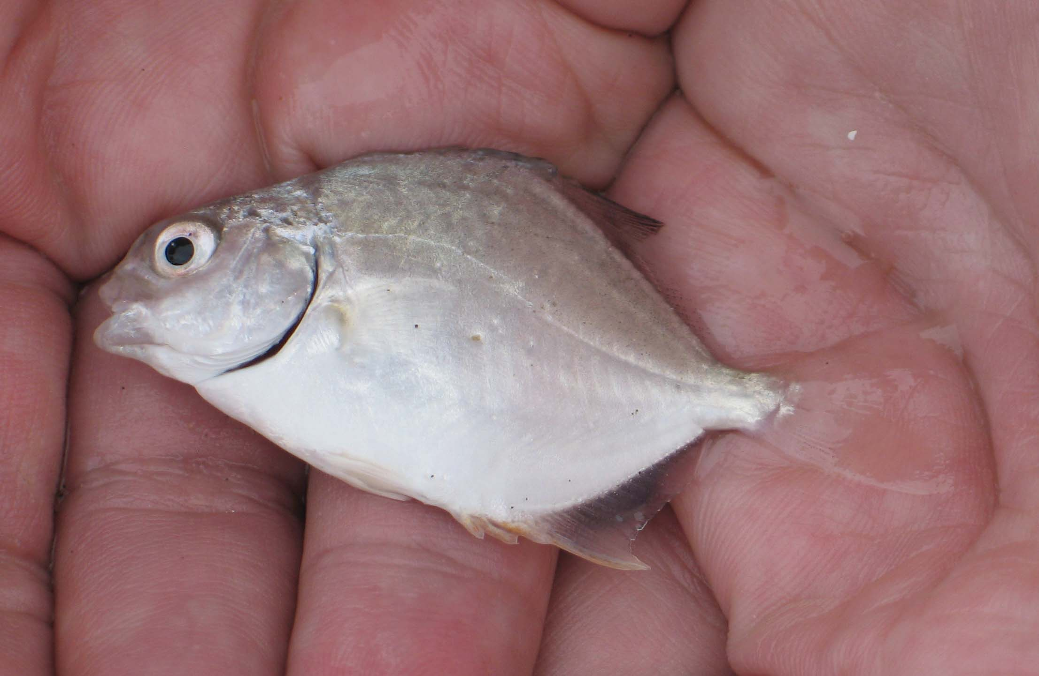

**Netted juvenile ‘permit’ fish. A western Atlantic fish their genus name (trachinotus) means ‘rough back’ for its scythe like dorsal fin that on an adult can protrude from the water when they feed near the surface.**

|  |  |  |  |  |  |
| --- | --- | --- | --- | --- | --- |
| ***ITEM*** | ***Sampling time 9:30-2:00 PM*** | | ***Reading 1*** | ***Reading 2*** | ***Comments*** |
| ***Physical*** |  | |  |  |  |
| Air Temperature |  | | 64° F  17.8° C |  |  |
| Wind Speed |  | | 8m/sec |  |  |
| Cloud Cover | 100% Cloudy most of day | |  |  |  |
| Weather today | Rainy & windy | | Gloomy, cold – sun at very end of time | | |
| ***Water Condition*** | Choppy and pounding | | | | |
| ***Water Temperature*** |  | 64° F  18.3°C | |  |  |
| ***Turbidity*** |  |  | |  |  |
| ***Chemical*** |  |  | |  |  |
| DO (drop count) |  |  | |  |  |
| pH meter |  |  | |  |  |
| Salinity | Hydrometer | 1.025 density | | 33.2 ppt TS |  |
| ***Fish Catch*** | **Total:**  1 | **Fish:**  1 Pemit fish | |  | **Div- 1**  **Total - 1** |
| ***Tides*** | LT ~9AM | Rising for full sampling period | |  |  |
| ***Currents*** | Trials during sampling | 2.5 m/30 sec  7m/30 sec  3.5 m/30 sec | | 0.83 m/sec  0.23 m/sec  0.12 m/sec | Flooding |
| ***Core –*** | **% water** | **Color** | | **Size** | **Content** |
| *Water/beach Junction* | High | Dark brown | | Coarse | Sand |
| *Beach/sand junction* | Med | Light brown | | Coarse | Sand |
| *Beach* | Med | Light brown | | Med | Shells |
| *Overall comments* | Lighter at the top and darker as you go down core. Middle of the core stuck together more than top or bottom. Further down had more moisture. Differences in consistency closer to the shore and farther. Mostly sand, few pebbles, broken shell pieces. | | | | |
| ***Biotic Organisms Seen*** | **Identification** | **Total #** | | **Comment** | |
| Ring-billed gull | Yellow bill, black ring | 50 | |  | |
| Common Moorhen? |  | 1 | | Listed with question mark on sheet – moorhen would be more expected in freshwater marsh environments – Perhaps an American coot? | |
| Rock Dove |  | 1 | |  | |
| Blue crab |  | 1 | |  | |
| Dogs |  | 10 | |  | |
| Unidentified insect |  | 1 | |  | |
| Unidentified plant | Pea looking plant growing in the sand | 50 | | Perhaps beach pea or seaside pea - Lathyrus japonicas – native to temperate N. American coastal areas – grows in sand | |
| Unidentified Tree | Thin and long leaves, small trunk | 5 | |  | |
| ***Abiotic things*** | Seashells, sand, precipitation, salt | | | | |
| ***Sea Level Rise*** | ***Group 1 – distance 0*** | ***Group 2 – distance 5m*** | |  | |
| Estimate ⬆28 cm | 2 meters | 3 meters | |  | |
| Estimate ⬆51 cm | 4 meters | 6.05 meters | |  | |
| Estimate ⬆98 cm | 10 meters |  | |  | |