**Day in the Life of the Hudson River 10/16/14 Data**

**(Hudson River Salt Front RM 65.9)**

**Bronx River Mile 8 Hunts Point & RM 7.5 (CSO HP-009)**

**Hunts Point Riverside Park, Bronx, NY**

**Rocking the Boat,**

**Lat 40.8172 – Lon. -73.8810**

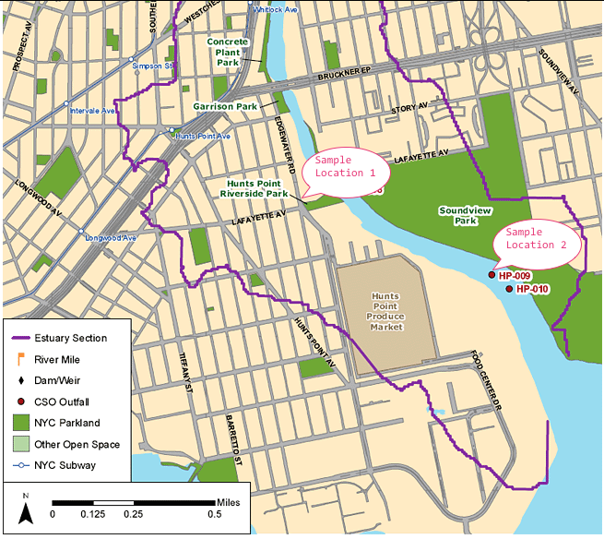

**Location:** Hunts Point, Riverside Park, Bronx River

**Area:** Mostly used for boating and fishing

**Surrounding Land Use:** 5% beach; 95% industrial/commercial

**Sampling Site:** Beach, pier, shoreline riprap, covered with vegetation, debris in the area

**River Bottom:** Sandy, Muddy, Rocky

**Plants in area:**

**Sampling Location 1 – Dock – Sample time 6:04 PM**

|  |  |  |  |  |
| --- | --- | --- | --- | --- |
| ***ITEM*** | ***Time*** | ***Reading 1*** | ***Reading 2*** | ***Comments*** |
| ***Water Temperature*** | 6:04 PM | 77°F  25°C |  |  |
| ***Turbidity*** |  | 50cm  58  52 | 53 cm average |  |
| ***DO*** |  | 7.5 mg/L  7.3  7.3  Average 7.4 | 25°C | 87% saturation |
| ***pH*** |  | 7.5  7.5  7.5 | 7.5 average |  |
| ***Salinity -*** |  | 10 ppt  7 ppt  8 ppt | 8.3 ppt average |  |
| ***Nitrates*** |  | 1. mg/L   0 mg/L  1.0 mg/L | 0.67 mg/L |  |
| **Tides** |  | LOW |  |  |

**Sampling Location 2 CSO HP-009 - 6:50 PM**

|  |  |  |  |  |
| --- | --- | --- | --- | --- |
| ***ITEM*** | ***Time*** | ***Reading 1*** | ***Reading 2*** | ***Comments*** |
| ***Water Temperature*** | 6:50 PM | 71.6°F  22°C |  |  |
| ***Turbidity*** |  | 44cm  46  48 | 46 cm average |  |
| ***DO*** |  | 7.5 mg/L  7.6  8.2  Average 7.7 | 22°C | 85% saturation |
| ***pH*** |  | 7.5  7.5  7.0 | 7.3 average |  |
| ***Salinity -*** |  | 17 ppt  20 ppt  17 ppt | 18 ppt average |  |
| ***Nitrates*** |  | 1. mg/L   1.0 mg/L  1.0 mg/L | 1.0 mg/L |  |
| **Tides** |  | LOW |  |  |