A Day in the Life of the Hudson River 10/16/14 data
(Hudson River Salt Front RM 65.9)
East River; Pier 16 South Street Seaport - AM group
Heather Page & the High School of Economics & Finance,
Maggie Flanagan, South Street Seaport Museum
22 - 11rd & 12th APES students, 3 adults
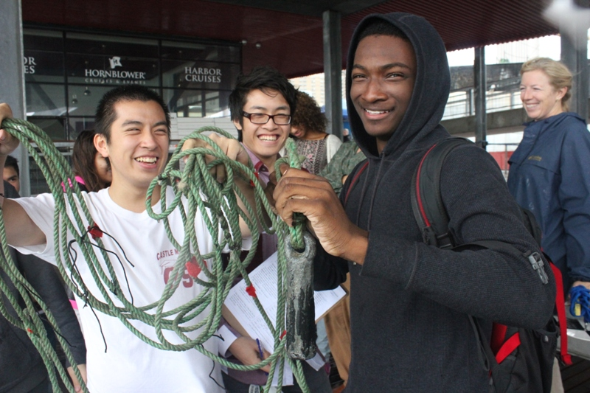
Location: South Street Seaport, Pier 16
Area: East River; Pier 16
Surrounding Land Use: Museum, Pier for boat access, Urban/residential and industrial/commercial
Shoreline: Pier, large docking with concrete and wood surface,
Bottom: Rocky shoreline
Water: Choppy
ITEM | TIME | Reading | Comments
Physical
Air Temperature | n/r
Cloud Cover |  | Mostly cloudy
Weather Today |  | Rainy, humid
Weather Recently | 10:29 AM | Partly cloudy | Consistent rain, chilly
Wind | 10:29 AM | Beaufort Force #2 | Southerly wind (strong per Maggie)
Water Temperature | 11:11 AM | 23° C
Water Surface | Choppy
Turbidity – long tube | 10:29 AM | 30 cm
Chemical
Salinity | 11:35 AM | 27 ppt  salinity | Plastic Hydrometer
pH - Color Match Test Kit | n/r
DO  (Dissolved Oxygen)-ampules | 11:11 AM | 5.5 ppm  - % saturation | Water temp, 23°C
Tides | 10:32 AM | Rising | 231.14 cm from pier to waterline
Site Depth – lead line | 10:32 AM | 12 ft. depth
Currents – strong flood current | 10:30 AM - Flood  10:37 AM - Flood | Not recorded  541 cm/30 secs | 18.3 cm/sec
Shipping | 10:23 AM | Name:  East River Valley | Color: Blue - loaded

