A Day in the Life of the Hudson River 10/16/14 data
(Hudson River Salt Front RM 65.9)
East River; Pier 16 South Street Seaport - PM group
Carrie Vaughn & the Blue School,
Maggie Flanagan, South Street Seaport Museum
12 – 2nd graders, 3 adults
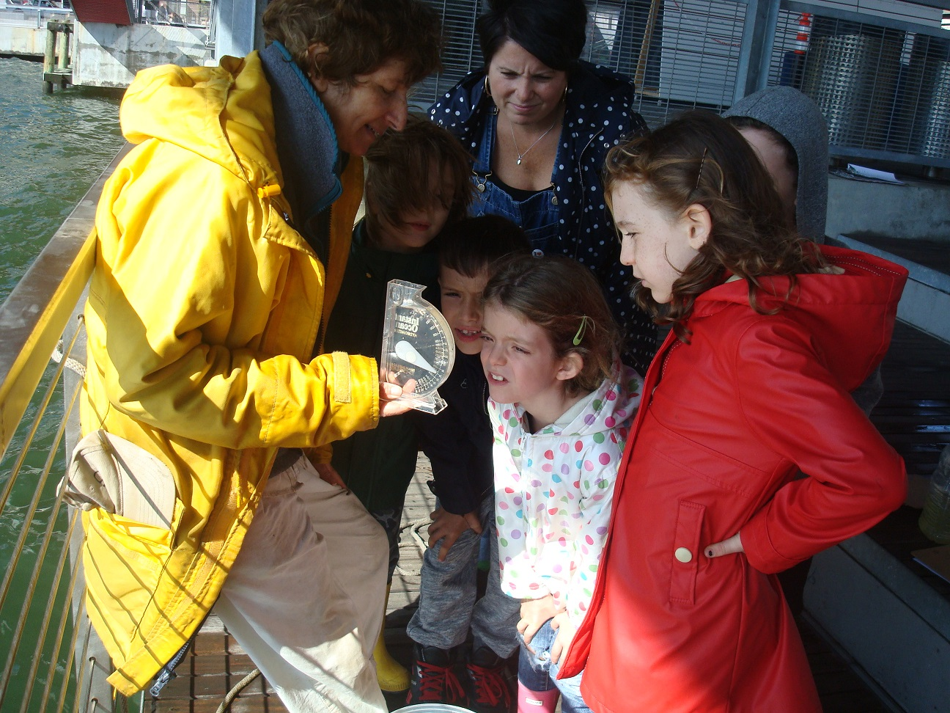 | 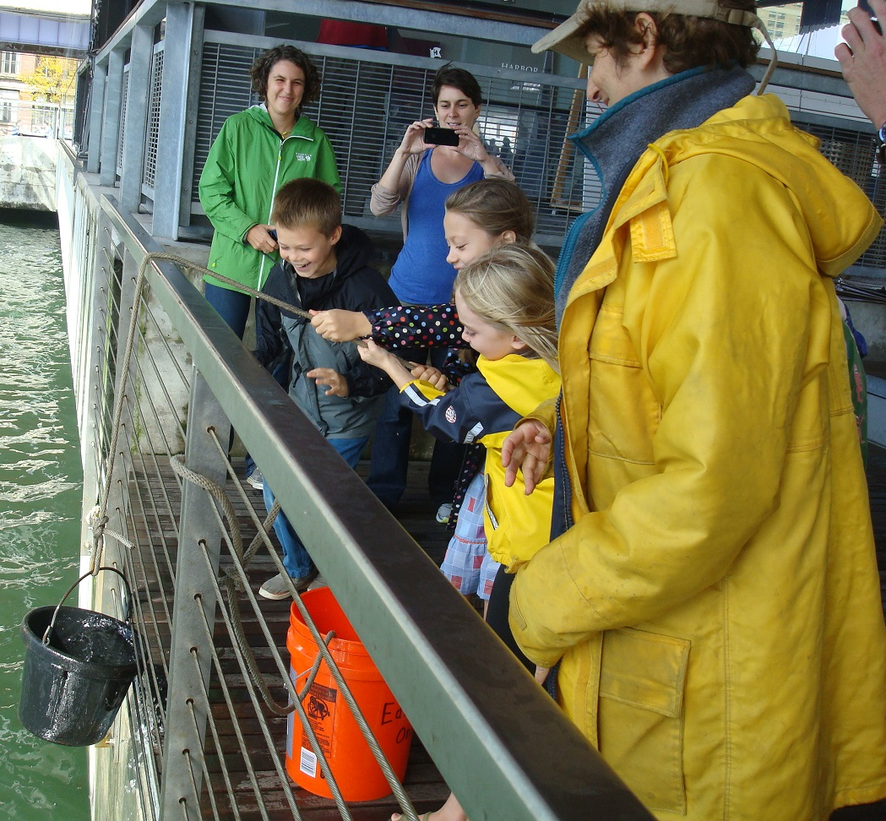
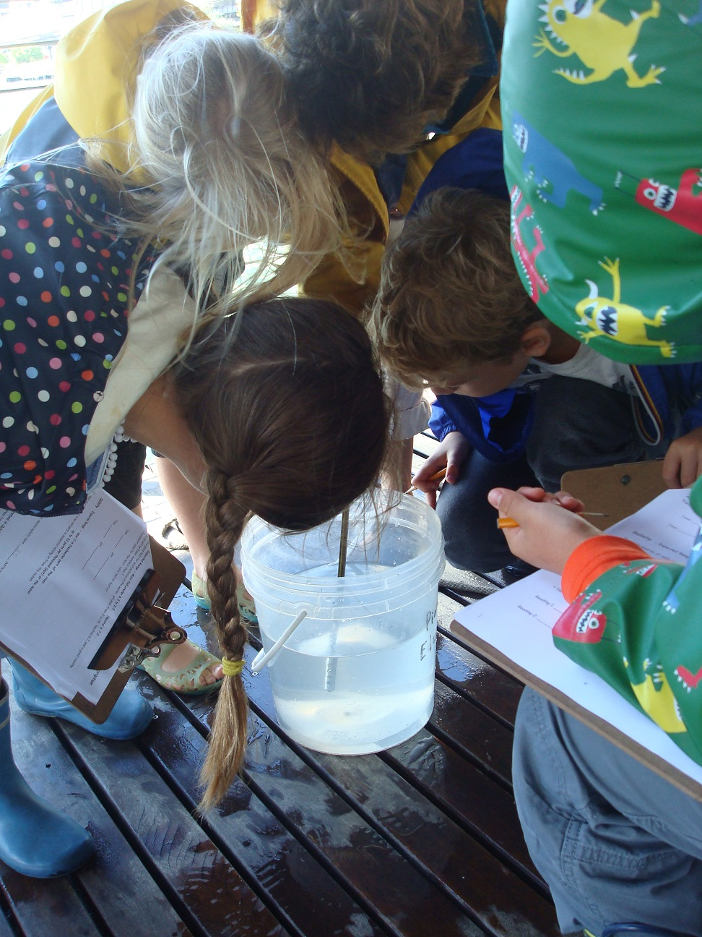
Location: South Street Seaport, Pier 16
Area: East River; Pier 16
Surrounding Land Use: Museum, Pier for boat access, 30% Urban/residential and 70% industrial/commercial
Shoreline: Pier, large docking with concrete and wood surface, piping entering river
Plants in water: None
Bottom: Rocky shoreline
Water: Choppy
ITEM | TIME | Reading | Comments
Physical
Air Temperature | n/r
Cloud Cover | 1:00 PM | Partly cloudy
Weather Today | Overcast and heavy rain in the morning broke for partly sunny skies at the sampling time in the early afternoon.
Weather Recently | 1:30 PM | Partly cloudy | Partly sunny
Wind | 1:30 PM | Beaufort Force #2 | Southerly wind
Water Temperature | n/r
Water Surface | Choppy
Turbidity – long tube | n/r
Chemical
Salinity | 12:45 PM | 25 ppt  salinity | Plastic Hydrometer
pH - Color Match Test Kit | n/r
DO  (Dissolved Oxygen)-ampules | 1:30 PM | 5.ppm  - % saturation
Tides | 1:00 PM | flood
Currents – | 1:00 PM | flood
Shipping | 1:00 PM | 5 Ferries
 | 1:00 PM | 1 Tour boat

