Day in the Life of the Hudson River 10/16/14 Data
(Salt Front RM 65.9)
Jamaica Bay
Brooklyn New School 4th grade group – contact Barbara Taragan
30, 4th grade elementary students, 10 adults
Location: Jamaica Bay, NY

Chemistry - pH had a reading of 7

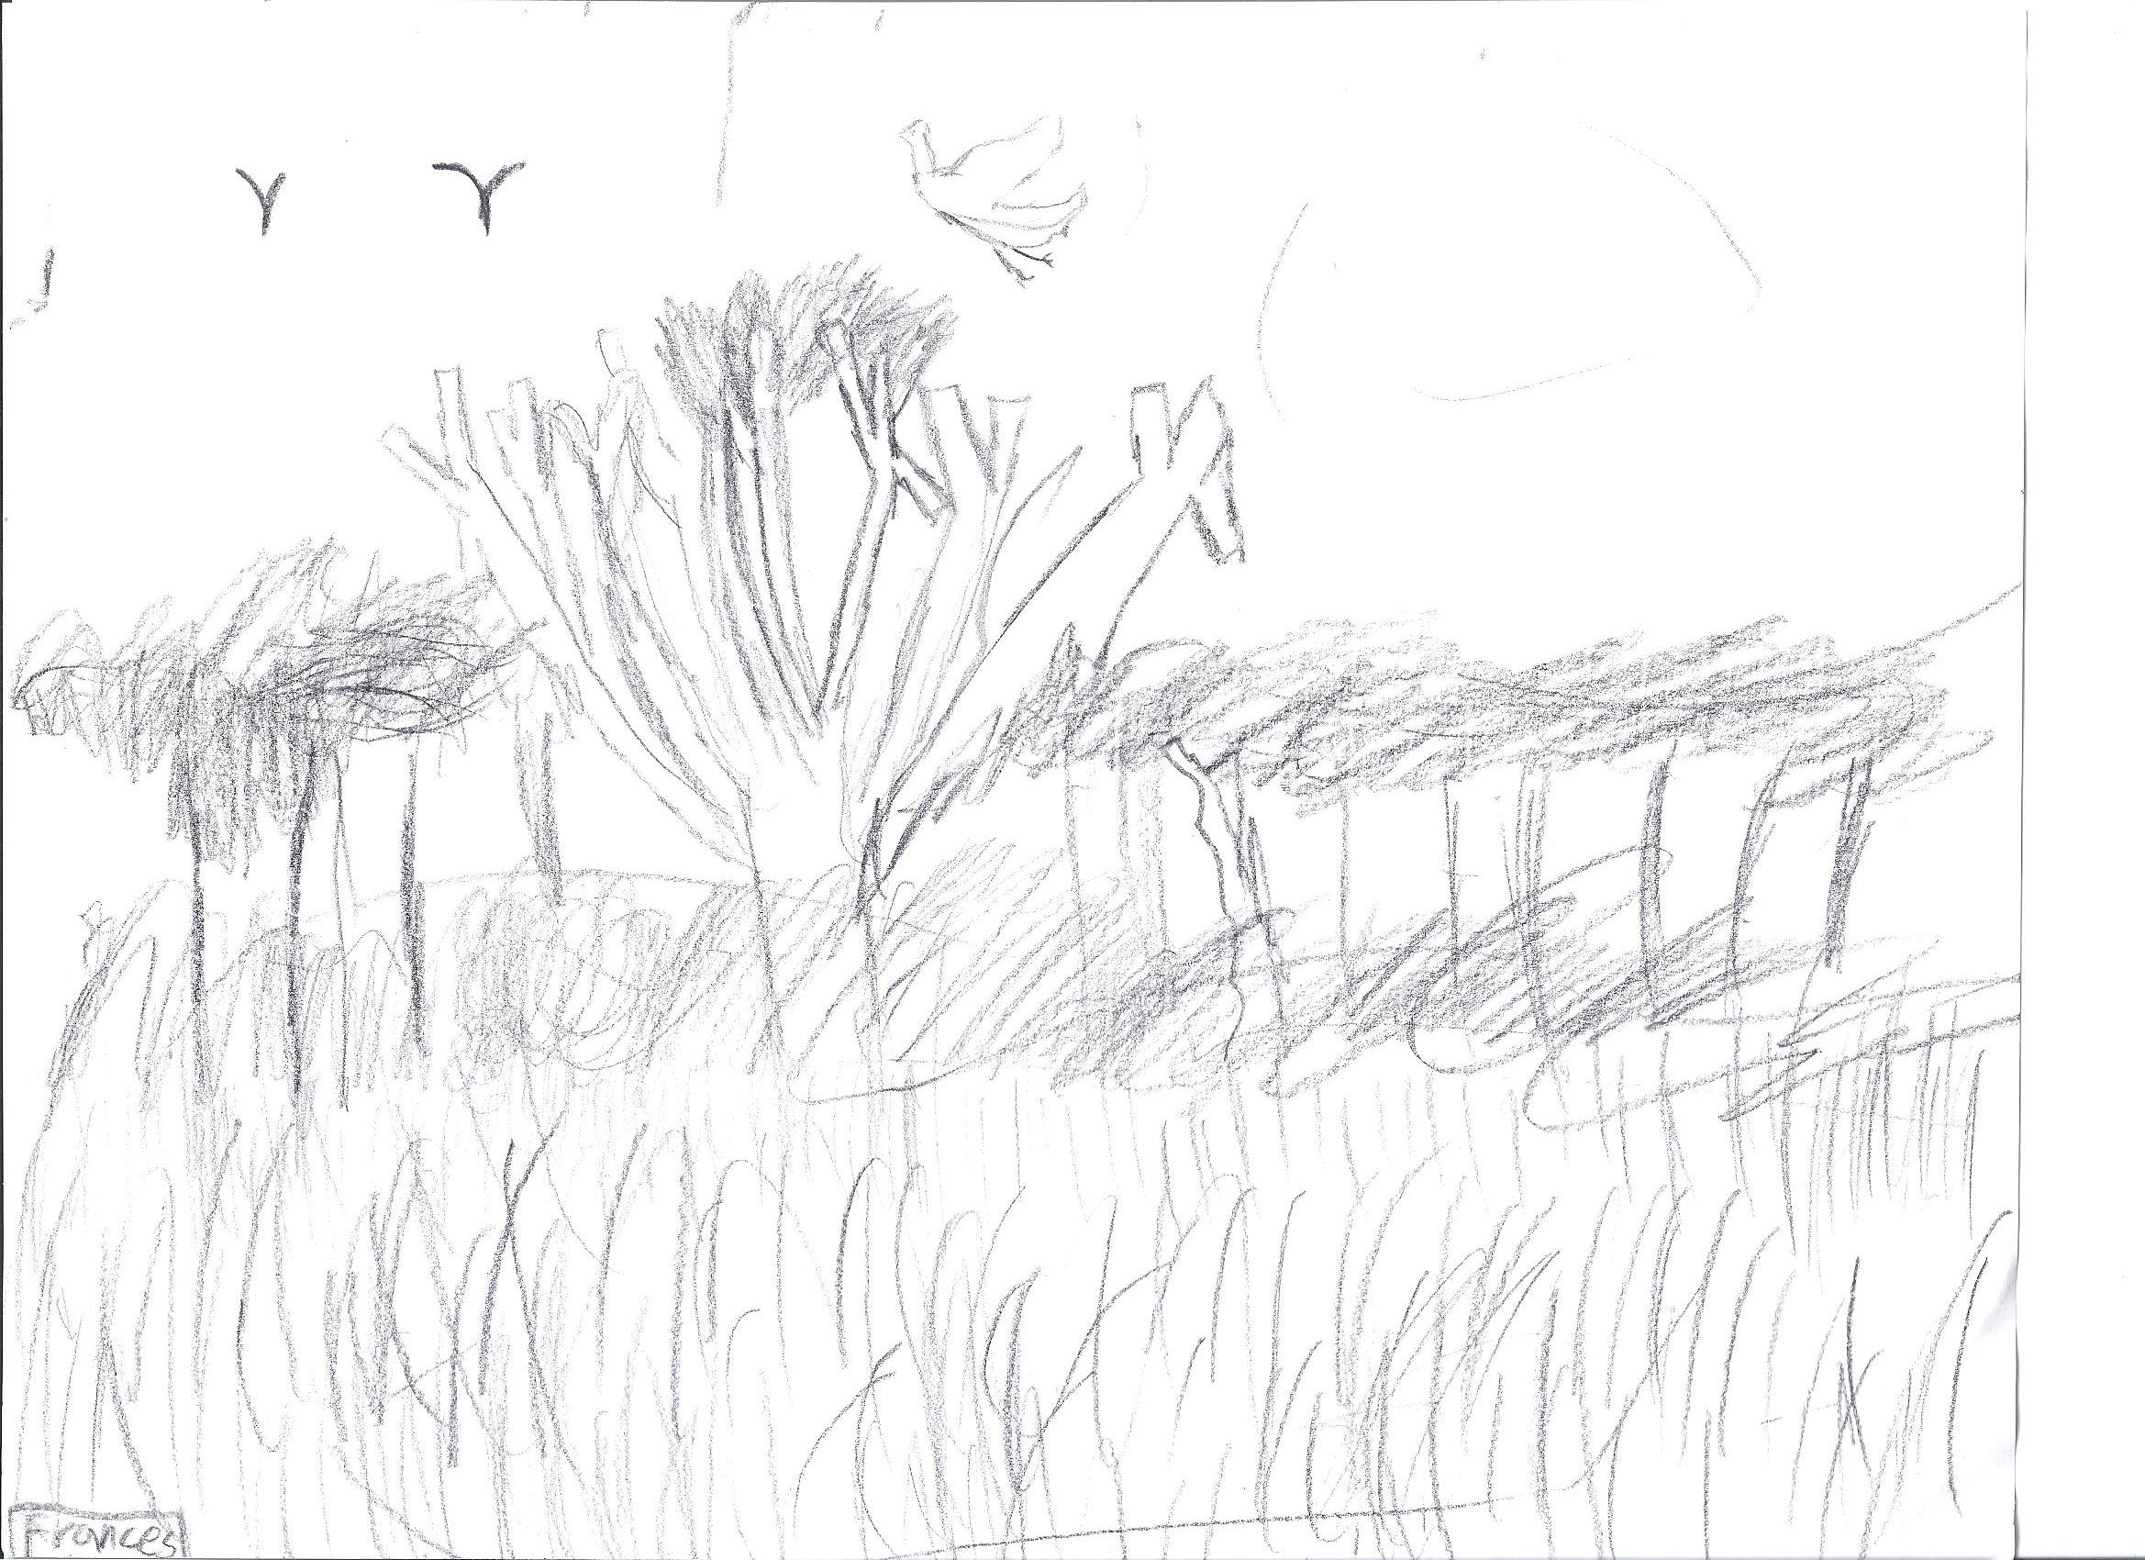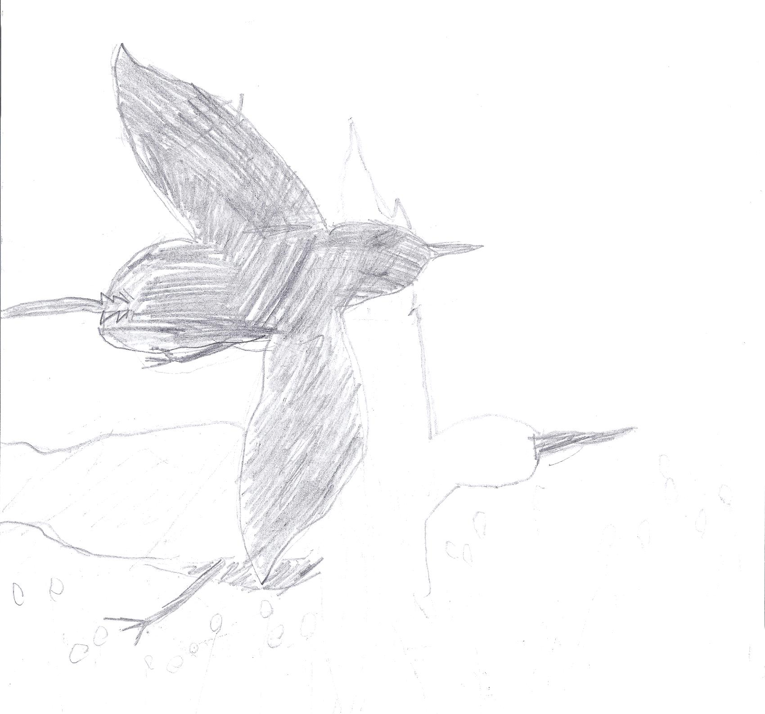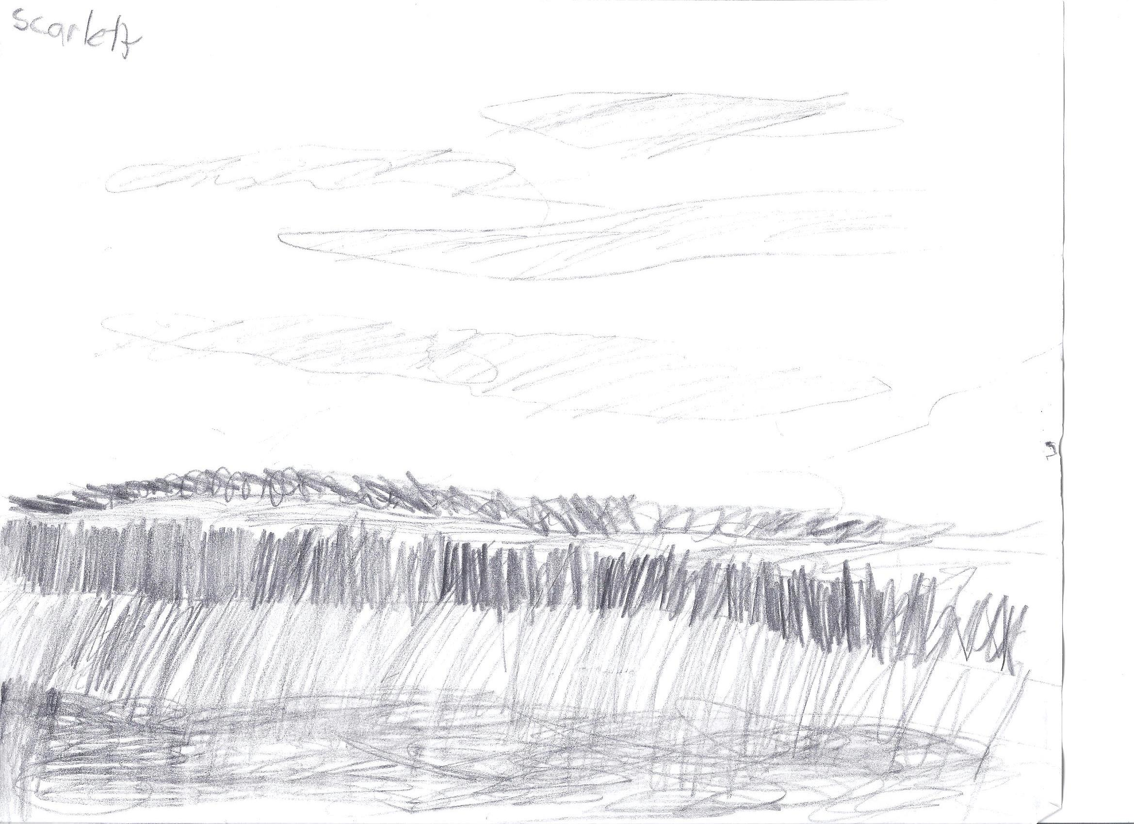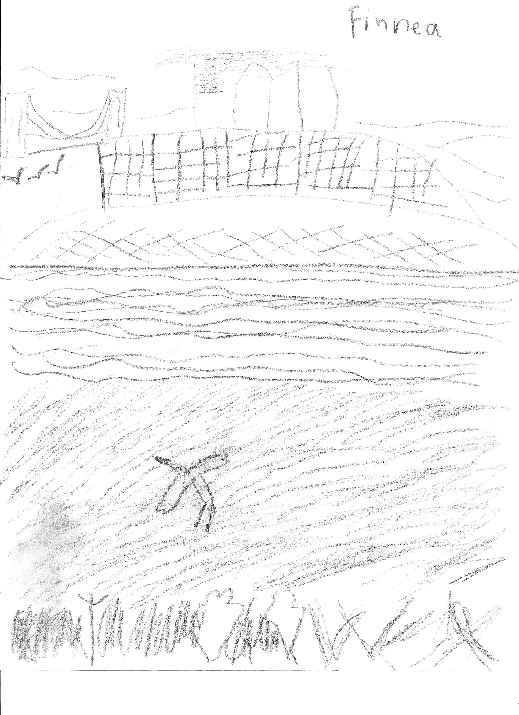
Marsh grasses at Jamaica Bay Wildlife

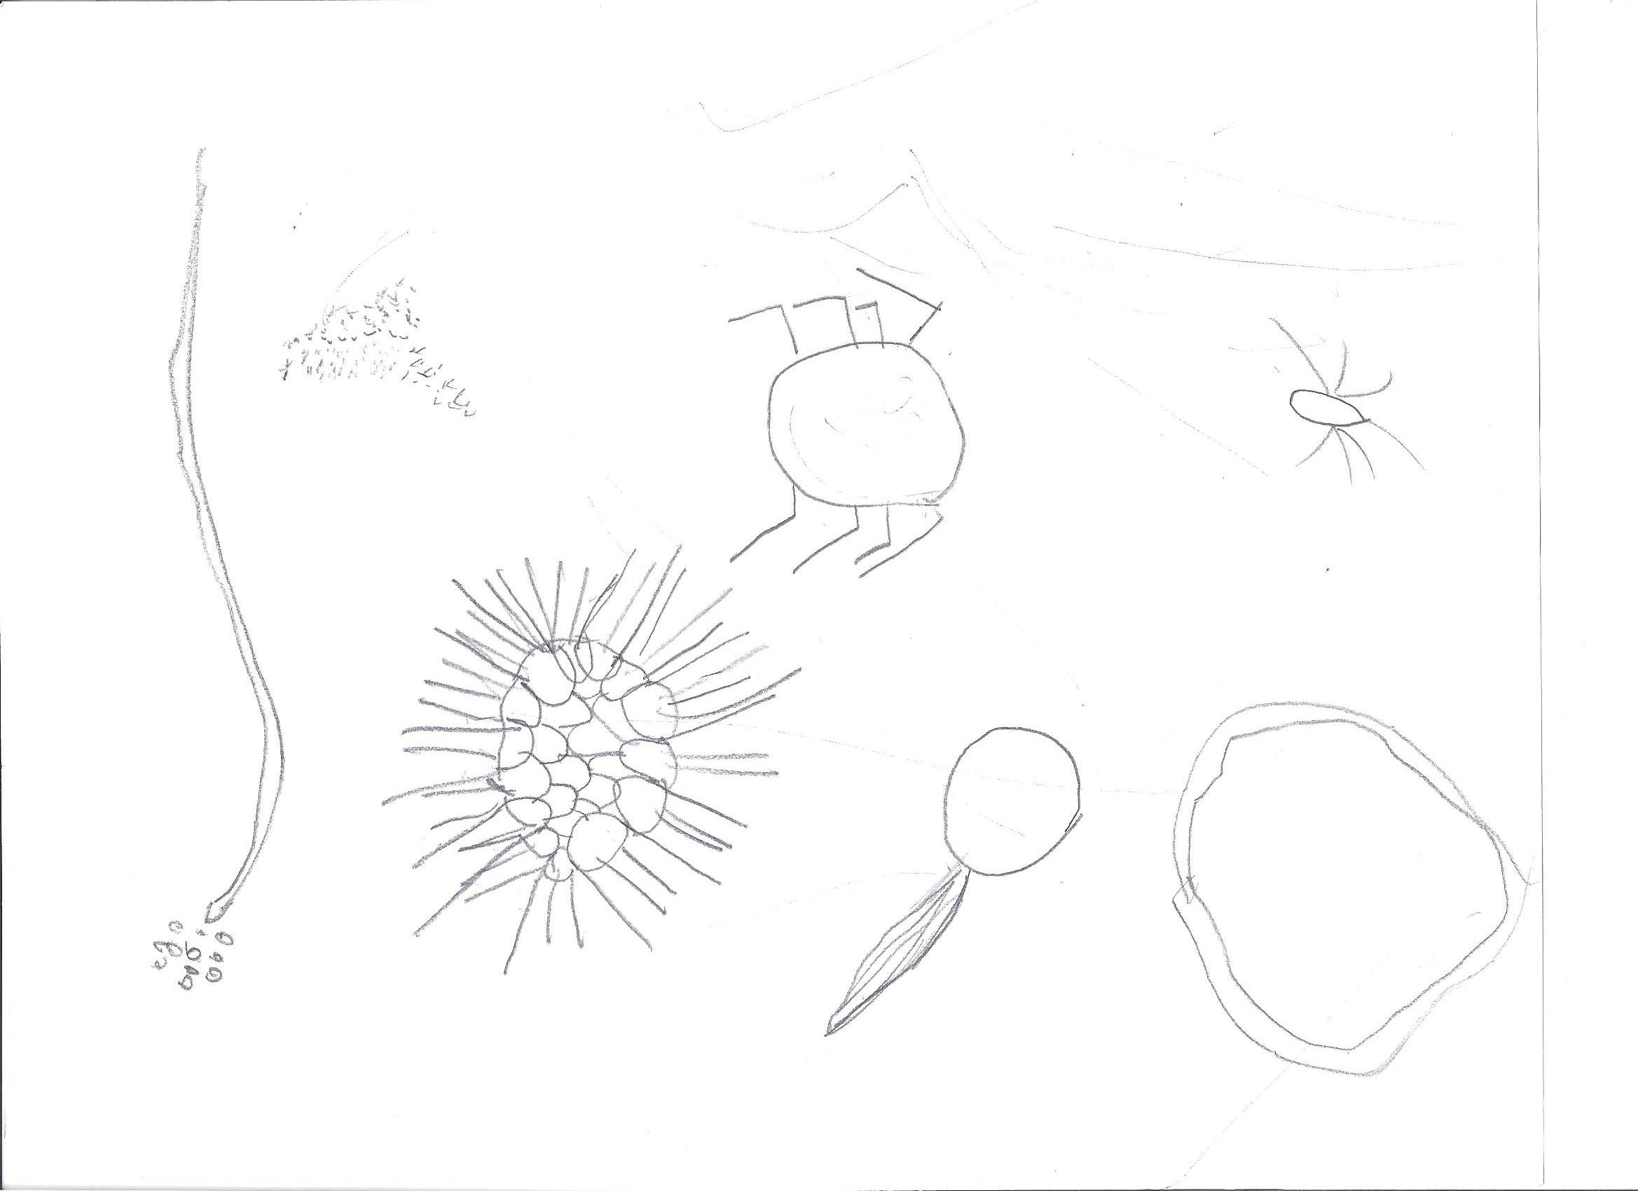
Microbes found in the marsh

