**Day in the Life of the Hudson River 11/17/14 Data**

**(Salt Front RM 66.2)**

**RIVER MILE -7**

**Fort Wadsworth, Staten Island**

**Mary Lee, St. Clare’s School, 60 Seventh graders and 12 adults**

**N 40**°**36.002’ - W-74**°**3.301’**

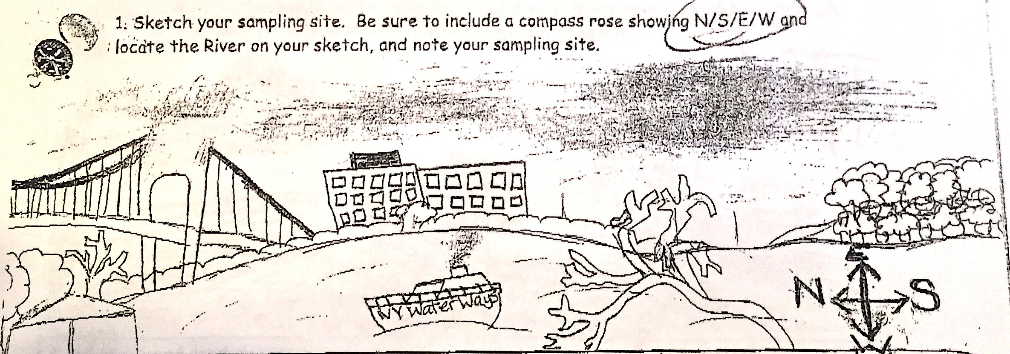

**Location:** Seabee Fishing Beach, Fort Wadsworth, just south of the Verrazano Bridge, Staten Island  
**Sampling Site:** Beach area with bulkhead, Shoreline is 90 % beach, 10% forested,  
**Surrounding Area:** 100% fishing beach – beach and riprap, concrete broken in area

**Water Depth:**

**River Bottom:**

**Plants in area:** No plants

|  |  |  |  |  |  |  |
| --- | --- | --- | --- | --- | --- | --- |
| ***ITEM*** | ***Time*** | | ***Readings*** |  | |  |
| ***Physical*** |  | |  |  | |  |
| Air Temperature | 10:05 AM | | 12.2°C | 54°F | | SAME all day! |
| Wind Speed | Before 11:30 AM | | 1.5 kts | After 11:30 no wind | | North |
| Cloud Cover | Overcast | |  |  | |  |
| Weather today | 10:30 AM Rainy and cold - | | Slow and constant drizzle | ***Water surface*** | | Very choppy |
| Weather recently | Rain started last night, cool last few days | | | | | |
| ***Water Temperature*** | Not recorded |  | |  |  | |
| ***Turbidity***  ***Turbidity tube*** | 10:17 AM | 70 cm  65.1 cm | | 67.55 cm avg |  | |
|  | 11:30 AM | 107 cm  68  90 | | 88 cm |  | |
| ***Chemical*** | **Time** | **ppm** | | **Temp** | **% Sat** | |
| DO – multiple readings – tablets -  Estuary Wide Monitoring Kit – | 10:10 AM  to noon | 2 ppm | | 10° C | 20% | |
| pH  Indicator Solution | 10AM-noon | 7 | | All groups |  | |
| Salinity - hydrometer | 10:00 AM to noon | 25 ppt | |  |  | |
| ***Fish Catch – seine 30ft. net –*** | ***Time*** | ***Species*** | | ***Number*** |  | |
| ***No fish caught!*** | 10:00-11:30 AM | Mole Crabs on the shoreline | |  |  | |
| ***Tides (from pier to water)*** | ***Time*** | ***Distance to water*** | | ***Rate of change*** | ***Flood or Ebb*** | |
| Unable to complete with the rain | |  | |  |  | |
| ***Currents - Time*** | ***Cm/30sec*** | ***Cm/sec*** | | ***Knots*** | ***N/S Ebb/Flood*** | |
| Unable to complete with the rain | |  | |  |  | |
| ***Core Sample*** | ***Length*** | ***Abundant*** | | ***Common*** |  | |
| ***Shipping – Time*** | ***Type*** | ***Name*** | | ***Color*** | ***Direction/ light or loaded*** | |
| 9:57 AM | NY waterway |  | | W/Blue | N light | |
| 10:13 AM | Cargo | Maersh | | Blue/red | N loaded | |
| 10:18AM | Sailboat |  | | W | N light | |
| 10:38 AM | Speedboat |  | | W | S light | |
| 10:59 AM | Speedboat |  | | Blue | S lgith | |
| 10:38 AM | Cargo |  | | R/B | N loaded | |
| 10:20 AM |  | Seastreak | | W | N/S light | |