A Day in the Life of the Hudson River 10/24/14 Data
(Salt Front RM 65.3)
RIVER MILE 102
Saugerties Light House, Town of Saugerties, Ulster Co.
Marie Daniels, Woodstock Day School
Grades 3rd & 7th, 25 students and 6 adults
Student Sketch of the Sampling Site along the pier
Location: Saugerties Light house @ northern bank of peninsula – pier with grassy area
Area: Pier of sorts, boating, fishing, swimming beach, picnics, hiking, walking
Surrounding Land Use: Beach 100%
Sampling Site: beach, bulkhead altered banks years ago, covered with vegetation, collected wood/debris in area, shoreline riprap at lighthouse, shoreline is sandy, muddy, rocky
River Bottom: muddy, weedy, sandy
Plants in area: 50% weeds, 30% trees, 10% leaves, 10% fålowers
Sampling Times – 10 AM to 1PM
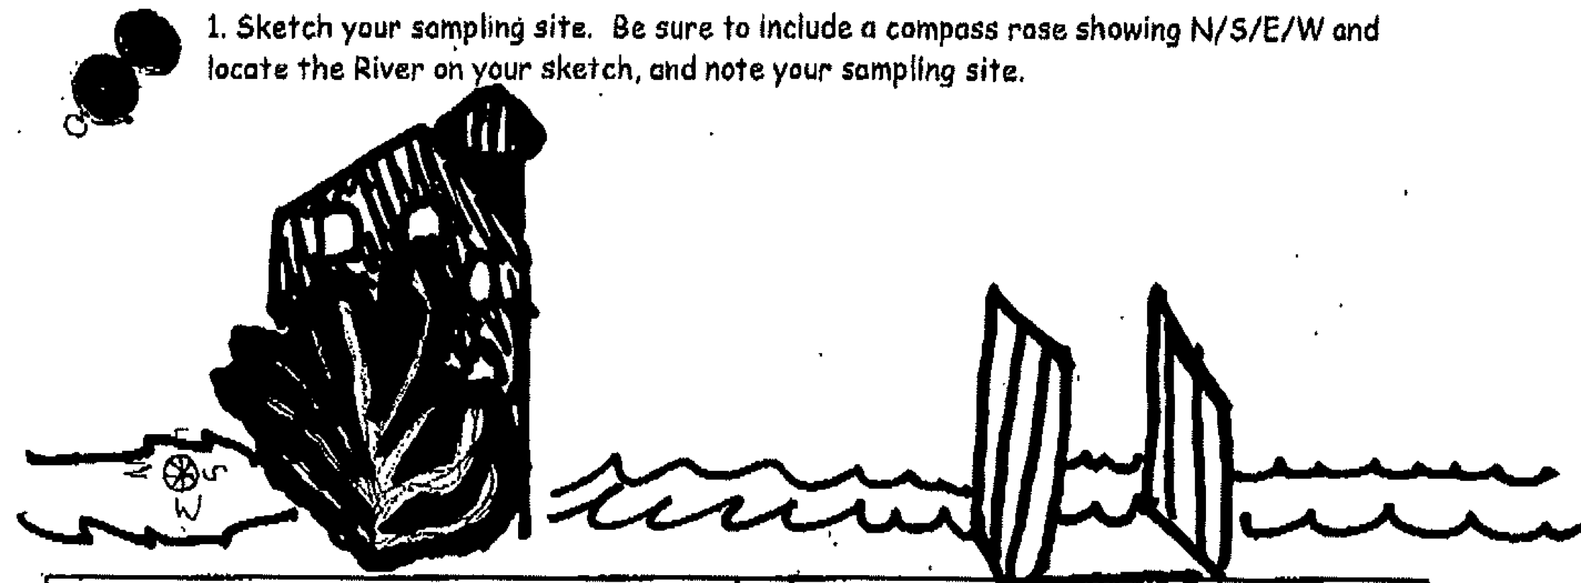
Student sketch of the lighthouse and sampling site

ITEM | Time |  | Reading 1 | Reading 2 | Comments
Physical
Air Temperature | 11:08AM  11:44 AM |  | 15°C  13°C
Wind Speed | 11:03 AM |  | Beaufort #5.5 |  | North
Cloud Cover | 11:04 AM |  | overcast | >75% cloud
Weather today | Sporadic rain
Weather recently | Rain yesterday
Water Temperature | N/R
Water Calm or Choppy | Somewhat choppy
Turbidity  secchi | 92 cm  66 cm |  |  | Average – 79 cm
Chemical
DO  (ampules) | 10AM-1PM | 8 to 10 mg/L
pH – color match kit | 10:36 AM | 7.5
Salinity Quantabs |  | 38 ppm Cl- |  | 68.6 TS
Tides | Time | Height |  | Falling/Rising
 | 11:30 AM | 80 cm |  | Rising | LT for area ~10:54
Currents | Time | Cm/30 secs |  | Cm/sec | N/S - E/F/S
 |  | 558 cm/30 sec |  | 18.6 cm/sec | Flood
 |  | 591 cm/35 sec |  | 16.9 cm/sec | Flood
Shipping | 10:15 AM | Bouchard |  | Northbound | Loaded

