Day in the Life of the Hudson River 10/21/14 Data
(Salt Front RM 64.3)
RIVER MILE 115
Cohotate Preserve, Athens, Greene Co.
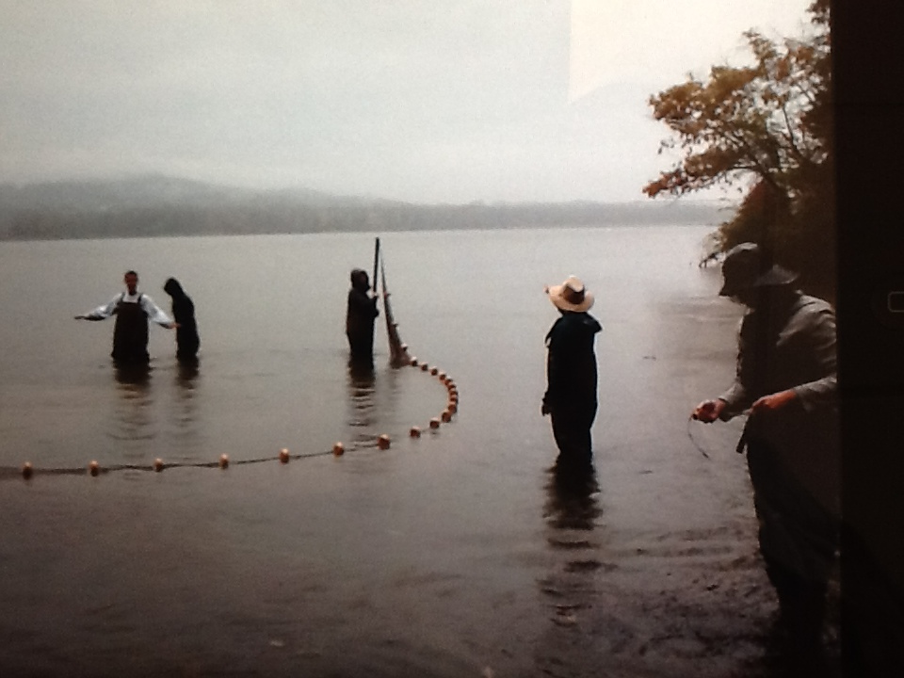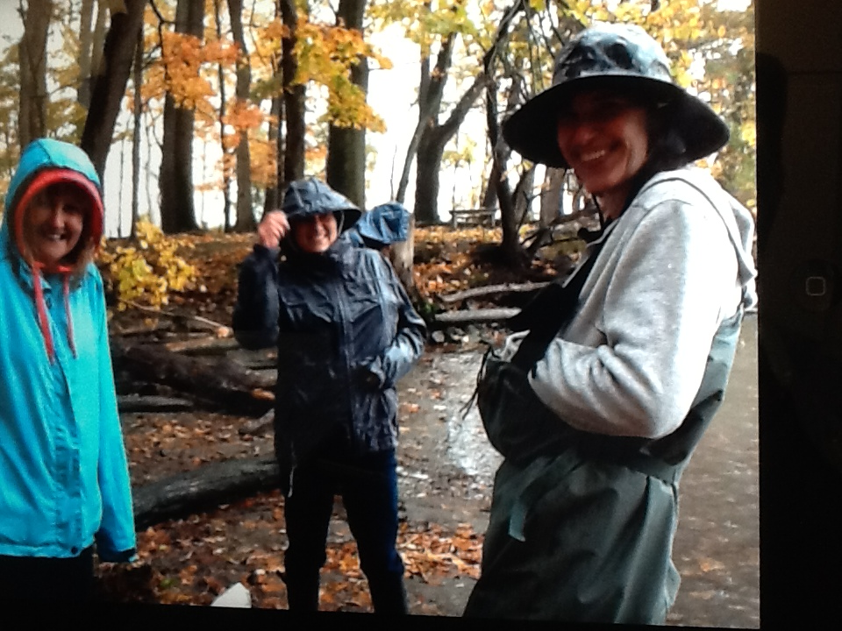
Liz LoGuidice, Cornell Cooperative Extension of Greene County
Tony Loughran, Coxsackie Athens High School, Env. Sci. - 19 students, 11-12th
Sue Boyle, Cairo Durham HS AP Bio – 19 students, 9th
(adults – 2 teachers, 4 chaperones, 2 instructors)
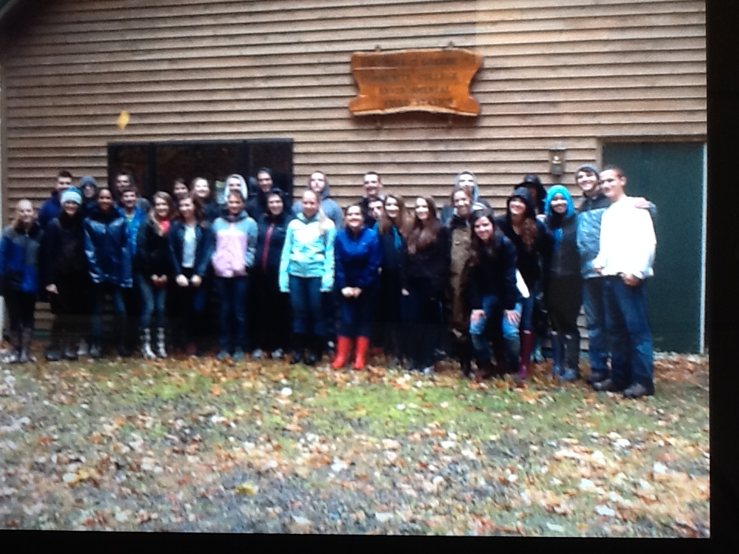
Location: Cohotate preserve – Ice house site –
Area: The ice house is a flat, grassy are on the river with several cotton wood trees. It is situated at the bottom of a forested hill. Large waterfront vegetated. The artificial shoreline of the bulkhead dominates the eastern shore. Shoreline is characterized by tidal mudflats. Area is used recreationally for picnicking, hiking and fishing. Ice house is approximately ½ miles walk from the parking area.
Surrounding Land Use: Forested 70%, Beach 5%; Urban/residential 15%; Industrial Commercial 5%; wetland 5%
Sampling Site: Beach area, Shoreline includes tidal mud flats in the southeast, with a rocky shore further south. To the north of the tidal mud flat there is an old bulkhead, with another tidal flat to the north of the bulkhead, rip rap in sections.
The banks have been altered at the bulkhead (entire ice house area is likely dredge spoil), wood and debris are collected in the southern mudflat, there is lots of vegetation and no pipes entering the water. Brick pieces on shoreline
Water Depth:
River Bottom: Muddy, rocky, weedy
Plants in area:
ITEM | Time |  | Reading 1 | Reading 2 | Comments
Physical
Air Temperature | 11:00 AM |  | 14°C  58°F
Wind Speed
Cloud Cover | CLOUDY
Weather today | RAIN most of the sampling time
Weather recently | Wet
Water Temperature | 11:00 AM | 14°C  58°F
Chemical
DO  Pasco Probe | 11:00 AM | 10.6 ppm |  | 14.16 °C
pH – Pasco Probe | 11:00 AM | 6.7 |  | Taken in shallow water in the pouring rain - acidic
Conductivity – Pasco probe | 11:00 AM | 26 μs/cm
Fish Catch  40 ft. X 30 ft. | Total # | Species – |  | Size | Totals
FISH – 12:30 PM |  | Banded killifish
Diversity 6 |  | Tessellated Darter
 |  | White Perch
Lots of fish in the net but rain made it hard to get a count |  | Herring
 |  | Pumpkinseed
 |  | White sucker
Tide | Afternoon | Flooding
Other Items:

