Day in the Life of the Hudson River 10/16/14 Data
(Salt Front RM 65.9)
RIVER MILE 152.2
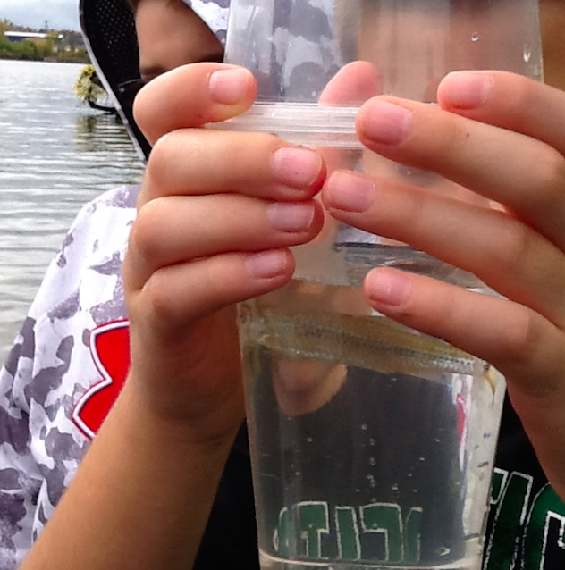
Hudson Shores Park, Watervleit, NY
Amy Parks/Stacey Shepard, North Colonie CSD
30 students, 5th grade students and 6 adults
Latitude 73* 41’ 55” W Longitude 42* 43’ 41” N
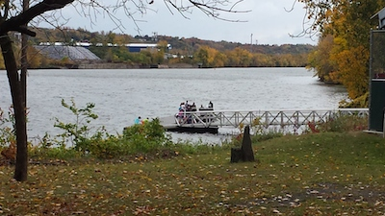

Location: Hudson Shores Park, Watervleit, Albany County, NY
Area: Rowing dock at park right on the river’s edge
Surrounding Land Use: Fishing launch, Rocky with weedy vegetation and a few small shrubs (gravelly)
Sampling Site: 10% beach at low tide, 70% park/parking area, 20% planted/forested, - across the river land use100% Industrial/Commercial
Shoreline: beach area, pier, shore with bulkhead, area covered with vegetation
Plants in area: none in the water
Water depth:
River Bottom: mixture of sand/mud, small rocks

ITEM | Time |  | Reading 1 | Reading 2 | Comments
Physical - Air Temperature | Time |  | °F | °C | Average
 | 9:50 am |  | 72* | 22* | 72* F/22*C
 | 10:46 am |  | 74* | 24*
 | 12:09 pm |  | 71* | 21*
 | 12:55 pm |  | 72* | 22*
Wind Speed: | Time |  | Beaufort | Anemometer | Direction
 | 10:10 am |  | 3 | 4.6 m/s | N
 | 10:48 am |  | 3/4 | 5.6 m/s | N
 | 12:14 pm |  | 3 | 4.5 m/s | N f
Cloud Cover | Clear (<25%) |  | Partly Cloudy (26-50%) | Mostly Cloudy (51-75%) | Overcast (>75%)
10:12 am |  |  |  |  | ✓
10:53 am |  |  |  |  | ✓
12:14 pm |  |  |  |  | ✓
12:45 pm |  |  |  |  | ✓
Precipitation | Time |  | Rain | Describe
 | 10:12 am |  | N
 | 10:54 am |  | N
 | 12:00 pm |  | Y | Heavy mist
 | 12:47 pm |  | N
Weather last 3 days | Today is Thursday. Monday – Wednesday were nice days. Tuesday & Wednesday had humid weather. Heavy rains Wednesday night into Thursday morning.
Water Temperature | Time |  | ºC | ºF | Average
 | 9:55 am |  | 19.46* | 67* | 18.76C /65.75F
 | 10:31 am |  | 18.9* | 66*
 | 11:52 am |  | 17.79* | 64*
 | 12:25 pm |  | 18.9* | 66*
Turbidity – long site tube | Reading 1 |  | Reading 2 | Reading 3 | Average
9:55 am | 73 cm |  | 82 cm | 95 cm | 83 cm
10:50 am | 74 cm |  | 81 cm | 89 cm | 81 cm
12:04 pm | 45 cm |  | 47 cm | 49 cm | 47 cm
12:23 pm | 57 cm |  | 70 cm | 64 cm | 64 cm
Chemical | Time |  | mg/L | Water Temp | % Saturation
DO (Hach Drop count) | 10:19 am |  | 10 mg/L | 20* | 108%
 | 10:55 am |  | 9 mg/L | 20* | 99%
 | 12:15 pm |  | 7 mg/L | 20* | 80%
 | 12:55 pm |  | 9 mg/L | 20* | 97%
pH – color match test kit | 10:02 am |  | 7.5
 | 10:37 am |  | 7.5
 | 11:55 am |  | 7.5
 |  |  | 7.5
Salinity - quantab
Fish Catch - | Time |  | ID | Number | Longest
Set 2 minnow traps & seined | Nothing in traps
Seined | 10:00 AM |  | Spot-Tail Shiner | 9 | 8 cm
Seined | 11:00 AM |  | Spot-Tail Shiner | 1 | 6cm
TOTALS |  |  | Diversity 1 | Totals 10
Tides -  *calculate by: change in elevation/change in time | Time |  | Water height |  | *Rate of change
 | 8:35 AM |  | 204.47 cm | Base reading
 | 9:42 AM |  | 254 cm | Rising
 | 10:37 am |  | 271.78 cm | Rising
**HT in Albany 11:58 AM | 11:53 am |  | 287.02 cm | Rising**
 | 12:46 pm |  | 259.08 cm | Falling
Currents - | Feet | cm | cm/30 sec | Cm/sec | N/S*
10:00 am | 6’2” | 190 | 190cm/30 sec | 6.3cm/sec | S
10:43 am | 9’9” | 297 | 297cm/30 sec | 9.9 cm/sec | S
12:03 am | 11’ 6” | 351 | 351cm/30 sec | 11.7 cm/sec | S
*Samplers expected a North flowing current because of the flood tide but it seems the recent run off from the rains overwhelmed the tidal current and caused the orange to flow south.

