Day in the Life of the Hudson River 10/23/14 Data
(Salt Front RM 61.1)
RIVER MILE 153
River Park, Green Island Park, Green Island NY
Kate Perry & Lynn Schuster, Robert C. Parker School
50 students - 2nd & 3rd and 6th and 7th grade students, 10 adults
42.74 N -73.69 W
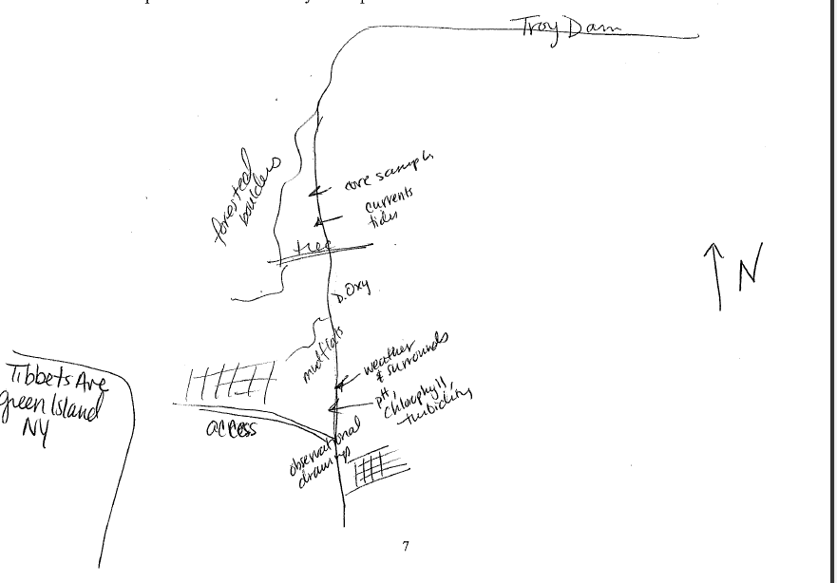
Sampling Site
Location: Green Island Park boat ramp, below the Troy Dam, Albany County, NY
Area: park above bluff and then beach below just south of the Troy dam
Surrounding Land Use: Forested, Rocky, Fishing access, gravel, some vegetation
Sampling Site: 100% industrial/commercial
Shoreline: Rocky, broken concrete docking, very rocky shoreline, slag, concrete at the launch, brick pieces, vegetation, pipe directly across sampling site
Plants in water: very few plants in the water – 1%
Plants in area: goldenrod, grasses, Joe Pyeweed
Water depth: 0-10 cm along shore
River Bottom: muddy, rocky
ITEM | Time |  |  | Reading 1 | Reading 2 | Comments
Physical
Air Temperature | 10:28 AM |  |  | 48 °F  8°C
Wind Speed | #3 Beaufort |  |  | 9 mph | North
Cloud Cover | Overcast
Weather today | Drizzling steadily ~ 4mm collected
Weather recently | Lots of rain last few days
Water surface | choppy
Water Temperature | 10:10 AM |  | 11°C |  | 52°F
Turbidity –long site tube | 10:15 AM |  | 9.4 cm  5.2 cm  2.0 cm |  | 5.5 cm average
 | PM |  | 51.1 cm  53.46  78.0 |  | 60.85 cm average
Chlorophyll | 10:20 AM |  | 0.0  1.0
Chemical | 10:00 AM |  | 1.0
DO  (Drop count kit | 10:24 AM |  | 11°C |  | 22 ppm* off scale – air bubble or not swirled | Off the chart
pH - pen | 10:10 AM |  | 5.0  6.0  7.0 |  |  | Average 6.0
Salinity – meter | 10:15 AM |  | 130 ppm
Fish Catch – dip net | Time |  | Number Caught |  | Species | Size Largest
 | 10:00 AM |  |  |  | Shells of mussel
 |  |  | 14 (in 15 minutes) |  | Freshwater snails
 |  |  |  |  | worms
 |  |  | Diversity |  | 3 species
 | TOTAL CATCH |  | 25 |  | TOTAL SPECIES | 4
 | Macro- invertebrates |  | Blue Crab Pieces |  | Aquatic Snails
Tides | Time |  | Height in cm |  | Rising/Falling | Rate of change
 | 10:28 AM
 | 10:37 AM |  |  |  | Falling | 0.25 cm/min
 | 10:51 AM |  |  |  | Falling | 0.21 cm/min
Currents ** | Time | Cm/30 secs | Cm/sec |  | Knots | N/S Ebb/Fld/Still
 | 10:00AM | 240 cm | 8cm/sec |  |  | S- Ebb –
 | 10:10AM | 120 | 4cm/sec |  |  | S Ebb
Nothing – the tide is low – normal obstructions are clear
Traffic | None observed
Other Items | Gulls, crows, and sandpipers
Almanac | We postponed from a potential thunderstorm to a day of drizzle. Our students felt they earned the badge of effort as they collected data in the chilly rain. Happy cheers arose upon finding snails, watching sandpipers and collecting good “currents” data. Our highlight was a successful core sample. An amazing, good, day.

