Day in the Life of the Hudson River 10/16/14 Data
(Above the Troy Dam and the Head of Tide)
RIVER MILE 154
Peebles Island State Park, Waterford, NY
Becky Zimmerman, Zipporah Galimore and Angela Jones
Pine Hills Elementary School
53 students – 4th grade, 19 adults total
42°47.051’N and 73°40.706 W
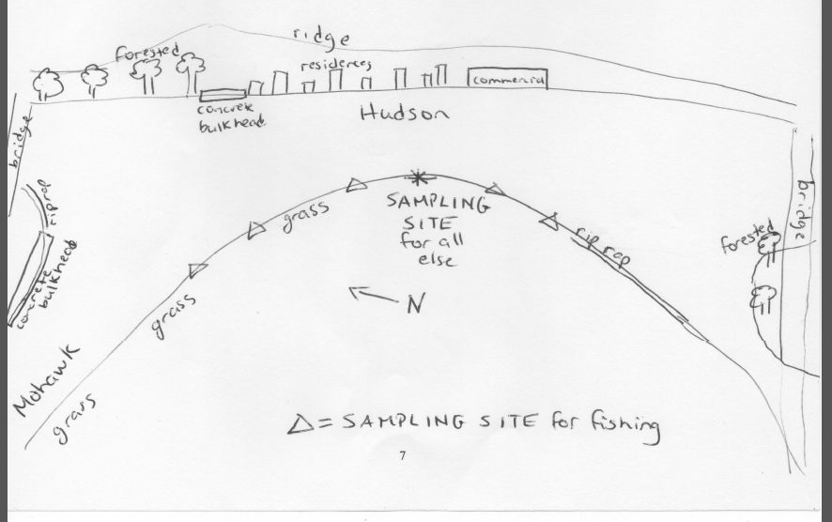
Peebles Sampling Area
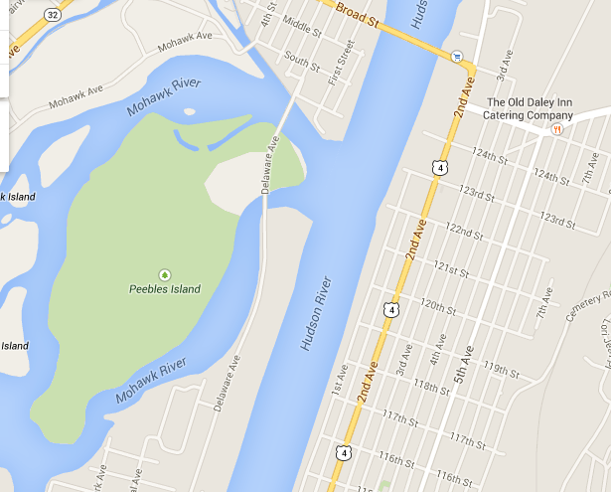
Location: Pebbles Island Park at the confluence of the Hudson River and the Mohawk River, Waterford, NY
Area: park just north of the Troy dam at the pavilion, grassy embankment
Surrounding Land Use: 75% grassy, 25% riprap
Sampling Site: Park area
Shoreline: riprap
Plants in area: none
Water depth: 12 inches
River Bottom description: muddy

 | Time |  | Reading 1 | Reading 2 | Comments
Physical
Air Temperature | 9:54 AM  12:55 PM |  | 72°F  72°F | 23°C  23°C
Wind Speed | 9:54 AM  10:39 AM  12:02 PM  12:55 PM |  | 3.5 kts  5.8 kts  18.3 kts  18.3 kts | 1  2  5  5 | Direction: South
Cloud Cover | Mostly cloudy
Weather today | Overcast, barest sprinkles for about 10 minutes
Weather recently | Heavy rain previous evening and heavy rain further up the Mohawk river earlier today.
Water surface | Calm early  Choppy later
Water Temperature | 9:43 AM  10:30 AM  11:55 AM  12:42 AM | 18°C  16  20  19 |  | 65°F  60  68  67 | *C based on reported F temperatures as they had disagreed
Turbidity –  long site tube  averages | 9:30 AM  10:20 AM  12:00 PM  12:30 PM | 31.7 cm  21.7 cm  61.9 cm  38.6 cm |  | 7 readings  3 readings  2 readings  4 readings
Chemical | Time | Water Temp |  | ppm | saturation
DO - drop count | 9:43 AM -  12:42 | 21.5°C |  | 5.5 ppm | 60%
pH – indicator solution | 12:42 PM |  |  | 7.5ppm  7.5  8  8 | Average 7.8
Water Level | 9:54 AM  10:39 AM  12:02 PM  12:55 PM  1:45 PM | 33.02 cm  34.29  33.02  36.83  45.72 |  | This is above the head of tide. Water level changes have to do with releases that occur from hydro plant that empties into the river below Cohoes Falls.
Velocity | 9:54 AM  10:39 AM  12:02 PM  12:55 PM | 7.8 cm/sec  still  2.4 cm/sec  still |  | Southerly winds
Fish Catch – 10 ft. net | Number | Species |  | Size largest | Diversity
10 m pull/ ½ cm mesh- | 146 | Banded killifish |  | 113 mm | Diversity 5  Totals 161
9 seines – | 11 | Spottail shiner |  | 85 mm
9:58 AM – 12:56 PM | 1 | Largemouth bass |  | 142 mm
 | 2 | Herring |  | 75 mm
 | 1 | Shiner |  | 122 mm
Boat Traffic | 10:15 AM | Small fishing boat |  | North | recreational
 | 1:10 PM | Medium fishing boat |  | South | Commercial
Other | 1 bald eagle | Seagulls |  | Canadian geese | crows
 | 1 decomposing bird on embankment

