**Day in the Life of the Hudson River 10/29/14 Data   
(Salt Front ~RM61.1 - on 10/28/14 at this location but not reported for 10/29-10/31 on 11/1/14 it was at 59.6)**

**RIVER MILE 18.5W**

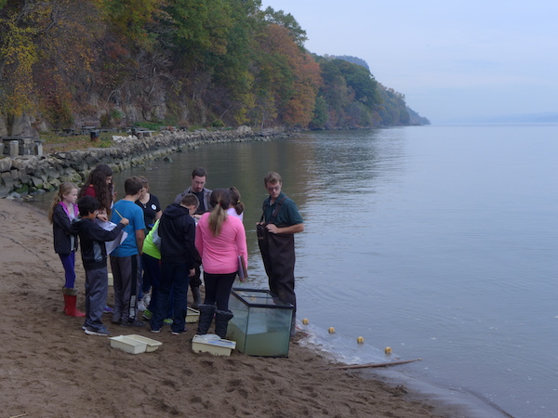

**Alpine Boat Basin**

**Colin Keegan, Alpine Park, Palisades Interstate Park**

**Lisa, Wolfelsperger, , Alpine Elementary School**

**Alpine NJ – 6th grade – 18 students, 2 teachers, 2 PIP educators (5 adults total)**

**N 40.7031**°**– W -74.0267**°

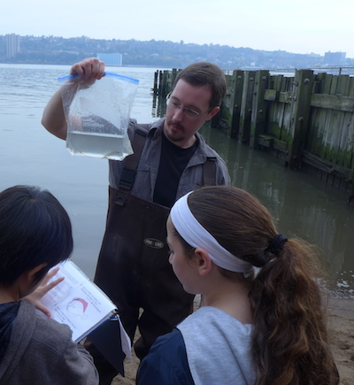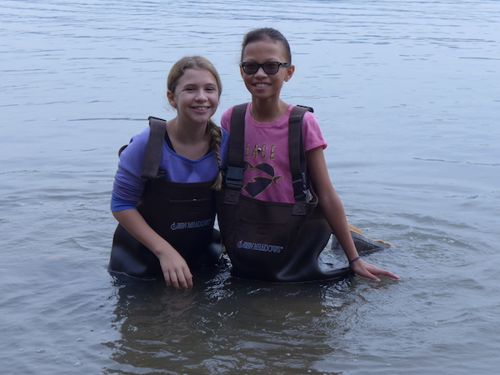

**Location:** North end of the Alpine Boat Basin, adjacent to a sandy beach area

**Area:** Pier, Forested, parking lot, used for picnics, boats, fishing and education programs

**Surrounding Land Use:** 63%Forested (at the foot of the Palisades, 6% Man made Sandy Beach , 6% Industrial/Commercial; 25%, recreationally developed pier

**Sampling Site:** sandybeach, banks altered, rip rap, bulkhead, pier, concrete

**Plants in area:** found few water chestnut seeds floating in the area but not growing

**River Bottom** – shallow depth - sandy, rocky

|  |  |  |  |  |  |
| --- | --- | --- | --- | --- | --- |
| ***ITEM*** | ***Time*** | | ***Reading 1*** | ***Reading 2*** | ***Comments*** |
| ***Physical*** |  | |  |  |  |
| Air Temperature | 11:24 AM | | 55 °F  19°C |  |  |
| Wind Speed |  | |  |  |  |
| Cloud Cover | Overcast | |  |  |  |
| Weather today | No rain | | | | |
| Weather recently | Rain | | | | |
| ***Water*** |  | | | | |
| ***Water Temperature***  11:20 AM | 27°C*  80.6 °F*  Reported | HRECOS notes it was closer to 59°F or 15°C | |  |  |
| ***Turbidity*** | Not read |  | |  |  |
| ***Chemical*** | **Not read onsite** | **HRECOS** | |  |  |
| DO -  Drop count kits | See HRECOS below | 8.2 ppm | |  |  |
| pH – test strips | See below | ~7.4 | |  |  |
| Salinity - | See Below | ~ 7 ppt | |  |  |
| ***Fish Catch -*** 8X4 ft. seine net | ***Number Caught*** | ***Species*** | | ***Size*** | ***Seine*** |
| 9:30-noon | 10 | Atlantic Silverside | | 5-8 inch |  |
|  | 2 | White Perch | | 7.5 inch |  |
|  | 3 | Striped Bass | | 4 inch |  |
|  | 3 | Bay Anchovy | | 3 inch |  |
|  | 1 | Northern Pipefish | | 8 inch |  |
| **TOTAL CATCH** | **19** | **TOTAL DIVERSITY** | | **5** |  |
| ***Tides*** | HT 11:10 AM | Stick floated away @ HT | |  |  |
| ***Currents-*** | **Time** | **Cm/30 secs** | | **Cm/Sec** |  |
| ***A pier juts out and we are not in the main stem of the Hudson River*** | 11:10 AM  11:14 AM  11:16 AM  11:20 AM | 13.57  30  266  266 | | 0.2655  51.4  0.468  0.468 | Flood/South  Flood/South  Still  Still |

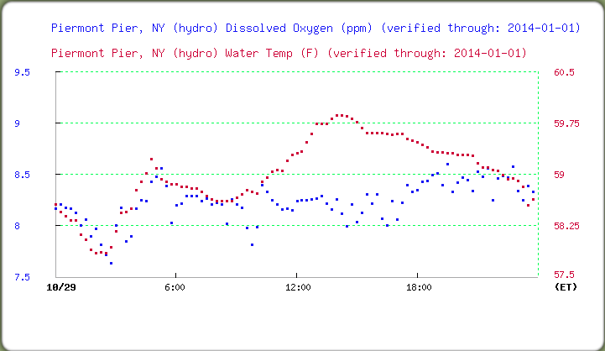

***D.O. and Water Temperature for closest HRECOS station at RM 25***

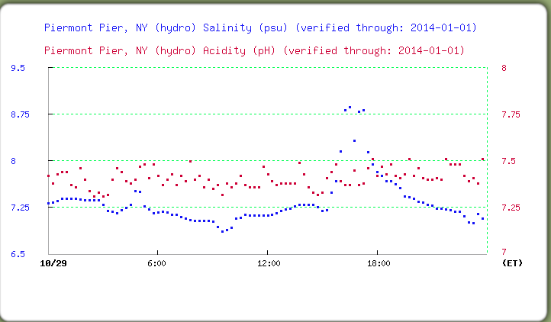

***Salinity and pH from Piermont – closest HRECOS station at RM 25***