**Day in the Life of the Hudson River 10/16/14 Data**

**(Salt Front RM 65.9)**

**RIVER MILE 18**

**Vicki Garufi - Sarah Lawrence College Center for the Urban River @ Beczak**

**Kathleen Ruen, Sarah Lawrence College and 12 Graduate Students in the Art of Teaching**

**Latitude – N 40.93813129121615 Latitude – W -73.90288889408111**

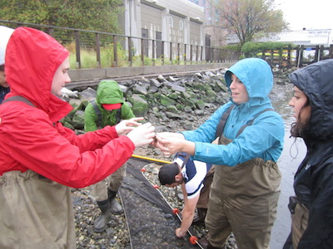 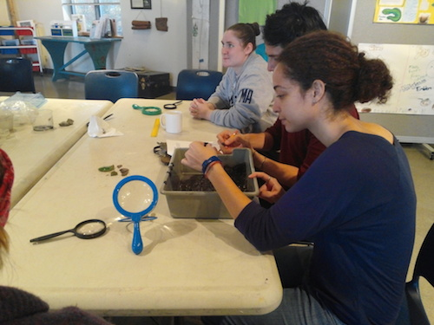

**Location:** Habirshaw County Park, Seining beach, SLCC@ Beczak, Yonkers, Westchester County

**Area:** 2 acreriverfront county park covered mostly by a grass lawn leading down to the river where it meets a tidal wetland and sandy beach. Propertyused for fishing, boats, seining, field trips and education programs – Park and some urban - 60% grassy, 20% parking lot, 20% waterfront/beach

**Surrounding Land Use:** Beach – 2 acre park

**Sampling Site shoreline:** sandy beach, tidal marsh area covered with vegetation, banks altered, large riprap on shoreline, collected wood/debris in area,

**Plants in area:** no plants in the shoreline waterfront however in the marsh area there is:

mud wort, saltwater cordgrass, phragmites, water celery

**Water depth –**

**River Bottom** – muddy, rocky

|  |  |  |  |  |  |
| --- | --- | --- | --- | --- | --- |
| ***ITEM*** | ***Time*** | | ***Reading 1*** | ***Reading 2*** | ***Comments*** |
| ***Physical*** |  | |  |  |  |
| Air Temperature | 11:00 AM – | | 21°C  70°F |  |  |
|  | 1:15 PM – | | 20.6°C  69°F |  |  |
| Wind Speed |  | |  |  |  |
| Weather today | Overcast, mostly cloudy and light rain | | | | |
| Weather recently | Humid = tropical storm | | | | |
| Water calm | choppy | | | | |
| ***Water Temperature –*** | 12:05 PM | 19°C  66°F | |  |  |
| ***Turbidity – sight tube –*** | 12:10 PM | 24 cm | |  |  |
| ***Chlorophyll*** | 11:50 AM | 4.0 | |  |  |
| ***Chemical –*** | **Time** | **Temp** | | **DO** | **Saturated** |
| DO – ampules | 12:15 PM | 19°C | | 4 mg/L | 40% |
| pH – indicator solution | 11:00 AM | 7.5 | |  |  |
| Salinity – hydrometer | 10:30 AM – | 12 ppt | |  |  |
| ***Fish Catch -***  Seine net 30 feet X 4 ft., 1.4 inch mesh- | ***Number Caught –***  ***10-11AM*** | ***Species*** | | ***Size of largest*** | ***Notes*** |
| **FISH** | 2 | American Eel | |  | **3 FISH DIVERSITY** |
|  | 5 | Bay Anchovy | |  |  |
|  | 1 | Herring | |  | **8 TOTAL FISH** |
| **OTHER** | 5 | Blue Crab | |  | **5 OTHER DIVERSITY** |
|  | 3 | Moon Jellies | |  |  |
|  | 1 | Comb Jellies | |  |  |
|  | 24 | Shore shrimp | |  | **35 TOTAL OTHER** |
|  | 2 | Soft shell Clam | |  |  |
| ***Tides*** | 10:00 AM |  | |  |  |
| *dead low 10:22 AM, Alpine NJ | 10:20 AM |  | | Rising* |  |
| 10:50 AM |  | | rising |  |
| 11:00 AM |  | | rising |  |
| 12:00 PM |  | | rising |  |
| ***Currents*** |  |  | |  |  |
| ***Core Sample*** | ***Entire Length*** | ***Grain Size*** | | ***Abiotic*** | ***Biotic*** |
| 2 layers - Dark black mud and sandy light mud | 5 inches  Smells sulfur like | Mix of grain sizes | | Stick  Rock/stone  paper | Crab  Worm |