**Day in the Life of the Hudson River 10/21/14 Data**

**(Salt Front RM 64.3)**

**RIVER MILE 23**

**Kinnally Cove & MacEachron Waterfront Park, Hastings-on-Hudson**

**Melissa Shandroff, Hastings High School APES 11th-12th grade, 70 students, 4 adults**

**Latitude 40°59’52”N, Longitude 73°53.03”W**

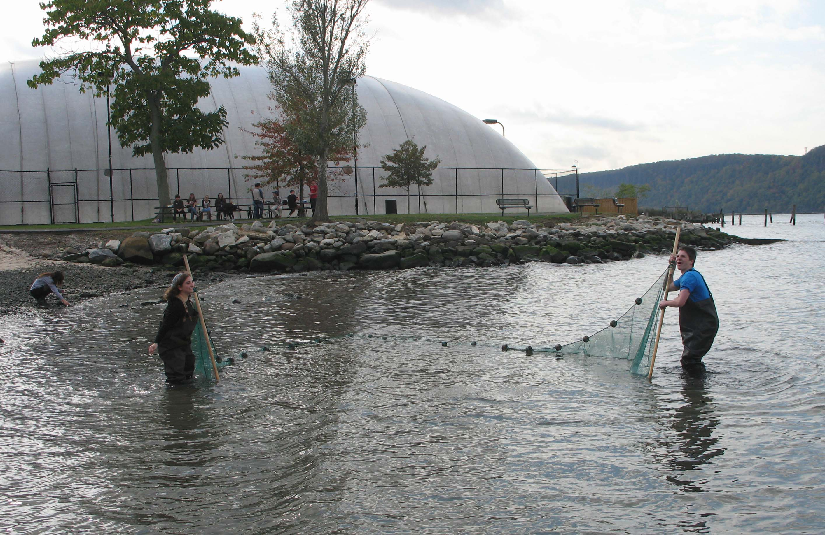

**Location:** Kinnally Cove, Hastings-on-Hudson, Westchester County

**Area:** Beach area with riprap shoreline, next to the park – used both spaces. Beach is totally covered during high tide.

**Surrounding Land Use:** 50% industrial/commercial (next to old Anaconda site) but mainly parking lot now, 15 % forested, 10% grassy, 25% beach

**Sampling Site:** beach, banks altered, riprap on shoreline, bulkhead

**Plants in area:** grass and weeds

**Water depth**:

**River Bottom** – sandy/rocky bottom

|  |  |  |  |  |  |
| --- | --- | --- | --- | --- | --- |
| ***ITEM*** | ***8:30 AM*** | | ***10:30 AM*** | ***12:30 PM*** | ***Comments*** |
| ***Physical*** |  | |  |  |  |
| Air Temperature  (From Piermont HRECOS) | 55 °F  13°C | | 58°F  14°C | 57.5°F  14°C |  |
| Wind Speed |  | |  |  |  |
| Cloud Cover | Overcast all day >75% | | | |  |
| Weather today | Overcast and cool – rain in the mid afternoon after sampling done | | | | |
| Weather recently | cooling over the last few days, rain on weekend but clear yesterday | | | | |
| ***Water Surface*** | calm | | | | |
| ***ITEM*** | ***8:30 AM*** | ***10:30 AM*** | | ***12:30 PM*** | ***Comments*** |
| ***Turbididty – long site tube*** | 43 cm | 33 cm | | 6.5 cm |  |
| ***Water temperature*** | 17 °C | Not collected | | 18°C |  |
| ***Chemistry*** |  |  | |  |  |
| *pH -* Pen | 7.6 | 7.9 | | **7.8** |  |
| *pH strips* | 6 | 7 | | **7** |  |
| *pH LaMotte kit* | 7 | 8 | | **7** |  |
| *DO – Hach kit* | 11 ppm | 10 ppm | | 9 ppm |  |
| *% saturation* | 110% |  | | 95% |  |
| *Salinity -hydrometer* | 12 ppt | 12 ppt | | 8 ppt |  |
| *Nitrate – LaMotte Kits* | 0 ppm | 5 ppm | | 0 ppm |  |
| *Phosphate – LaMotte kit* | 1 ppm | 2 ppm | | 1 ppm |  |
| ***Fish Catch***  Seine 30 ft. | 9Atlantic Silversides  4 Bay Anchovy  2 Blue Crab (F)  5 shrimp | 10 Atlantic Silversides  3 Shiners  1 Striped Bass  1 Blue Crab (F) | | 7 Atlantic Silverside  1 Striped Bass  2  Mummichogs | ***DAY TOTAL***  ***FISH Diversity 5***  ***TC – 37***  ***MACRO***  ***Diversity 2***  ***TC - 8*** |
| ***Fish Only*** | Diversity 2 | Diversity 3 | | Diversity 3 |  |
| ***Total Catch*** | T.C. 13 | T.C. 14 | | T.C. 10 |  |
| ***Macros*** | Diversity 2 | Diversity 1 | | Diversity 0 |  |
| ***Total Catch*** | T.C. 7 | T.C. 1 | | T.C. 0 |  |
| ***Sediment Cores*** | **Length/ description** | **Abundant** | | **Common** | **Rare** |
| ***Tide*** | 1:20 PM |  | | 90 cm |  |
|  | 1:35 PM | Falling | | 89 cm | 0/067 cm/min |
| ***Currents*** |  |  | |  |  |
| ***Time*** | ***Cm/60 secs*** | ***Cm/sec*** | | ***Knots*** | ***N/S Ebb/Flood Still*** |
| ***Shipping*** |  |  | |  |  |