**Snapshot Day 10/23/14 Data**

**(Salt Front RM 61.1)**

**RIVER MILE 25E**

**Matthiessen Park, Irvington**

**Joanna Morabito- Irvington High School AP Env. Sci.**

**20 students, 11/12th graders**

**\*Philip Levine- Irvington Middle School**

**180 students, 6th Grade**

**Latitude 41** ͦ **2’ 30” N Longitude 73** ͦ **52’ 32” W**

**\*Middle School Data Recorded and posted separately**

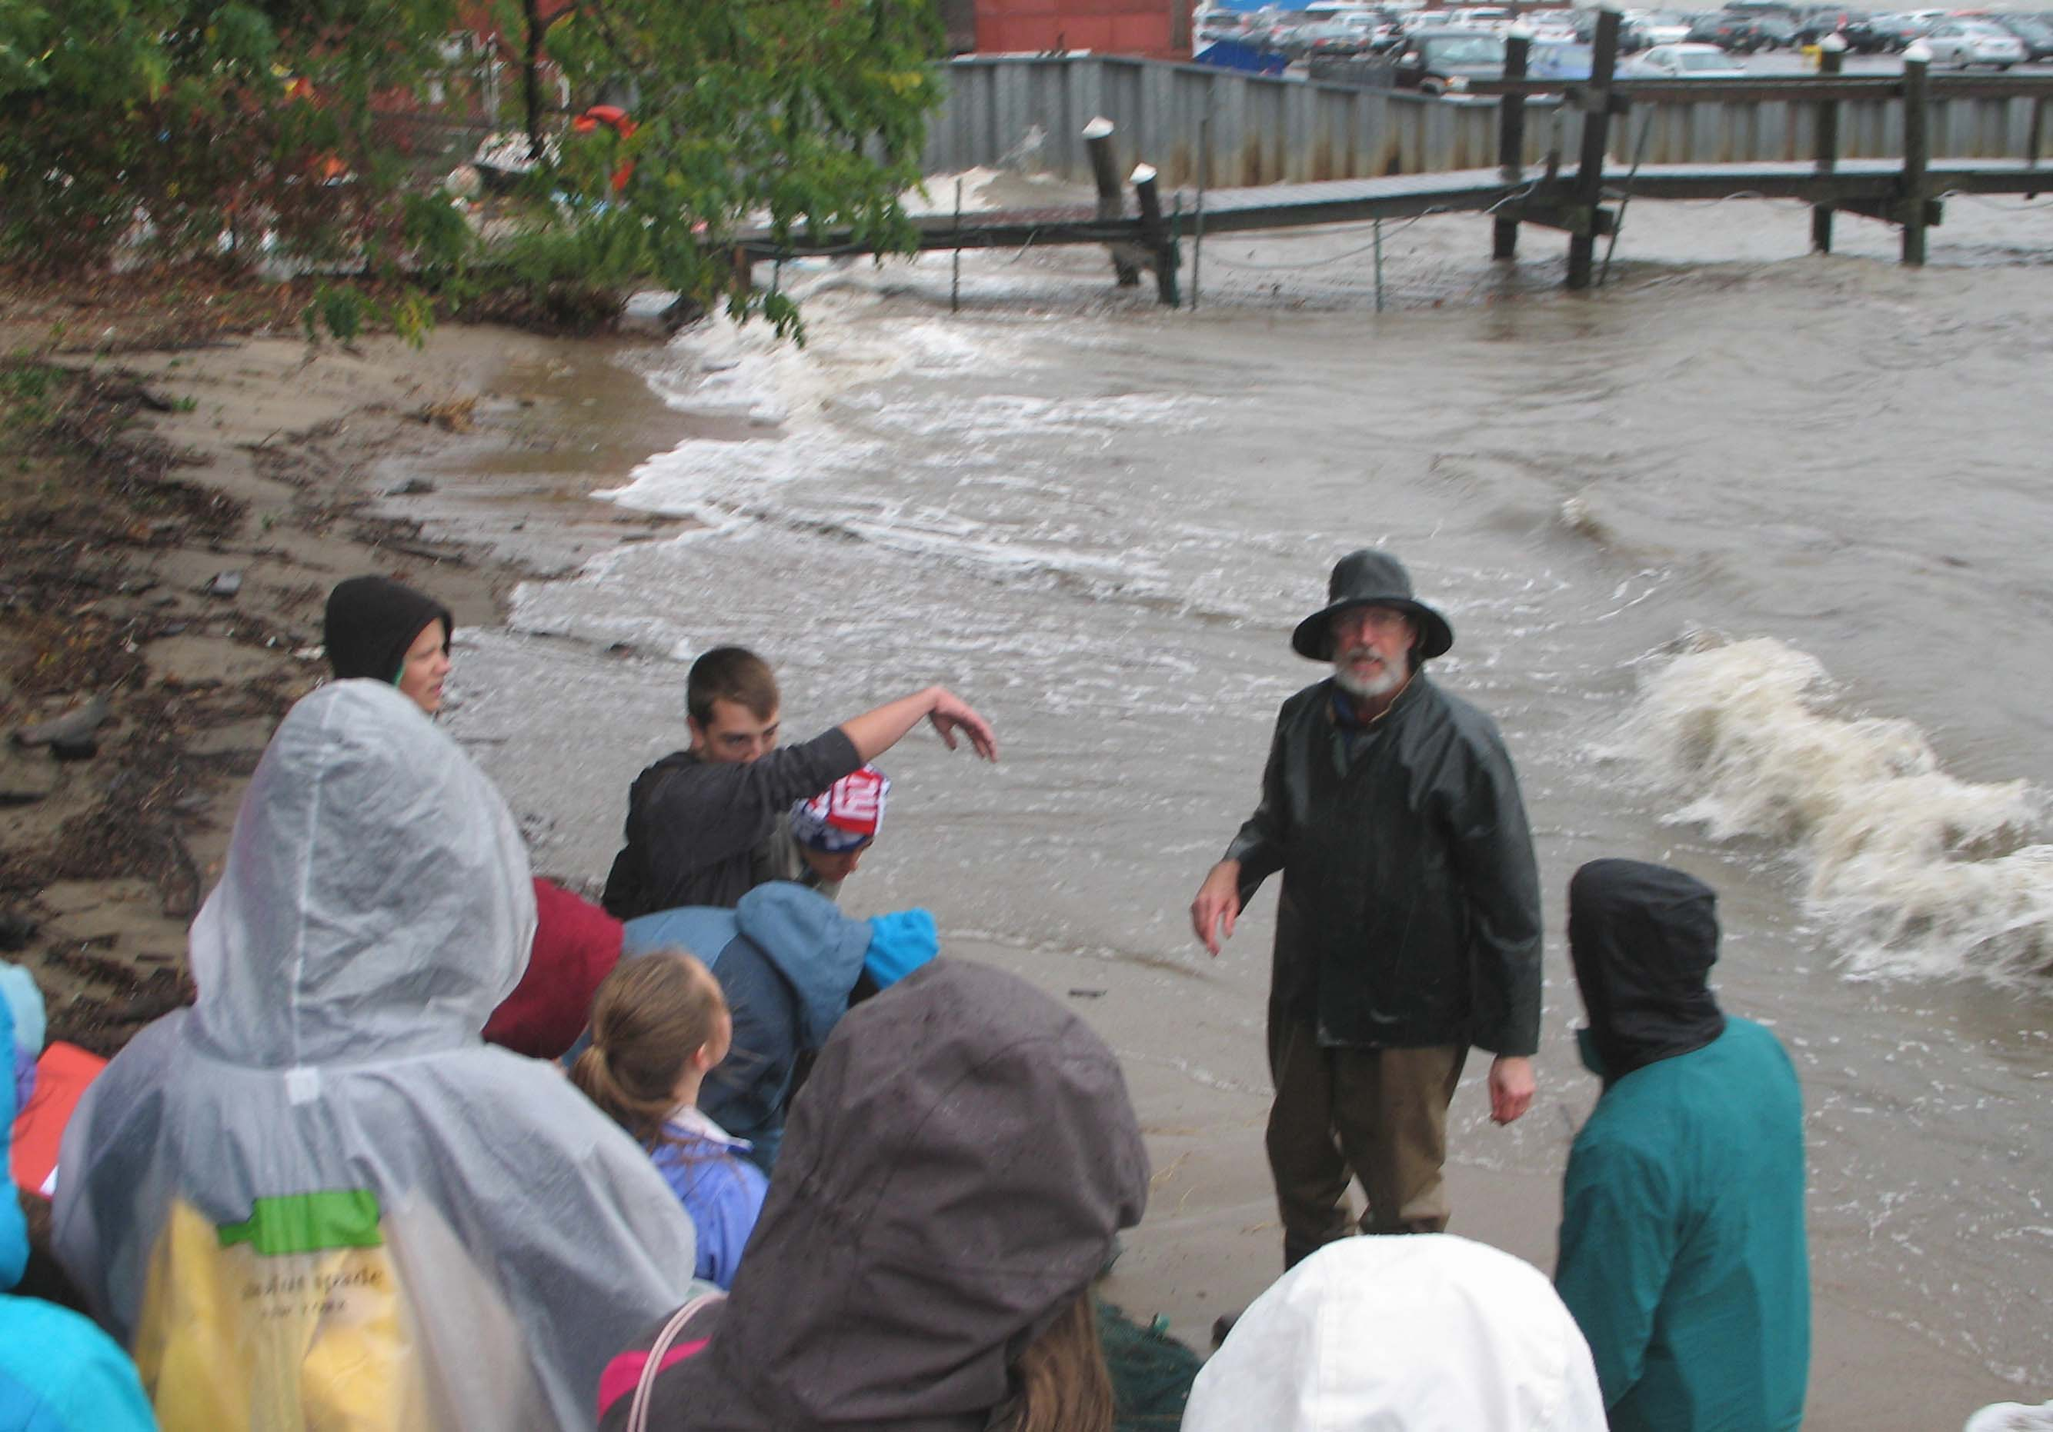

**Area:** 40% grass, 10% beach, 5 % forested, 45% river

**Surrounding Land Use:** train, boats, buildings, cars, park

**Sampling Site**: Matthiessen Park

**Water Depth**: varied; depth increased as the day progressed

**River Bottom**: Rocky close to the beach and muddy farther away

**Weather Conditions:** Raining! (see photo!)

|  |  |  |  |  |  |  |
| --- | --- | --- | --- | --- | --- | --- |
| ***ITEM*** | ***Reading 1*** | ***Reading 2*** | | ***Reading 3*** | | ***Reading 4*** |
| ***Physical*** | 9:42 am | 10:02 am | | 10:20 am | | 10:45 am |
| Air Temperature | MS students recorded | 7°C | |  | | 7°C |
| Cloud Cover | 100% | 100% | | 100% | | 100% |
| Weather today | Very rainy | | | | | |
| Weather recently | Rainy and cool | | | | | |
| ***Water Temperature –*** | 13°C  13°C  13°C  13°C  13°C  *average 13°C* | | 13°C  13°C  10°C  13°C  12°C  *average 12°C* | | 12°C  12°C  9°C  10°C  *average 10.75°C* | 12°C  12°C  10°C  10°C  *average 11°C* |
| ***Turbidity –water chemistry test kit*** | 27 cm  27 cm  27 cm | | 21 cm  21 cm  21 cm | | 8 cm  8 cm | 8 cm  8 cm |
| ***Chemical*** |  | |  | |  |  |
| ***DO***  (tablet kits) | 6 ppm  6 ppm  8 ppm  8 ppm  *average 7 ppm* | | 4 ppm  4 ppm  9 ppm  8 ppm  *average 6 ppm* | | 4 ppm  4 ppm  9 ppm  *average 5.67 ppm* | 6 ppm  6 ppm  9 ppm  *average 7 ppm* |
| pH | 7  7  7  7  *average 7* | | 7  7  7  7  *average 7* | | 8  8  7  *average 7.3* | 8  8  8  *average 8* |
| Salinity – Quantab recorded as # and ppm Cl- | 7 - 2273 ppm  7 – 2273 ppm  6 – 1499 ppm | | 8 - 3654  8 - 3654  6 - 1499 | | 8 - 3654  8 - 3654 | 8 - 3654  8 - 3654 |
| Recorded as Total Salinity | 4106 ppm TS  4106 ppm TS  2708 ppm TS | | 6601 ppm TS  6601 ppm TS  2708 ppm TS | | 6601 ppm TS  6601 ppm TS | 6601 ppm TS  6601 ppm TS |