Snapshot Day 10/23/14 Data
(Salt Front RM 61.1)
RIVER MILE 25E
Matthiessen Park, Irvington
Philip Levine- Irvington Middle School
180 students, 6th Grade
supported by *Joanna Morabito- Irvington High School AP Env. Sci.
20 students, 11/12th graders
Latitude 41 ͦ 2’ 30” N Longitude 73 ͦ 52’ 32” W
*High School Data Recorded and posted separately
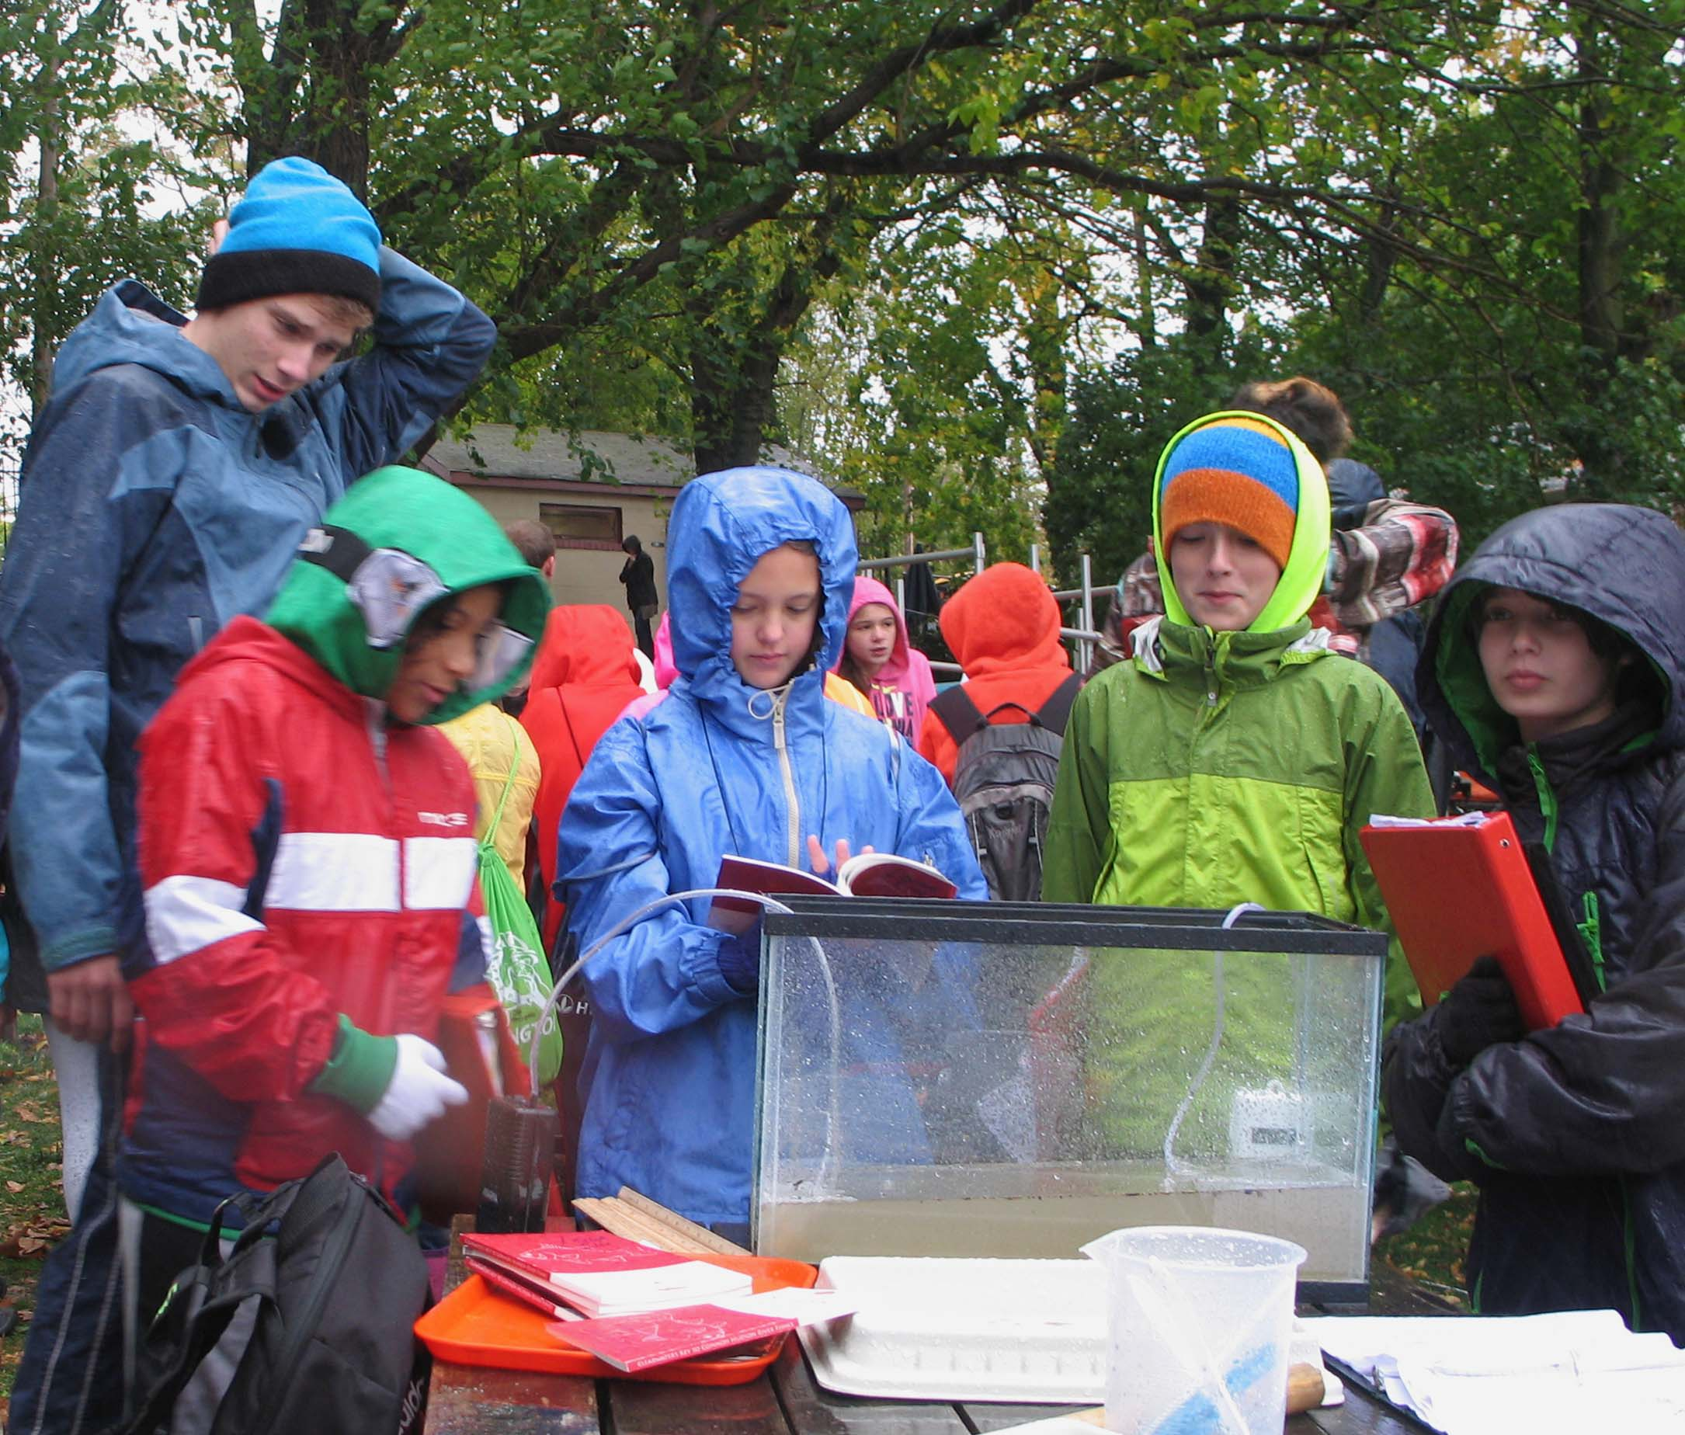
Sampling Site: Matthiessen Park, Irvington NY
Surrounding Land Use: Pier, forested, grassy, parking lot used for recreation: boating, jogging, fishing, picnics, playground
Area: 50% recreation, 30% commercial/industrial, 10% urban/residential, 5% forested, 5% beach
Shoreline: Beach, banks altered, riprap, wood bulkhead, pipe entering the water, area covered in vegetation
Plants: 80% grass, 15 % trees (not forest), 5% flowers & bushes
Water Depth: varied; depth increased as the day progressed
River Bottom: muddy, rocky

ITEM | Times | Reading 1 |  | Reading 2 |  | Reading 3
Physical
Air Temperature | 9:15 AM  10:00 AM  10:36 AM | 39 F (4 C)  45 F (7 C)  45 F (7 C)
Wind Speed | 10:00 AM | 6 (Beaufort Wind Scale) |  | North
Cloud Cover | 10:15 AM | >75% |  | Overcast
Weather today | 10:00 AM rain/drizzle
Weather recently | Rainy, cold, windy
Water Surface | choppy
TIMES |  |  | 9:15 |  | 9:30 | 9:50
Water Temperature – | 9:30 AM  10:15 AM  11:00 AM |  | 52 F  55 F  54 F |  | 12 C  13 C  12 C | Taken in 1.5 ft. water depth – overcast day
Turbidity –  site tube | 9:30-11:00 AM |  | 4.9 cm  5.8 cm  5.1 cm  5.3 cm |  | AVERAGE | 5.3 cm - very turbid – not clear and dirty – lots of small things like leaves and rocks.
Chemical
DO  Estuary wide kits | 9:30 AM  10:00 AM  10:30 AM |  | 8 ppm  6 ppm  6 ppm |  | 12 degrees C  10 degrees C  10 degrees C | 74% saturated  35% saturated  37% saturated
pH – color match test kits | 9:30 AM  10:00 AM  10:30 AM  10:45 AM |  | 7 X 3  7 X 3  8,7,8  7.5, 8, 7.5 |  | Averages | 7  7  7.67  7.67
Salinity - hydrometer | 9-11:30 AM |  | 6 ppt
Fish Catch-  10:30-11:15 AM  30 ft. net | Species  At. Silversides  Striped Bass  Bay Anchovy |  | # Caught  2  4  1 |  | Largest (inches)  3 inches  7 inches  2 inches | Totals  Total Diversity: 3  Total Catch: 7
Tides | Time  9:30 AM  9:45 AM  10:00 AM  10:15 AM  10:30 AM |  | H20 height  20 cm  28 cm  42 cm  27.5 cm  24 cm |  | Rise/Fall  Rising  Rising  Falling  Falling | Rate of change  8 cm/15 mins  14 cm/15 mins  14.5cm/15 mins  2.5 cm/15 mins
Currents | Time  9:30AM  9:40 AM  10:05 AM  10:30 AM |  | m/60 sec  10m/139 sec  10m/120 sec  10m/75 sec  10m/46 sec |  | Cm/sec  7.19 cm/sec  8.33 cm/sec  13.33 cm/sec  21.73 cm/sec | Direction  Flood  Flood  Flood  Ebb
Core – 10:15 AM  Water depth 30 cm | Length  7 inches |  | Rare  Leaves  Brick  Coal |  | Common  Mud | Abundant  Sand  Gravel  Pebbles
Traffic- Commercial | 9:30 AM |  | US Coastguard |  | Red/White/Blue | Southbound/light
Recreational | 10:50 AM |  | sailboat |  | Blue/white | Northbound/light
Other Items | Devils’ heads (water chestnut seedpods) geese droppings, shells, geese, seagulls, small flies

