Day in the Life of the Hudson River 10/21/14 Data
(Salt Front RM 64.3)
RIVER MILE 25W
Piermont Pier
Margie Turrin & 9 Lamonters, Lamont-Doherty Earth Observatory
Latitude N 41 degrees 02’592 Longitude W 73 degrees 53’789
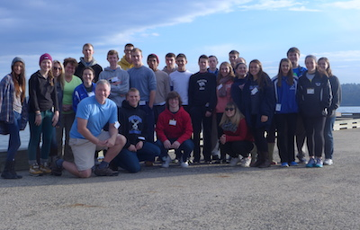 | 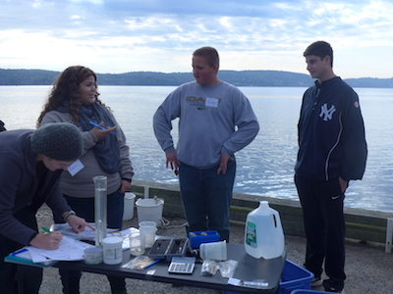
Tom Mullane, Eileen McCaffrey, and Catherine Bonanno– Pearl River HS APES – 24 Students | Patti Kilkelly,  Tappan Zee High School  10 Environmental Science Students
Latitude 41°02.591N Longitude 073°53.794W

Location: Piermont Pier, Piermont NY
Area: Man made fishing/shipping pier at the east end, long pier with paved roadway and vegetated strip along both sides
Surrounding Land Use: Urban/residential 80% , Forested 20%
Sampling Site: Pier, roadway in center of whole pier, parking area at end, Plants and trees along side. Shoreline Rip Rap, collected wood in area and piping entering river on the south of sampling site
Plants in area: no submerged aquatic plants in the water
Water depth: Varied by location on the pier and by tide
River Bottom – sandy/rocky bottom with marsh grass growing in or near the water
Plants in area: sumac and other plants 15%; phragmites 85%
ITEM | Time |  | Temperature |  |  | Weather & Observations
Physical
Air Temperature | 9:32AM |  | 17°C  63°F |  |  | Beaufort 1 North  Mph 1-3
 | 9:58 AM |  | 14.5°C  58°F
 | 10:46 AM |  | 14°C  57°F |  |  | Beaufort 2 North
 | 1:03 PM |  | 16 °C  61°F |  |  | Beaufort 4 North
Weather recent | Rain last few days, wind picked up during day. Clouds.
Water Temperature | Time | Surface Sample
 | 9:32AM | 17°C
 | 9:58 AM | 17°C
 | 10:46 AM | 18°C
 | 1:03 PM | 17°C
Turbidity – | Time | Long Site Tube |  |  |  |  |  | Average |  | Secchi
Long Site Tube | 9:15 AM | 24.8 cm  29.9 cm |  |  |  |  |  | 27.3 cm |  | Not read
 | 10:00 AM | 42.0 cm  37.5 cm |  |  |  |  |  | 39.75 cm |  | 60 cm
 | 10:43 AM | 35.1 cm  38.5 cm |  |  |  |  |  | 36.8 cm |  | 63 cm
 | 12:16 PM | 32.2 cm  28.9 cm |  |  |  |  |  | 30.55 cm |  | 46 cm
Chemical | SAMPLES * see HRECOS readings appended at the end of the student reporting
DO | TIME |  | DO Reading |  |  |  | Water Temp |  | % Saturation
Drop count | 9:32AM |  | 7 ppm |  |  |  | 17°C |  | 65%
 | 9:58 AM |  | 8 ppm |  |  |  | 17°C |  | 85%
 | 10:46 AM |  | 8 ppm |  |  |  | 18°C |  | 85%
 | 1:03 PM |  | 8 ppm |  |  |  | 17°C |  | 85%
pH | TIME
colorimeter | 9:32AM |  | 7.25
 | 9:58 AM |  | 7.5
 | 10:46 AM |  | 7.3
 | 1:03 PM |  | 7.5
Phosphates | TIME
colorimeter | 1:03 PM |  | 0.43mg/L
Nitrates | TIME
Drop count | 10:46 AM |  | 0.44 mg/L
 | 1:03 PM |  | 0.44 mg/L
Alkalinity | TIME
Drop count | 10:46 AM |  | 120 ppm
 | 1:03 PM |  | 108 ppm
*Salinity - | Refracto. |  | Hydrometer Glass  Hydrometer |  |  |  | Quantab ppm cl⁻ |  | *Quantabs ppm total salinity
9:32AM | 9 ppt |  | 6.7 ppt |  |  |  | 7.3 units - 2603 ppm cl⁻ |  | 4702 ppm
9:58 AM | 10 ppt |  | 6.7 ppt  1.0050 s.g. |  |  |  | 8.2 units - 4067 ppm cl⁻ |  | 7347 ppm
10:46 AM | 10 ppt |  | 8.9 ppt  1.0065 s.g. |  |  |  | 8.4 units - 4554 ppm cl⁻ |  | 8227 ppm
1:03 PM | 11 ppt |  | 8.0 ppt  1.006 s.g. |  |  |  | 8.4 units - 4554 ppm cl⁻ |  | 8227 ppm
Tides-  Time | Pier to river bottom |  | Pier to water |  | Water Depth |  | Tides |  | Currents
10:27 AM | 552 cm |  | 138cm |  | 414 cm |  | Ebb
12:52 PM | 550 cm |  | 206 cm |  | 344 cm |  | Ebb |  | 27 cm/sec
1:20 PM |  |  |  |  | 340 cm |  | Ebb |  | 23 cm/sec
Fish Catch  Northside of pier | Number Caught |  | Species |  |  |  | Measure of largest |  | TIME & CATCH
Rotation #1 | 117 |  | Atlantic Silverside |  |  |  | 10 cm |  | 9:00 AM
 | 12 |  | Herring |  |  |  | 5 cm |  | Diversity 2
 |  |  |  |  |  |  |  |  | 129 Total
Rotation #2 | 24 |  | Atlantic Silverside |  |  |  | 9.5 cm |  | 10:00 AM
 | 1 |  | Striped Bass |  |  |  | 5 cm |  | Diversity 5*
 | 6 |  | Herring |  |  |  |  |  | 33 total catch
 | 1 |  | Bay Anchovy |  |  |  | 6 cm |  | *not in total
 | 1 |  | Rough Silverside
 | 25* |  | Juvenile moon jellies
Rotation #3 | 22 |  | Atlantic Silverside |  |  |  | 8 cm |  | 10:30 AM
 | 1 |  | Blue Fish |  |  |  |  |  | Diversity 2*
 | 1* |  | Blue Crab (M) |  |  |  |  |  | *23 Total Catch
 | 8* |  | Comb Jelly small |  |  |  |  |  | *Not in totals
 | 1 |  | Naked Goby from trap |  |  |  | 3 cm |  | 24 Total catch
Rotation #4 | 1 |  | Mummichog |  |  |  | 6.5 cm |  | 11:30 PM
 | 78 |  | Atlantic Silverside |  |  |  | 11 cm |  | Diversity 3*
 | 2 |  | Striped Bass |  |  |  | 10 cm |  | 81 Total Catch
 | 2* |  | Ctenophore* |  |  |  |  |  | *Not in totals
Grand Total | Count 266  Count 36 |  | Fish only  macros |  |  |  |  |  | Div. 7 fish  Div. 3 macro
Plankton | Time |  | ID |  |  |  | Magnific.
 | 9:30 AM  9:34 AM  9:30 AM  9:34AM  10:19 AM  10:19 AM  10:22 AM  11:00 AM  11:00AM  11:00 AM  11:00 AM  11:00 AM  12:42 PM  12:34 PM |  | Hydroid medusa  Hydroid medusa  Anacystis Species  Adult copepod  Phyto-Diatom Dinoflagellates  Larvae of ? Bosmina  Adult copepod  Water flea  Anacystis species  Melosira species  Echinopluteus Species  Skeletonema Species  Bivaliger larva (clam)  veliger (snail) |  |  |  | 10X  20X  20X  10X  microbscope  1X  1X  microbscope  microbscope  2.5X  10X  25  microbscope
Sediment Cores | Length |  | H2S Smell | Rare |  |  | Common |  | Abundant
9:15AM | 11 cm total:  9-11 clay  7-9 silt  5-7 fine sand  5-4 med.sand  top-pebbles |  | Yes | Brick |  |  | Sand  Silt  Clay  Pebbles  Leaves  Wood |  | Mud  Sand
9:30 AM  water 46 cm | 10 cm with oxidized top |  | Yes | Leaves wood  roots |  |  | Sand  Gravel  pebbles |  | Clay  mud
10:40 AM –  water 76 cm | 14 cm |  | Yes | Sand  Pebbles  Leaves  Wood |  |  | Clay,  mud
10:42 AM | 13 cm  bottom 6 cm woody  Top 7 cm  Cap of pebbles |  | Yes | Mud  Sand  Gravel  Pebbles  roots |  |  | Sand  wood |  | Clay,  wood
12:15 PM –  water 61 cm | 11 cm |  | Yes | Sand |  |  | mud
12:15 PM | 11 cm |  | Yes | Sand |  |  | mud
12:45 PM | 9 cm
1:09 PM | 15 cm |  | Yes | Pebbles  Coal |  |  | Leaves  Brick |  | Clay  Mud  Sand  Wood
1:15 PM  water 75 cm | 14 cm |  | Yes | Sand pebbles |  |  |  |  | Clay,
Other Observations | Overcast day that ended with rain just as students were leaving.

HRECOS Screen Captures on following pages
HRECOS site is located just behind the rectangular eastern end of the pier attached to one of the pier stations. When operational it is a continuous data feed recorded every 15 minutes.
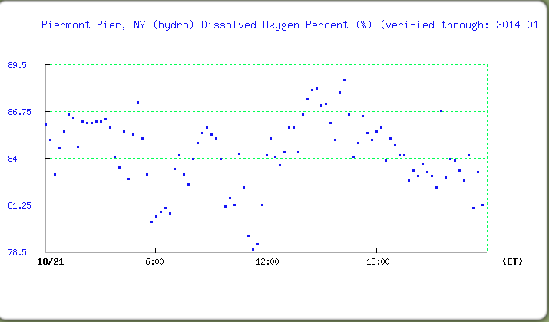
DO % Saturation
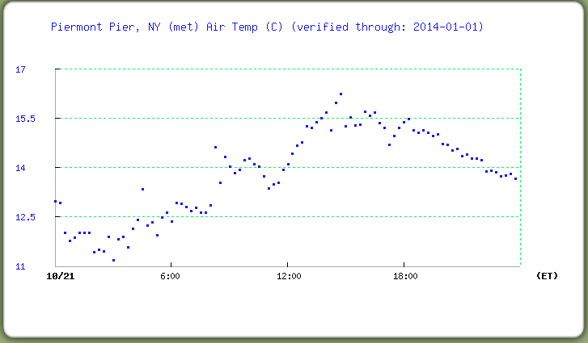
Air Temperature

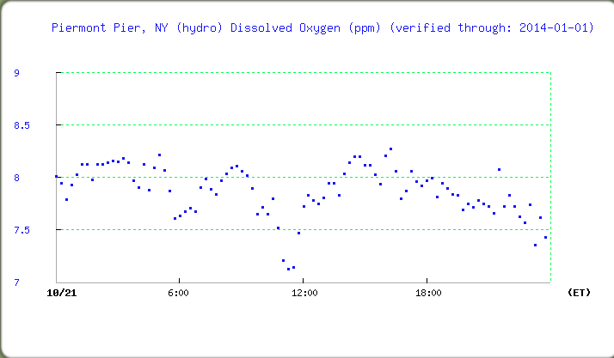
DO ppm
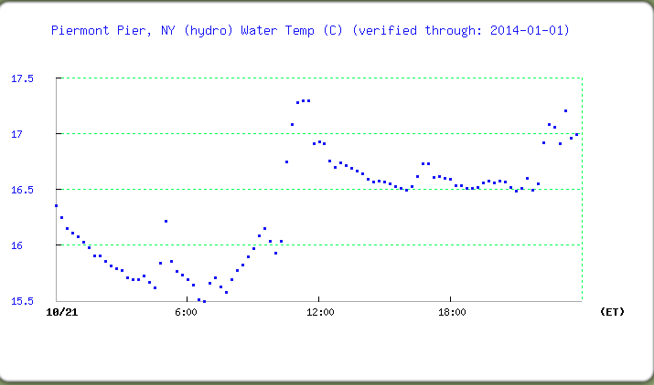
Water temperature

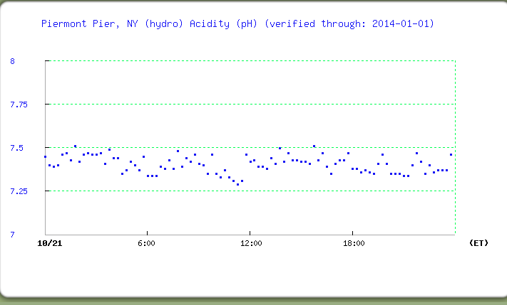
pH

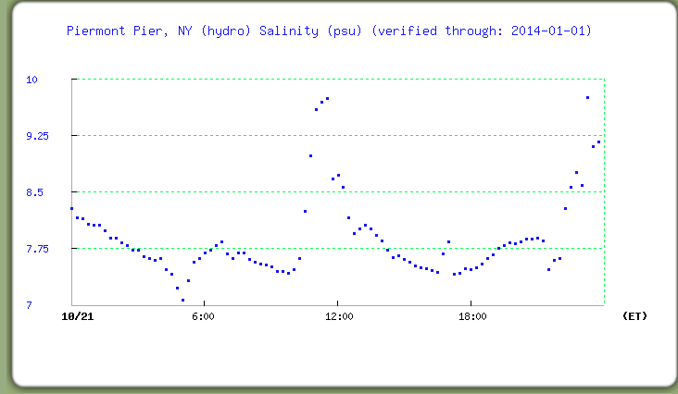
Salinity in psu (equates in the Hudson to ppt)
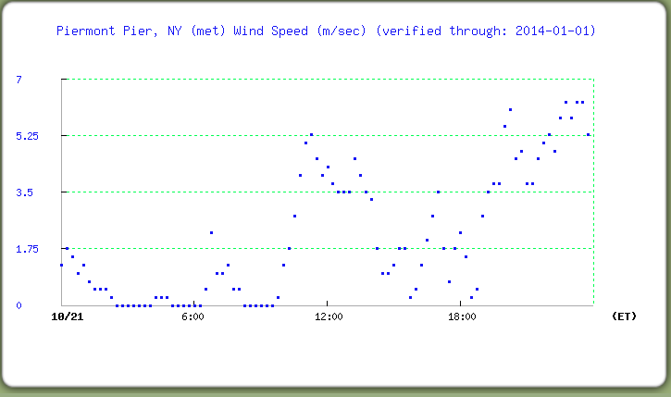
Windspeed in meters per second

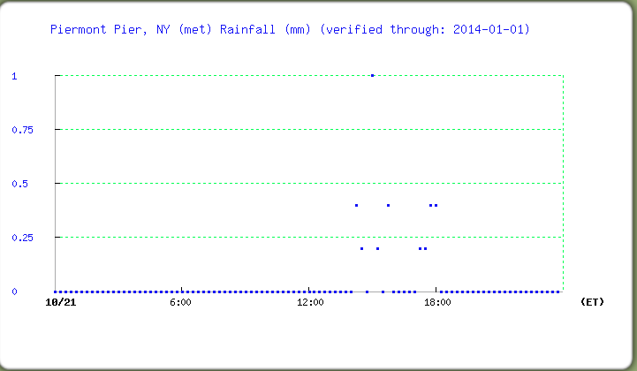
Rainfall for today – rain just after we sampled!
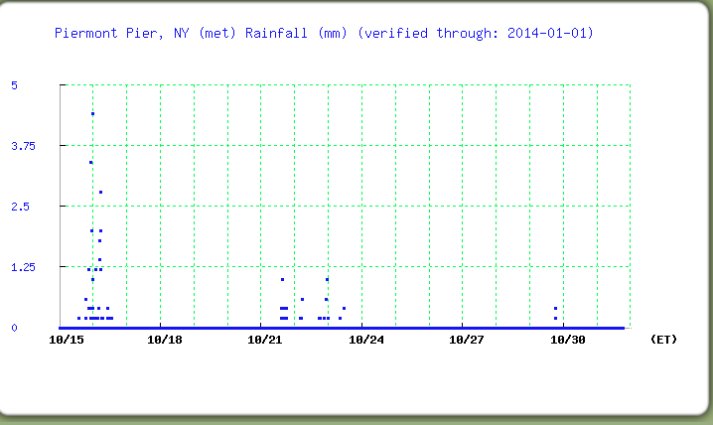
Why we sampled on the 21st and not on 10/16/14!

