A Day in the Life of the Hudson River 11/6/14 Data
(Salt Front RM 65.7)
RIVER MILE 28
Memorial Park, Nyack
Nicole Liable, Rockland County & Margie Turrin, LDEO
Dr. Kaufman & 3 other 3rd grade teachers, 80 students
Upper Nyack Elementary School
Latitude: +41.087267 degrees North Longitude: -73.915652 degrees West

*Collected sample at the park and worked with students in the classroom due to rainy weather

Location: Nyack Memorial Park, at the end of Piermont Ave, Nyack NY
Area: Park shoreline with a sandy and slightly rocky beach and pier area
Surrounding Land Use: Park with homes behind - Located along the shoreline of Memorial Park, Piermont Avenue, Nyack, NY. This stretch of shoreline is lined with riprap, a short pier, a concrete boat ramp, freshwater input site (Nyack Creek- NYS Environmental Protection Fund site), and some mud flats where HS students seined.
Sampling Site: Surrounding the shoreline is a large parking lot and some mowed grass fields. The area’s main use is for boating, fishing, and jogging as it is a major recreation site for the Village of Nyack residents. The altered banks were 95% riprap covered and the remaining 5% were mudflats.
Shoreline: Primarily rocky due to the riprap with muddy (silt/clay/mud) sediments. Tappan Zee bridge construction was in the view of our site, dredging, and increased boat traffic in the distance was noted.
Plants in area: vegetation is sparse
Water depth:
River Bottom heavy alteration of the river bottom
ITEM | Time |  | Reading 1 | Reading 2 | Comments
Physical
Air Temperature | 12:30 PM |  | 9.5°C | 49 °F
Wind Speed & Direction
Cloud Cover | All day overcast
Weather today | Overcast & Rain
last 3 days | Cold with some rain
Water | Slightly choppy
Water Temperature – | 12:30 PM | 12.25°C
Salinity  Refractometer | 12:30 PM | 9 ppm
Fish Catch –  seined | Atlantic Silverside - 7  Striped Bass - 2  Mummichog – 1 very round and large  Grass Shrimp - 1
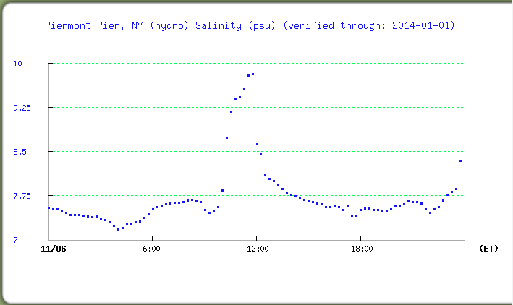
SALINITY 110614 – Water collected at 12:30 PM at Memorial Park 6 miles upriver from Piermont Pier.

