Day in the Life of the Hudson River 10/21/14 Data
(Salt Front RM 62.5)
RIVER MILE 3.2
Hudson River Pier #51
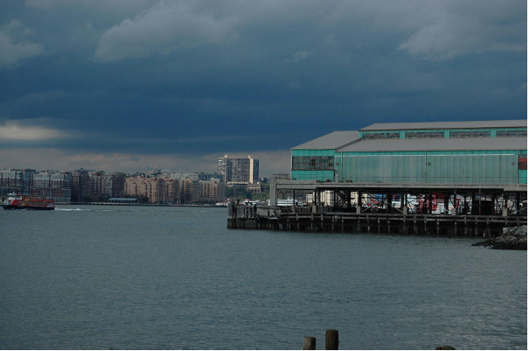 | 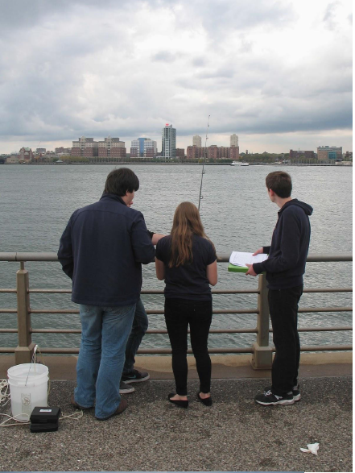 | 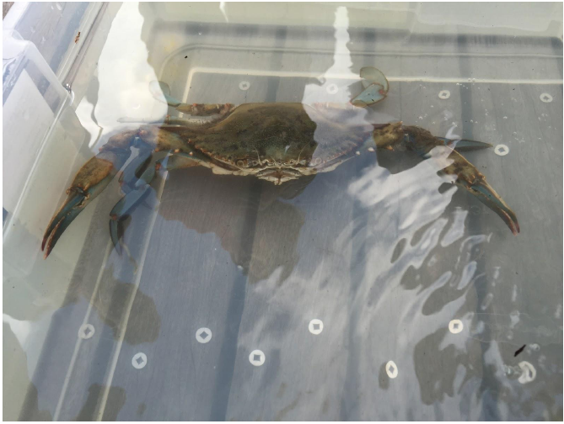

Susan Price & 3 other lab teachers - 120 APES students (64 samplers and rest observing) 11& 12th grade NYC Lab H.S.
Sam Edels & Megan Davidson form NYUs Wallerstein Collaborative
GPS coordinates: 40.738138, -74.010706
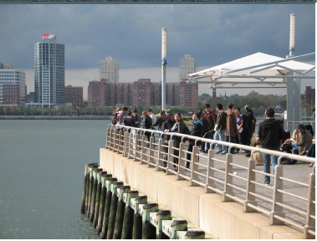 | 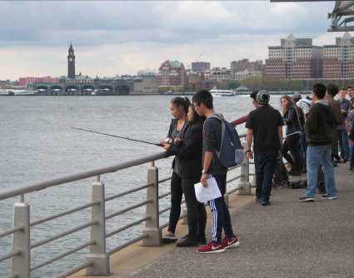 | 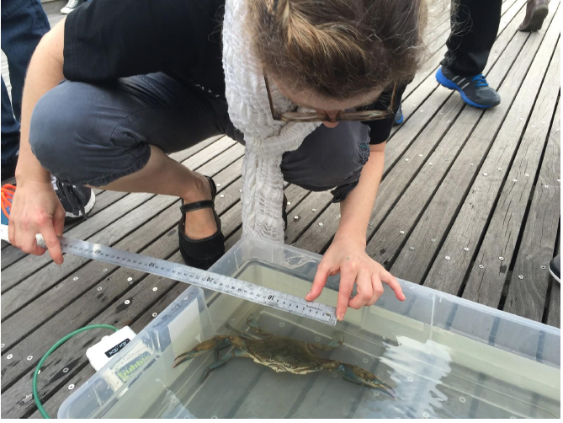

Location: Pier 51 – the Playground Pier,
Area: Pier used for boating, picnics, fishing, playground, jogging, sitting and walking
Surrounding Land Use: 60% Urban/residential; 30% Industrial/Commercial; 5% Entertainment, 5% Planted.
Sampling Site: Recreational pier, grassy and concrete
Shoreline: Banks altered, wood bulkhead, pipe entering water, riprap, concrete bulkhead
Water Area: Bottom muddy, weedy, rocky
Water: Choppy, some wind
Plants in area: 5% seaweed in water area; on pier area 10% trees, 10% grass, 5% miscellaneous

ITEM | Time | Air Temp. | Wind | Wind
Physical |  |  | Beaufort # | Anemometer
Air Temperature & WInd | 12:50 PM | n/r | #3 - SE | 4.5 m/s SE
 | 1:00 PM | 17.8°C | #4 - SW | 6 m/s SW
 | 1:15 PM | n/r | #4 - W | 5 m/s W
 | 1:30 PM | 15.6°C | #3 - SW | 5.5 m/s W
 | 1:45 PM | 16.1°C
Wind | Windy - blustery
Cloud Cover | Mostly cloudy | 51-75%
Weather today | No rain, bright sunny day. Some cumulus clouds north of pier
Weather recently | Rained Saturday, partly cloudy rest of 3 days. Moderate wind

Water Temperature | 12:40 -12:45 PM | 19°C  (19,19,19) | 19°C  (20,18,19) | 20°C  (20,20)
 | 1:00 PM | 19°C | 21°C | Avg – 20°C
 | 1:10 PM | 18°C | 20°C | Avg – 19°C
 | 1:00-1:35 PM | 20°C  21°C  19°C  20°C |  | Avg- 20°C
Turbidity –site tube | Secchi  *assume they measured from pier to line of sight rather than water surface? | 434 cm*  133 cm
Description - turbid; difficult to see through beyond surface; cloudy, pale, blue-green tint | Long Sight Tube | 68.2 cm  63.2 cm  67.2 cm  64.4 cm  65.75 cm |  | Avg – 65.75 cm
Chemistry | Time | Sigma Test Strip | pH Pen | Universal Test
pH – 3 methods | 12:55 PM  1:08 PM  1:21 PM  1:28 PM | 5  7  6  7 | 4  4  4  4.1 | 6  6  6  6
Salinity – plastic hydrometer | 12:55 PM  1:08 PM  1:21 PM  1:28 PM | >26 ppt  21 ppt  27 ppt  broken | (recorded as 1.015 density)
D.O. - CHEMets | 12:40 PM  12:50 PM  1:06 PM  1:30 PM | 19°C  19°C  17°C  18°C | 5-6 ppm  5 ppm  5 ppm  5 ppm | 58% saturated  53  50  52
Nitrogen – API Saltwater Master Test Kit | Nitrate – 0.25 ppm | Ammonia - 0 | Nitrite - 0
Macro- invertebrates* | Blue Crab | 12 cm ` | Male | At least 10 people fishing for at least 1 hr. – lot of effort for 2 crabs
*see fishing observations – end of report | Blue Crab | 16.5 cm | Male
Tides | 12:45 PM | 90 cm
Water height from the pier surface in cms  (LT ~2:00 PM) | 1:13 PM | 92 cm | *2cm/28 mins *2cm/1680 secs  *0.0012 cm/sec | Falling
Currents: | 12:15 PM | 225 ft/28 min |  | Ebb
 | 1:00PM | -75 ft/12 min |  | Ebb
*Currents - When we started our observation at about 12:15 the current was moving ebb and after 15 minutes the current had flowed 225 feet ebb. Although after one hour the current had flowed 75 feet flood from the location of which we first started tracking the current. So which we were out there the current changes from ebb to flood.
*The comments here do not align exactly with the times on the data collected.
Commercial Traffic | 1:06 PM | Circle Line | White | Northbound - Loaded
 | 1:07 PM | Water Taxi | Yellow | Southbound Loaded
 | 1:08 PM |  | Beige | Northbound Loaded
 | 1:32 PM | Cargo Boat | Red | Northbound Loaded
 | 1:37 PM | Coast guard | White | Northbound Loaded
Recreational Traffic | 12:54 PM | Speedboat | White | Southbound Light
 | 1:07 PM | Same Speedboat | White | Northbound Loaded
 | 1:12 PM | Speedboat | Black | Northbound – 2 people
 | 1:40 PM | Motor boat | White | Southbound – few people
 | 1:55 PM | Sailboat | White | Southbound  Few people
Fishing Observations | There is obviously life down there but either the smell of bait is not getting to them or in some cases some were using those “rubber” baits and fish can’t see them because the water is really murky. You barely can see past the surface.  There was definitely something interested in the bait, as it either slipped off or was eaten. Toward the bottom of the river there were objects that interfered with the fishing  line. Blue crabs prefer oysters as a food source, which is most likely why we caught them. They also tend to live on the bottom of the river, so if we let our lines drop all the  way down we would be most successful in catching them. (Chris)  There was something going after the bait that was being used. The only type of bait was clams and clams are mostly used for flounder or fluke fishing. I’ve only caught shads when using squid so this may be why we didn’t catch any fish. And since most of the people were using sinkers, they were bottom fishing so that is probably the reason why crabs were pulled up instead of fish. Likewise, using the lure proved ineffective either because the fish couldn’t see them or they were being used ineffectively. However, the most likely cause of why no fish were caught was because of the timing in which the fishing started. Fishing usually peaks at dawn and dusk. We started fishing at around noon and this is when fishing tends to be at the worst. (Brian)
Other Observations | Student 1: We saw a lot of apartment buildings, pigeons, humans, and boats. There is a children’s playground and many benches around the area. The area overall is nice and very clean unlike the pier next to this one. It is kept well-organized and clean for children to interact with the surrounding at the playground itself. Along the concrete walkway there are areas of grass with where people can relax or use for other purposes.  Student 2: The wind, transportation, pier, people, and time of day/tide can impact these results. When we went, it was sunny and there were slight breezes here and there.  Student 3: Temperature, season, weather and things like traffic can also affect the results and data that we collect. The surroundings will differ depending on the weather because people and boats are most likely to not be out if the weather is bad.  Student 4: When we got to the Pier, it was dark but within a period of 10 minutes, it was really sunny and at times it got windy. When we first got to the pier, it looked like it was about to rain and it was very gloomy. But after a while, it got really bright and the sun was peeking out of the clouds as well. It was a cool day and it was colder near the water.  Student 5: The water turned out to be a lot cleaner than it looked. The water was full of life and there was barely any trash in the river, the shore and the ground! The water is full of life like crabs and seaweed. The surrounding in this place was beautiful and clean. There wasn't any garbage lying around the park and in the river and there was several trashcans around the park to help keep it clean for other people to enjoy.  Initially the sky was very dark and there was a lot of wind; however, later on it would begin to clear up and the sun would show. The water was very clean, but the second  layer of the pier (the metal part) was very rusty and would rub off. I was working with the crab cage group and our cage would sometimes get stuck because of the metal part, and on our string we saw the rust rub onto our string.

