Day in the Life of the Hudson River 10/29/14 Data
(Salt Front ~RM61.1 - on 10/28/14 at this location but not reported for 10/29-10/31. on 11/1/14 it was at 59.6)
RIVER MILE 31 – Nyack Beach Hook Mountain State Park
Margie Turrin, Lamont-Doherty Earth Observatory
Nancy Arias, Rockland Community College, 7 students, 2 adults
41°07.5”N 73°54.5”W
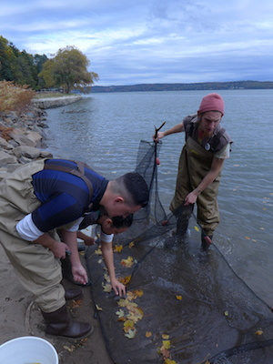
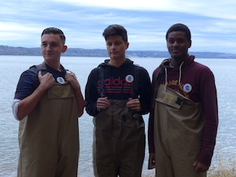
Location: Nyack Beach, Upper Nyack, Rockland County NY
Area: Park/Boat launch, near Hook Mountain Sandy Beach by the large sitting stairs, Surrounding Land Use: 70% forested, 5% urban/residential, 20% beach – used for recreation & picnics
Sampling Site: Beach – sandy and rocky at edges, covered with vegetation beyond the beach, stone wall, riprap shore, collected wood debris –
Piping coming into river south of sampling site
Water depth:
River Bottom –sandy

ITEM | Time | Reading 1 | Reading 2 | Comments
Physical
Air Temperature | 2:30 PM | 16°C
Wind Speed |  |  |  | N
Cloud Cover | cloudy
Weather today | No rain | Cooled off
Weather last 3 days | 2 days of rain & fog
Water Temperature
Turbidity –  Long site tube | 3:30 PM | 57.7 cm | 3:45 PM | 48 cm
Chemical
DO  Drop count | 3:00PM | 8 ppm
pH  Colormetric kit | 3:00 PM | 7
Nitrates | 3:10 PM | 0.3 ppm
Salinity – refractometer | 2:30 PM | 5 ppm
Fish Catch |  | Number Caught | Species | Macroinvert.
Seine 12 ft. X 6ft.  Mesh 0.25 inch |  | 5 | Atlantic Silversides
Diversity 2 |  | 2 | Striped Bass
Total Catch 7 + moon jellies |  | many | Small moon jellies | Nickel size

