**Day in the Life of the Hudson River 10/21/14 Data**

**(Salt Front RM 64.3)**

**RIVER MILE 35E**

**Croton Point Park, Croton on Hudson**

**Cheri Baron, Our Montessori School - (52) 1st-6th graders, 12 adults**

**Being assisted by Deborah Ashley, PNWBOCES (11) 12th graders, 1 adult**

**Latitude 41degrees 11.174’N Longitude 73 degrees 53.913’W**

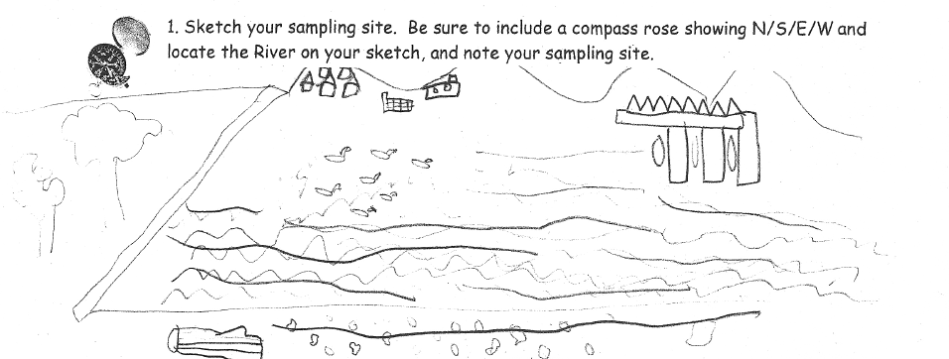

**Location:** Mother’s Lap, Croton Park NY

**Area:** Rocky beach surrounded by rising forested land and small yard and driveway

**Surrounding Land Use:** Forested 70%, Beach 30%

**Sampling Site:** Beach area with with raprap @ north end, collected wood debris in area

**River Bottom** – sandy bottom

|  |  |  |  |  |  |
| --- | --- | --- | --- | --- | --- |
| ***ITEM*** | ***Time*** | | ***Reading 1*** |  | ***Comments*** |
| ***Physical*** |  | |  |  |  |
| **Air Temperature** | 10:45 AM | | 62°F  17°C |  |  |
| **Wind Speed** | **Time** | | **Beaufort #** |  |  |
| Cloud Cover | Mostly cloudy | |  |  |  |
| Weather today | 10:45 AM sprinkled | | | | |
| Weather recently | Fall like - rain | | | | |
| Water | Choppy | | | | |
| ***Water Temperature*** | 11:10 AM  11:20 AM | 15°C  15.9°C | |  |  |
| ***Turbidity –***  **Turbidity meter** | 11:20 AM | 70.1 NTU | |  |  |
| ***Chemical*** | ***TIME*** | ***Reading*** | |  |  |
| ***DO*** | 11:53 AM  12:50 PM | 9 ppm  9 ppm | | 16 °C  16 °C | 90% saturated |
| **pH (litmus paper)** | 11:10 AM  11:10 AM  11:40 PM | 6  5  6.5 | |  |  |
| ***Salinity -*** | 11:10 AM  11:20 AM | 9.2 ppt  9.2 ppt | |  |  |
| ***Tides*** |  |  | |  |  |
| ***Currents*** |  |  | |  |  |

|  |  |  |  |  |
| --- | --- | --- | --- | --- |
| ***Fish –*** | ***Number*** | ***Species*** |  | ***Totals*** |
| 10:50 AM | 14 | Atlantic Silversides | 3 inches | **Diversity 3** |
|  | 1 | Herring | 3 inches | **Total Catch 35** |
|  | 20 | Bay Anchovies | 2 inches | **PLUS 1 crab** |
|  | 1 | Blue Crab (M) |  |  |
| ***Core Sample*** | ***Length*** | ***Abundant*** | ***Common*** | ***Rare*** |
|  | 8 inches  H2S smell | Sand | Clay  Mud  Gravel  Pebbles | Macro-invertebrates  Living Vegetation |
| ***Other*** | We saw dragonflies | | | |