Day in the Life of the Hudson River 10/16/14 Data
(Hudson River Salt Front RM 65.9)
RIVER MILE 35W – Bowline Park, Haverstraw Waterfront
Chuck Barone, Nanuet High School – 12th grade – 19 students, APES and NAPES
4 adults
41.° 12’11” N 73.° 57’ 48” W
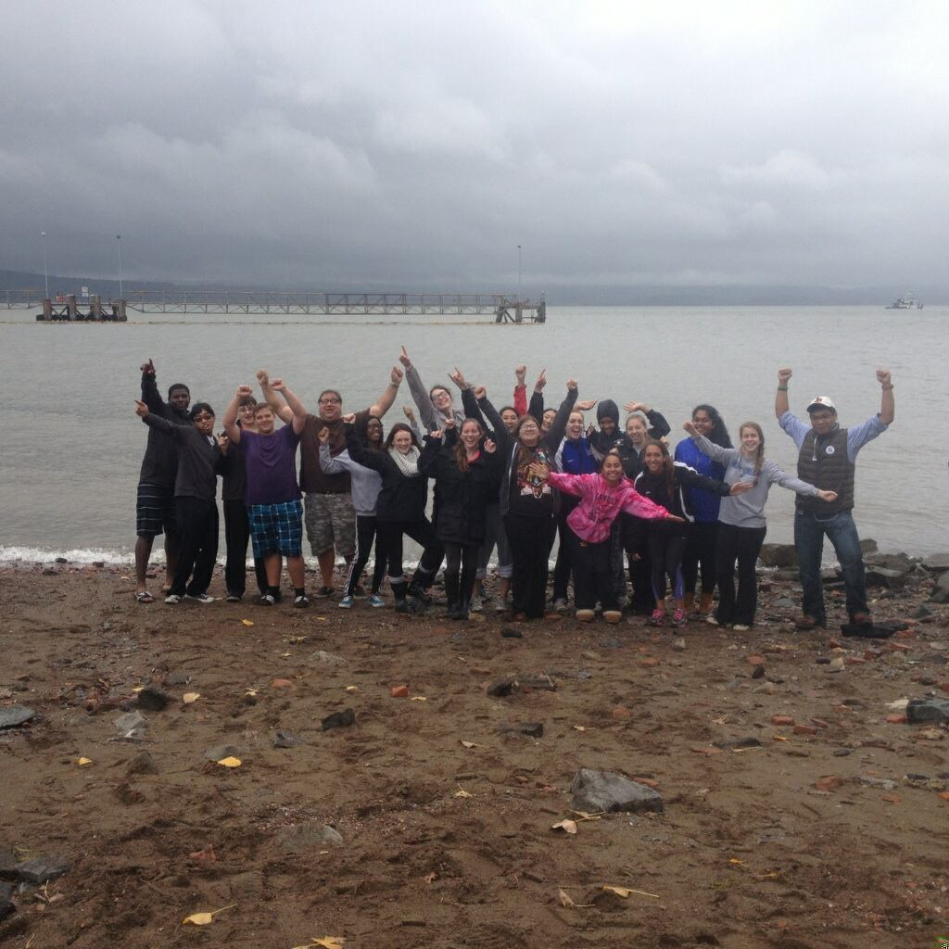

Location: Bowline Park, Haverstraw waterfront, Rockland County NY
Area: Parking lot, recreation, fishing
Surrounding Land Use: 30% beach, 50% Industrial/commercial, 20% urban/residential
Sampling Site: shoreline is sandy, muddy, rocky, small beach, bank altered, large rip rap, bulkhead, industrial tress spans the water to the north and east, bricks in the sand
Other Notes: The beach has a distinctive marker showing the high tide line or more commonly referred to as the ‘rack line’ where natural and man made debris line up
Plants in area: none
Water depth:
River Bottom – muddy
ITEM | Time |  | Reading 1 | Reading 2 | Comments
Physical
Air Temperature | 9:45am |  | 20°C | 68°F
 | 10:30 AM |  | 20°C | 68°F
Wind Speed | 11:21 AM Beaufort #4 |  | 11-16 kt | 13-18 inches wave height | South
Cloud Cover | Mostly cloudy
Weather today | Overcast |  | Cold | drizzle
Weather last 3 days | Humid – unseasonably warm – rain last 2 days and into today, windy in the evening
Water | See wave height above
Water Temp. | 9:45 AM |  | 21°C | 69.8°F
 | 10:30 AM |  | 23°C | 73.4°F
Turbidity – Long site tube | 9:45 AM |  | 27.3 cm  28.5  38.2 |  | 31.3 cm
 | 10:30 AM |  | 43 cm  35  34.9 |  | 37.63 cm
Chlorophyll | 11:35 AM |  | 0.0
Chemical
DO  Drop count | 10:00 AM |  | 20°C  20 | 7 ppm  6.6 ppm | 70 % sat.  65% sat.
 | 10:30 AM |  | 23°C  19°C | 5.1 ppm  6.2 ppm | 60 % sat  65% sat.
pH | 9:45 AM |  | 5
Salinity:  Quantabs | 9:45 AM | 5 HR |  | 1216 ppm Cl- | 2197 ppm TS
 | 10:30 AM |  | 5 HR | 1216 ppm Cl- | 2197 ppm TS
Fish Catch | Time |  | Number Caught | Species | Length of largest
Seine 50 ft. X 6ft.  Mesh 0.25 inch | 9:45 AM |  | 2 | Striped Bass | Diversity - 2  Totals - 4
 |  |  | 2 | Bay Anchovies
 | 10:30 AM |  | 4 | Striped Bass | Diversity – 2  Totals - 14
 |  |  | 10 | Bay Anchovies
 | 10:40 AM |  | 2 | Striped Bass | Diversity 3  Totals 6
 |  |  | 3 | Bay Anchovies
 |  |  | 1 | Alewife
 | TOTAL DIVERSITY |  | 3 | TOTAL CATCH | 24
Tides | 9:15 AM  10:30 AM |  | 200 cm  90 cm | 110 cm/75 mins  1.47 cm/min | falling
Currents | CM/60 secs |  | Cm/Sec | North/South Ebb/Flood/Still | Knots
9:15 AM | 200cm/30 sec |  | 6.6 cm/sec
10:30 AM | 156 cm/30 sec |  | 5.2 cm/sec
Core – | Unable to collect – too much sand
Shipping | 1 barge |  | No name | loaded
Observations | 3 deer

