**Day in the Life of the Hudson River 10/17/14 Data**

**(Salt Front RM 65.3)**

**RIVER MILE 36E**

**Senasqua Park, Croton on Hudson**

**Maureen Dillon, Jennifer Barth, Catherine Brennan – Pierre Van Cortland MS –135 5th graders and 20 adults**

**Latitude 41degrees 11.174’N Longitude 73 degrees 53.913’W**

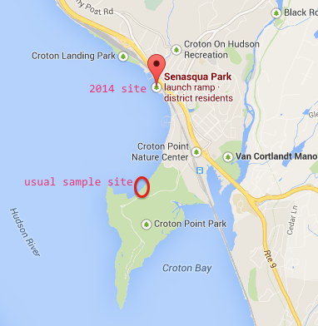

**2104 sample site was in a different location due to the rain date**

**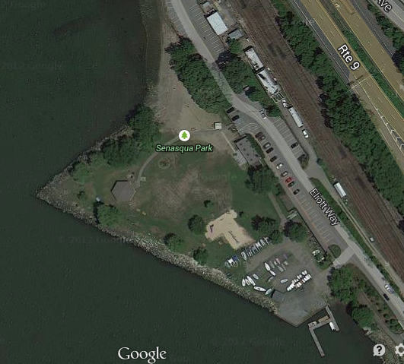  
Location:** Senasqua Beach, Croton waterfront north of Croton Point Park, Croton NY

**Area:** Park with boat launch, gazebo and lawn, rocky beach surrounded by roadways

**Surrounding Land Use:**

**Sampling Site:** Beach area with with raprap @ north end, collected wood debris in area

**River Bottom** –

|  |  |  |  |  |  |  |
| --- | --- | --- | --- | --- | --- | --- |
| ***ITEM*** | ***Time*** | | ***Reading 1*** |  | | ***Comments*** |
| ***Physical*** |  | |  |  | |  |
| **Air Temperature** |  | |  |  | |  |
| **Wind Speed** | **Time** | | **Beaufort #** |  | |  |
| Cloud Cover | clear | |  |  | |  |
| Weather today | Clear and humid - warm | | | | | |
| Weather recently | Rained yesterday and humid last few days | | | | | |
| ***Water Temperature*** | AM |  | | |  |  |
| ***Turbidity –***  **turbidity tube** | AM | 35 cm average | | |  |  |
| ***Chemical*** | ***TIME*** | ***Reading*** | | |  |  |
| ***DO*** | AM | 8.0 ppm | | |  |  |
| **pH** | AM | 7.4 | | |  |  |
| **Nitrates** | AM | 0 ppm | | |  |  |
| ***Salinity -*** | AM - school | Quantabs - 5 on HR | | | 1081 ppm Cl- | 1953 ppm TS |
|  | Runner | Quantabs - .49% NaCL | | | 2991 ppm Cl- | 5403 ppm TS |
| ***Tides*** | HT 6AM | Falling during sampling | | |  |  |
| ***Currents*** |  |  | | |  |  |

|  |  |  |  |  |
| --- | --- | --- | --- | --- |
| ***Fish –*** | ***Number*** | ***Species*** | ***Macros #*** | ***Species*** |
| Multiple seines | 86 | Atlantic Silversides | 1 | Lg Blue Crab |
|  | 1 | Bay Anchovy | 6 | Sm Blue Crab |
|  | 7 | Spottail Shiner |  |  |
|  | 3 | Alewife |  |  |
|  | 3 | Northern Pipefish |  |  |
|  | 13 | Striped Bass |  |  |
|  | 4 | Bluefish snapper |  |  |
|  | 1 | American eel |  |  |
|  | 2 | Yellow Perch |  |  |
|  | 1 | Catfish |  |  |
|  | 1 | American Shad |  |  |
| **Total Catch** | **122** |  | **7** |  |
| **Diversity** | **11** |  | **1** |  |