Day in the Life of the Hudson River 10/16/14 Data
(Salt Front RM 65.9)
RIVER MILE 41
Steamboat Dock Park, Verplanck, Westchester
Bob Connick, Sott Rizzo, Mahopac High School;
Environmental Research and Field Biology 9th - 12th graders –14 students, 2 teachers
Latitude N 41°14958 & 41.24936 Longitude W 73°936474

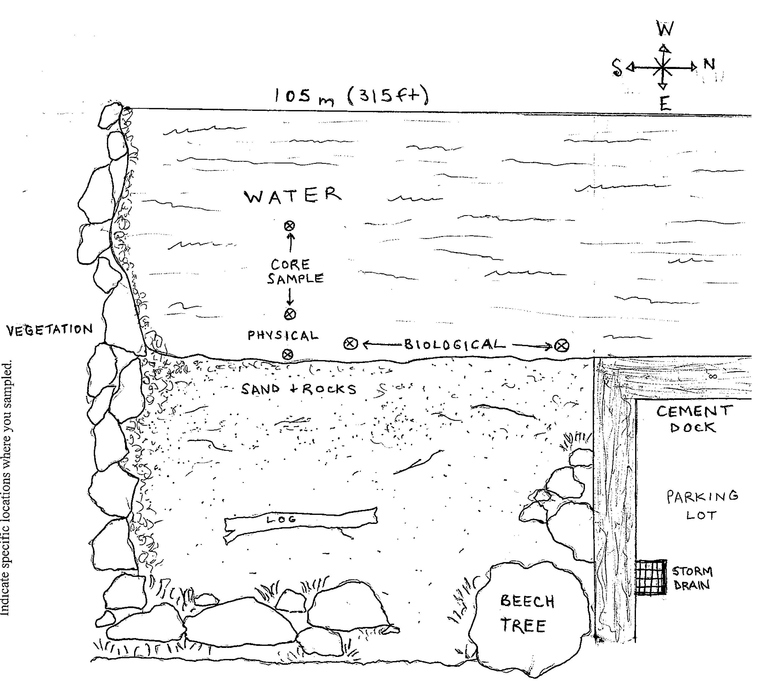
Location: Steamboat Dock Park beach, City of Verplanck in Westchester County
Area: located in a small cove between a point and a bulkhead – Pier, Grassy, Parking Lot
Surrounding Land Use: Boating, Picnics, Swimming, Fishing, Jogging
Sampling Site: beach, riprap, banks altered, dock, bottom rocky, bulkhead, pipe south of the sampling site 10-15 m.
Shoreline: Sandy, rocky
Plants in area:
Other: No plants in water
Water depth: 3 ft.
River Bottom – sandy, rocky

ITEM | Time |  |  |  | Reading 1 | Reading 2 |  |  | Comments
Physical
Air Temperature
Wind Speed | 11:30 AM |  |  |  | Beaufort 5
Cloud Cover | 11:30 AM |  |  |  | >75% cloud cover | Overcast
Weather today | 11:30 AM –cloudy, rainy
Weather recently | Humid and wet
Water Surface | Choppy
Water Temperature – | 11:30 AM |  |  |  |  |  | 21.1ºC  21.1ºC
Turbidity – | 11:35 AM |  |  | ~43 cm  Transparency tube |  |  | 14 NTU
Chemical
DO  (drop kits) | 11:43 AM |  |  | 21.1 ºC |  |  | 9 ppm |  |  | 98%  Saturation
pH  Indicator solution | 11:30-  11:40 AM |  |  | 8.0  7.6 |  |  |  |  |  | 7.8 average
Salinity  YSI SCT meter | 11:25 AM |  |  | 5.0 ppt
Alkalinity  (Hach dropcount) | 11:43 AM |  |  | 80 mg/L
Nitrates  (Hach color kit) | 11:45 AM |  |  | 0 mg/L |  |  | Used Hach colorimeter w/10 mg/L standard – read 9.6 mg/L
Phosphate  (colorimeter) | 10:50 AM |  |  | 0.57 ppm |  |  | Used Hach colorimeter w/3.0 ppm standard – read 2.89 ppm
Fish Catch- 12:05 AM | Number Caught |  |  | Species |  |  | Size of largest |  |  | Seine
25 ft net X 4ft– 300 ft. pull | 3 |  |  | Striped Bass
 | 2 |  |  | Atlantic Silversides
 | 18 |  |  | Shiners
Total Catch | 23 |  |  | Total Diversity 3 species
CPUE | 25 ft x 100 ft |  |  | 23 fish/762 m |  |  | 0.030 CPU
Coring |  | Unable to collect
Tides* |  | TIME | Amt. Rise/ Fall
 |  | *Stick was swept away by wind, waves and current
Current * |  | Time |  | Direction |  | Ebb/Flood |  | Speed
 |  | *not recorded
Traffic - commercial |  | Type |  | Name |  | North/South |  | Loaded/Light
11:140 AM  12:00 PM  12:00 PM |  | Tug |  | McRussel  Kape Wendy  Thomas DWhite |  | Southbound  Southbound  Southbound |  | Loaded
Birds |  | 6 Ring Bill Gull, 2 Canadian geese, 6 Turkey Vulture, 6 Mallards, 4 Cormorants, 1 Peregrine Falcon

