Snapshot Day 10/16/14 Data
(Salt Front RM 65.9)
RIVER MILE 41 & 52 - Boat
Aboard the Clearwater, Sampled in King Marina Dock, Verplanck, and West Point
Tom O’Dowd, Hudson River Sloop Clearwater
Crew collected deep and surface samples
Also posted transect of sail

Location: Verplanck & West Point Samples
Area: Channel Sampling – surface and depth
Sampling Site: Pier shoreline where started but sampled in open water

ITEM  RM 45 | Time | SURFACE | DEPTH  95 ft. | Comments
WEST POINT | 10:00 AM
Physical
Cloud Cover | Full Cloud cover | Mild rain
Weather yesterday | Rainy yesterday and humid
Water
Water Temperature | 10:00 AM | 19 ° C | 19 ° C
Chemical
DO  (drop count kit) | 10:00 AM | 9 ppm | 11 ppm
% Saturated |  | 100% | 120%
Salinity | 10:00 AM | 4 ppt | 5 ppt | Refractometer

ITEM  RM 41 | Time | SURFACE | DEPTH  60 ft. | Comments
VERPLANCK | 11:30 AM
Physical
Cloud Cover | Cloud cover | Rain
Weather yesterday | Rainy yesterday and humid
Water
Water Temperature | 11:30 AM | 20 ° C | 21 ° C
Chemical
DO  (drop count kit) | 11:30 AM | 8 ppm | 10 ppm
% Saturated |  | 55% | 65%
Salinity | 1130 AM | 5 ppt | 6 ppt | Refractometer

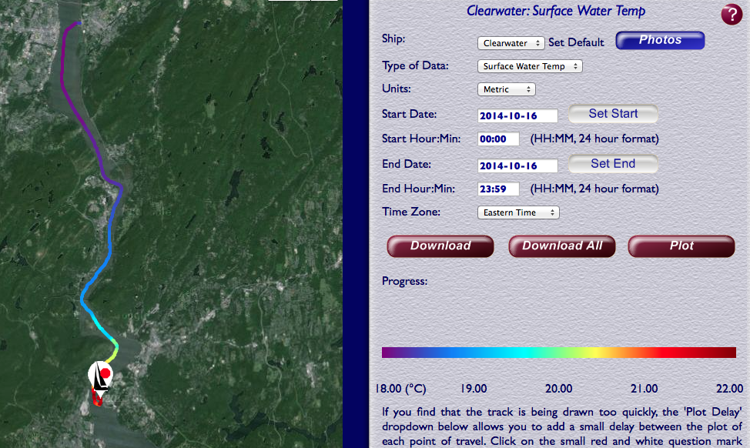
Temperature full trip

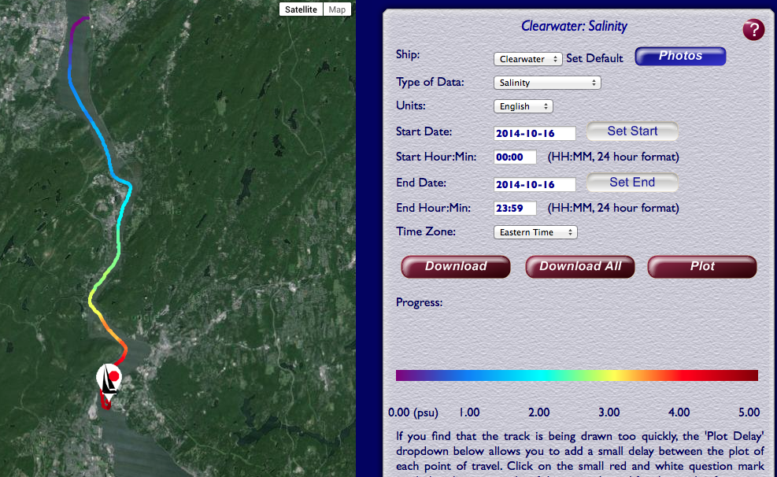
Salinity Full Trip
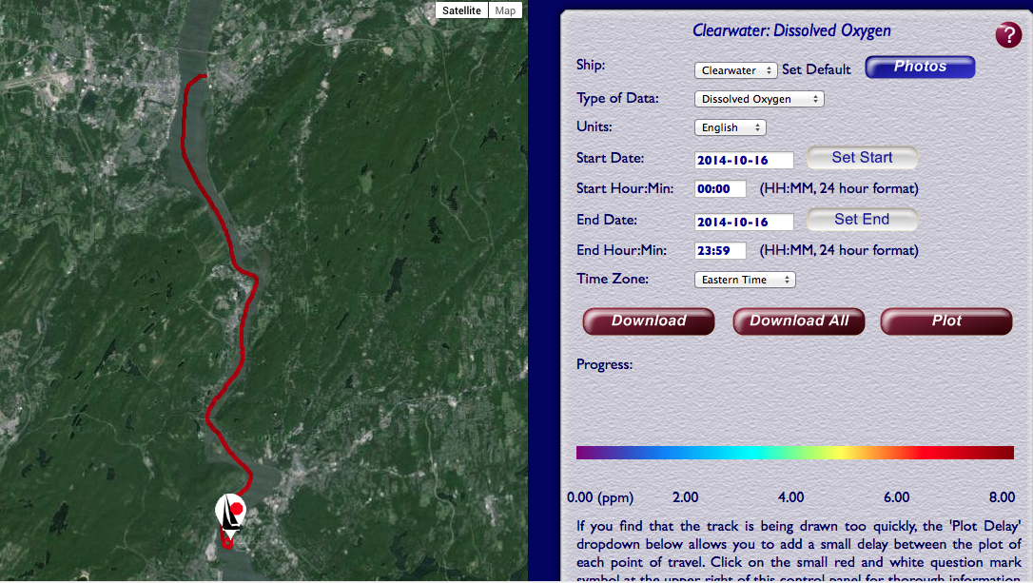
Dissolved Oxygen Full Trip

