Day in the Life of the Hudson River 10/24/14 Data
(Salt Front RM 65.3)
RIVER MILE 43
Riverfront Green, Peekskill, Westchester
Michael Billy, Walter Panas High School - 44 students, 12th grade APES, 6 adults
Latitude N 41°17’13” Longitude W 73°55’54"
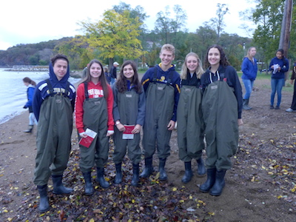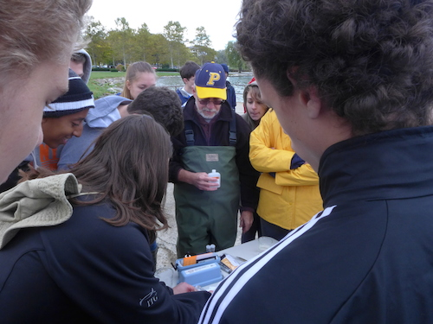 d
Location: Riverfront Green, Peekskill, Westchester County
Area: Grassy, park area with beachfront, pier, sandy beachfront, used for picnics, boating and fishing
Surrounding Land Use: 100% beach
Sampling Site: beach with brick, charcoal, slag and concrete bulkhead
Water depth: 2 ft.
River Bottom – sandy, rocky.
Plants – Cottonwood, willow and sycamore trees
Site Observations: rocks, brick, crab shells, glass, water chestnut pods (devil’s heads), twigs, leaves
ITEM | Time | Reading 1 | Reading 2 | Comments
Physical
Air Temperature | 9:52 AM | 51°F  10.5°C
Wind Speed | 9:53 AM | 3 Beaufort | 8 kts  10 mph | NE
Cloud Cover | overcast
Weather today | Cold and overcast
Weather recently | Rain and drizzle
Water Surface | Choppy
Water Temperature – | 8:45 AM | 48 °F  12°C | 10:32 AM | 59 °F  15°C
Turbidity – as noted | 9:00 AM | 1) Secchi  2)Long site tube | 61 cm  50 cm | Water somewhat turbid
Chemical
DO  (drop kits) | 10:32 AM | 9 mg/l | 15°C | 88 % saturated
pH | 10:18 AM | 7.2
Salinity -  quantabs | High range 5.4 | .236 %NaCl | 1432 ppm Cl- | 2586 ppm Total Salinity
Fish Catch- Noon | Number Caught | Species | Length | Diversity/ Totals
8:25 AM  60 ft. net X 4ft. | 2 | White Perch | 8.6 cm | DIV = 3  Totals - 24
 | 21 | Alewives | 8.6 cm
 | 1 | Striped Bass | 8 cm
9:00 AM  30 ft. net | 29 | Herring | 9.1 cm | DIV = 1  Totals - 29
9:56 AM  30 ft. net | 19 | Herring | 8.9 cm | DIV = 2  Totals - 21
 | 2 | Striped Bass | 8.2 cm
GRAND TOTAL | Total DIV | 4 | TOTAL Catch | 74
Tides | 8:20 AM | 2 ft.
 | 10:42 AM | 4 ft |  | Rising
Currents | Time | Cm/30 sec | Cm/sec | Direction
 | 10:01 AM | 82cm/30 sec | 2.73 cm/sec | Flooding
Sea Level Rise Activity | A 36 inch rise in sea level resulted in an ~17 ft. ingress into the park.
Other Items | Crow and seagull

