Day in the Life of the Hudson River 10/16/14 Data
(Salt Front RM 65.9)
RIVER MILE 4
Pier 84
N 40.76408 W-74.001893
Tina Walsh, Carrie Robles and staff, Hudson River Park Trust
Lavonne Hunter and staff, Baychester Middle School in the Bronx, 38, - 7th graders, 9 adults
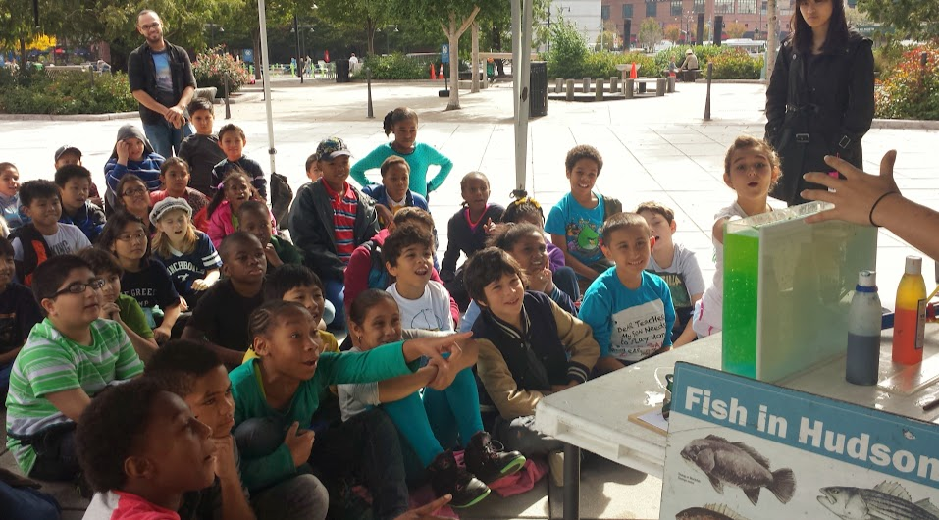
Location: Pier 84, is an educational pier used for picnics, boating, jogging, fishing
Area: Pier – bulkhead – mainly concrete & wood
Surrounding Land Use: 60% urban/residential, 40% Industrial Commercial
Sampling Site: Recreational pier – rocks near the edge, banks altered – all hard edged
Depth: ~12 feet off pier
Plants in area: No plants
Water: Calm

ITEM | Time |  | Readings
Physical
Air Temperature | 11:00 AM  11:30 AM  12:00 AM |  | 20°C  18.9°C  17.8°C
Wind Speed | 10:30 AM  10:55 AM  11:20 AM  11:45 AM |  | Beaufort 3 Beaufort 3  Beaufort 3  Beaufort 3
Cloud Cover | 10:30 AM  10:55 AM  11:20 AM  11:45 AM |  | 100%  100%  100%  100%
Weather today | Rainy |  |  | Water surface | choppy
Weather recently | Humid some rain
Water Temperature | 11:00 AM  11:02 AM  11:30 AM  11:50 AM | 20, 19, 20°C  19°C  20°C  18, 19°C
Turbidity  Turbidity tube – cm | 11:15 AM  11:35 AM  11:45 AM  12:15 PM | 30, 43.5, 47,47  30 cm  30, 30 cm  53.5 X 5 |  | AVERAGE | 41.75 cm  30 cm  30 cm  53. 5 cm
Chemical | Time | ppm |  | Temp | % Sat
DO  Estuary wide monitoring Kit – | 10:50 AM  10:50 AM | 2  2 |  | 18° C  19°C | 20%  20%
pH  kit as above | 11:30 AM  11:50 AM | 7  7
Salinity -refractometer | 11:50 AM  11:50 AM  11: 50AM | 24 ppt  24 ppt  24 ppt
Salinity -hydrometer | 11:00 AM  11:05 AM  11:05 AM  11:05 AM  11:05 AM  11:08 AM  11:20 AM | 21.6  19  22  23  21.6  20  20 |  | Average | 21 ppt
Fish Catch | Time | Species |  | Size | All caught on line
Hook, line, sinker | 10:35 PM | Blue Crab |  | 5 inches
Tides - water depth | Time | Distance to water |  | Rate of change | Flood or Ebb
*HRECOS has much larger rate of change | 10:30AM  12:20 PM | 295 cm  305 cm |  | Start point  10 cm* | Flooding
Currents | Time | Meter/sec |  | Cm/sec | Ebb/Flood
 | 10:15 AM |  |  |  | Flooding
 | 10:30 AM |  |  |  | Flooding
 | 11:00 AM |  |  |  | Flooding
 | 11:30 AM |  |  |  | Flooding
